Overview  Market Opportunity  Witnessing the success of social computing applications in the consumer space, more and more enterprises are looking for ways to apply social computing to their business processes. These enterprises want a social computing solution that is specifically designed for business purposes. And many of these enterprises want the simplicity of a hosted offering.  Solution  NewsGator created Social Sites to provide enhanced social computing capabilities that are designed specifically for enterprise use. Social Sites features include social networking, online communities, enriched user profiles, and enterprise RSS. NewsGator has integrated Social Sites with SharePoint Online and Microsoft Office SharePoint Server 2007, offering enterprises the flexibility of a hosted or on-premise solution.  Benefits  - Offers enterprises the benefit of social computing features without the need to install and maintain hardware and software  - Works with both SharePoint Online and on-premise Microsoft Office SharePoint Server 2007 deployments  - Provides social networking capabilities that enhance collaboration, increase innovation, and improve productivity  - Lowers IT investment and support costs  - Speeds deployment times |  |  | “The combination of SharePoint Online and NewsGator Social Sites offers enterprises a powerful social computing solution without the need for an upfront investment in hardware and software. This offering enables enterprises to affordably achieve the business benefits provided by social computing such as enhanced collaboration, increased innovation, and improved productivity all while lowering IT support costs.”  JB Holston, CEO and President, NewsGator  Many enterprises are challenged to increase innovation while containg or lowering costs. Social computing , with its ability to improve collaboration, increase knowledge capture, and simplify expertise discovery, offers enterprises a viable way to meet such challenges.  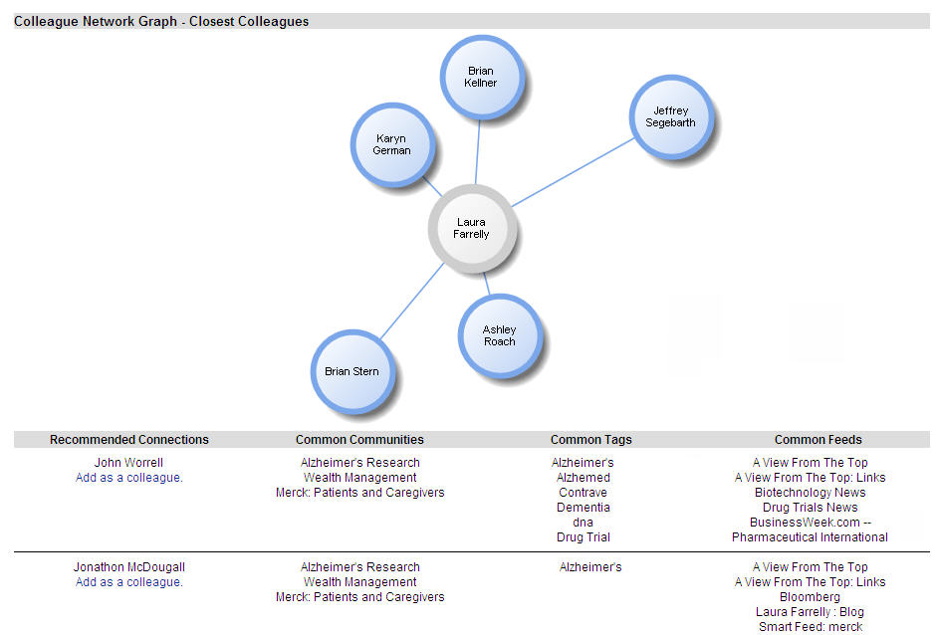  The integration of NewsGator Social Sites with SharePoint Online provides enterprises with business-focused, social computing capabilities including social networking, online communities, enriched user profiles, and enterprise RSS. By integrating Social Sites with SharePoint Online, NewsGator provides enterprises with a social computing solution that takes advantate of existing IT investments and controls IT support costs. This flexible solution enables enterprises to quickly and affordably implement social computing in order to drive innovation and gain competitive advantage.

Solution Description
NewsGator Social Sites provides enhanced social computing for SharePoint Online. Fully integrated with SharePoint, Social Sites features include social networking, online communities, enriched user profiles, and enterprise RSS. Social Sites helps businesses to better collaborate, share content, expand employee knowledge and improve productivity.

Solution Components
Online Communities
The ability to easily and instantly create online groups for increased collaboration.

Social Network Graphs
A graphical display of your social network based on explicit and implied connections.

Social Profiles
A snapshot view of a user’s interests and expertise based on their authoring, tagging, RSS behavior, and SharePoint activity.

Social Profile Building
Automated population of profiles based on system actions and profile builder wizards.

Activity Streams
A constantly updating list of community activity and colleagues’ activity within and outside of SharePoint (Facebook, Twitter, blogs, etc.) for improved worker knowledge.

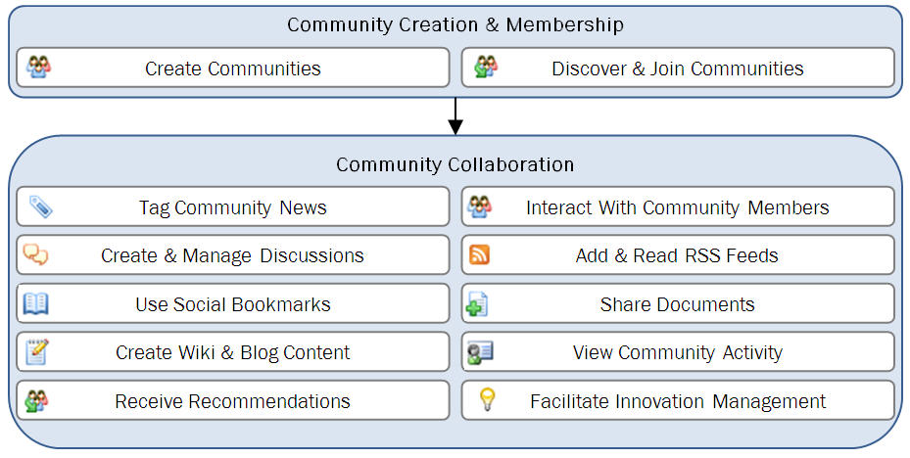
Innovation Management
The integration of idea generation, capture, and prioritization into your social network for an improved competitive position.

Social Business Intelligence
Extensive reporting and insight into your enterprise social networks so that you can fine-tune them for increased business benefit.

Enhanced RSS
The aggregation of internal and external information and delivery to the device/location of your choice (including Outlook, web, portal, mobile, and desktop).

Social Bookmarking
The ability for users to automatically share any URL with a community.

Social Search
A coupling of the power of search with that of social computing to make it easier for you to find subject matter experts, relevant communities, and pertinent content.

Community Collaboration Scenario
Social Sites enables the creation and use of online social Communities within SharePoint Online. Steps in this scenario are described in the following text.

Create Community
Users easily create public or private communities.

Discover & Join Community
Users discover and join public communities.

Tag Community News
Members add tags to automatically populate the community with relevant information.

Interact With Community Members
Users view members’ mini profiles and communicate and connect with members.
Create & Manage Discussions
Members create discussion threads and can reply, mark read, tag, rate, and subscribe via email.

Add & Read RSS Feeds
Members easily add information to the community and read/interact with content.

Use Social Bookmarks
While away from the portal, members share information back to the community.

Share Documents
Members create, share, and co-develop documents.

Create Wiki & Blog Content
Members develop and collaborate around content using Wiki and Blog features.

View Community Activity
Members stay up to date on all community actions with activity streams.

Receive Recommendations
Members receive recommendations for relevant communities they may wish to join.

Facilitate Innovation Management
Members share and collaborate around ideas and use idea voting, searching, and prioritization features. Innovation actions are integrated with the social network.
Solution Development and Implementation
NewsGator developed Social Sites using the Agile Software Development methodology. Social Sites was launched in June 2007 as a premise-based solution. NewsGator built the product using Microsoft Office SharePoint Server 2007, Microsoft SQL Server, Microsoft Windows Server, Microsoft Internet Information Server, and ASP .NET AJAX 1.0 Extensions. Social Sites integrates with Active Directory and Microsoft Exchange Server. It is compatible with Microsoft Internet Explorer.

NewsGator evolves Social Sites’ features and applications through close collaboration with customers. Seeing more and more customer demand for hosted offerings, NewsGator worked with Microsoft to integrate Social Sites with SharePoint Online.

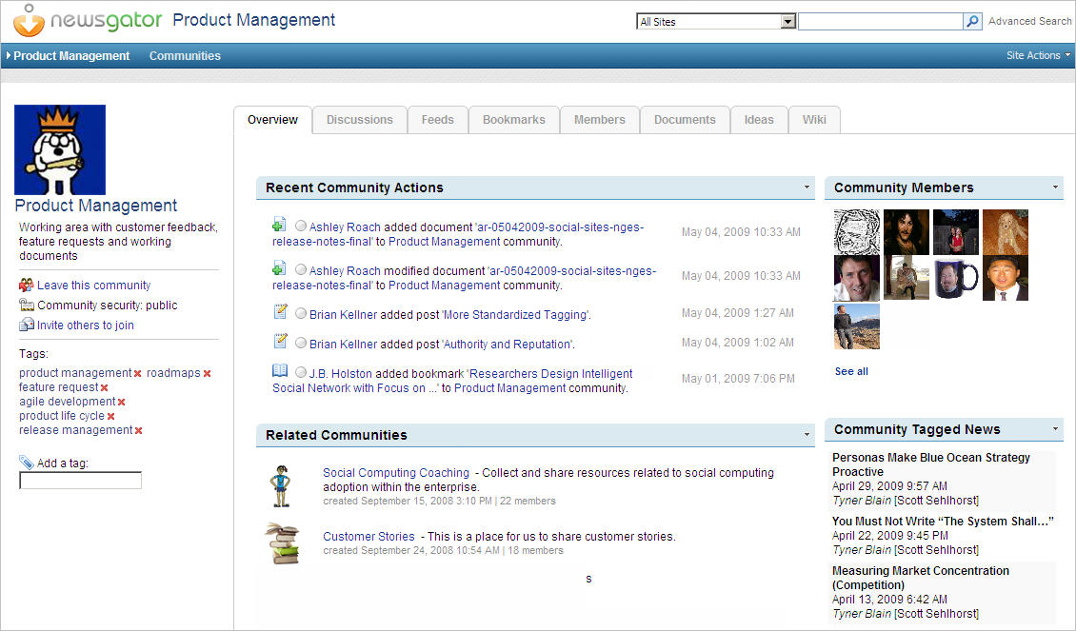
The process to port Social Sites to the SharePoint Online environment was straightforward. NewsGator performed architecture reviews with Microsoft. NewsGator then made simple code extensions in Social Sites – these code changes exposed new configuration settings that were necessary for running in an online environment. Finally, NewsGator worked with Microsoft to verify that end user performance was comparable to the premised based software version.

Social Sites is a packaged product offering and with the porting and verification tasks completed, all that remains for customer deployments is the implementation phase. The implementation phase involves configuring Social Sites to meet your company’s individual needs and requirements. The steps detailed on this page provide you with an overview of the implementation process.
Implementation Step 1: Define Requirements
NewsGator will work with you to define the benefits you hope to realize and the business problems that you are trying to solve with social computing.

Implementation Step 2: Map Use Cases
After understanding your requirements, NewsGator will work with you to identify very concrete use cases, including the actors and events involved in the use cases.

Implementation Step 3: Select Features
After detailing your use cases, NewsGator will help you to select which social computing capabilities and features to activate within SharePoint Online and Social Sites.

Implementation Step 4: Configure Environment
NewsGator will then configure Social Sites to work within your SharePoint Online environment – this includes addition of Social Sites web parts to the various sections of your portal, integration with Active Directory, and mapping to your SharePoint master template for look and feel integration.

Step 5: Develop Best Practices
If you opt to use NewsGator’s coaching services, NewsGator will work with you to develop best practices for adoption and use of the social computing capabilities. NewsGator will also work with you to identify and remove barriers to participation and to assist with the cultural transformations that are needed to support optimal social computing usage.

Step 6: Define & Measure Success Metrics
If you opt to use NewsGator’s coaching services, NewsGator will work with you to define metrics and key performance indicators to measure the success of your social computing solution. NewsGator will also assist with tracking the metrics and making recommendations for process modifications to improve metrics over time.

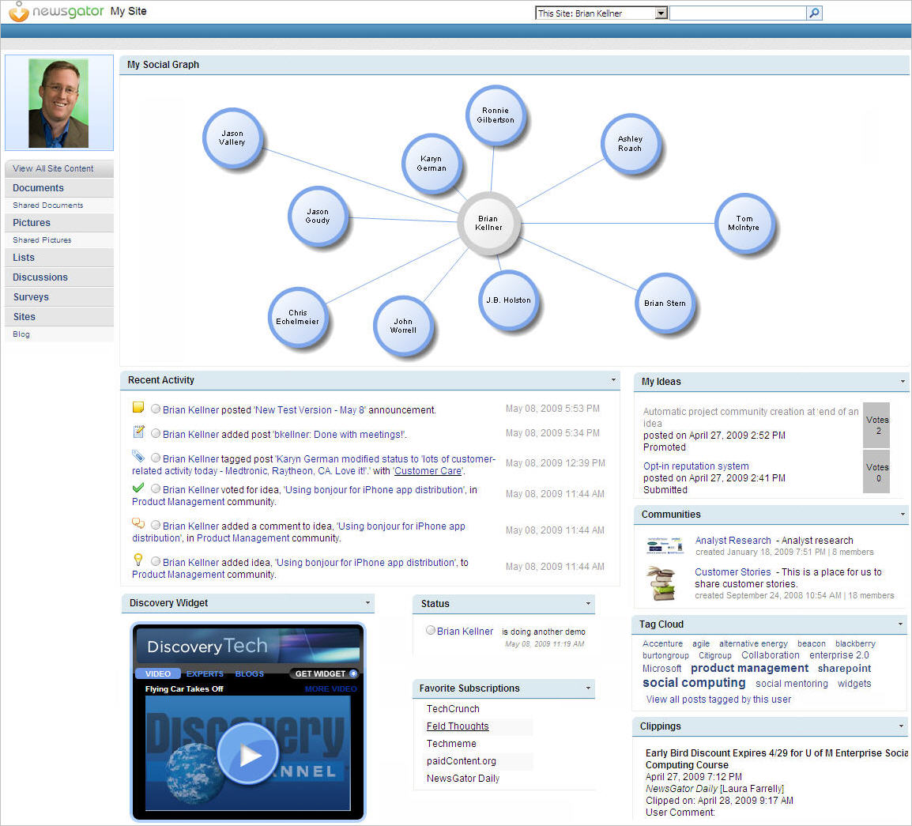

Benefits
Customer Benefits
- Improve Collaboration
- Enhance Customer Service
- Increase Knowledge Capture & Sharing
- Gain Superior Market & Competitive Intelligence
- Lower IT Support Costs
- Increase Productivity
- Simplify Expertise Discovery
- Improve Recruiting & On-Boarding

Partner Benefits
- Create New Revenue Streams
- Quickly & Easily Expand Product Portfolio
- Inexpensively Meet Customer Demand
- Reduce Time-To-Market

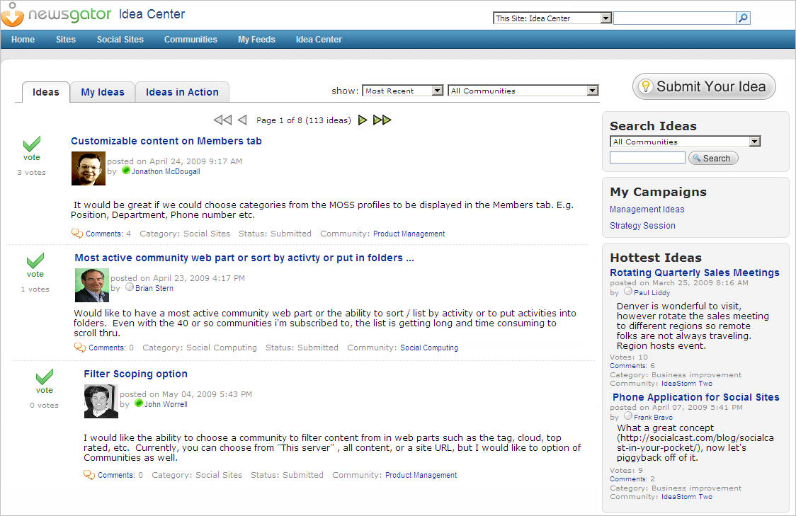

Introducing the Business Productivity Online Suite
Microsoft Online Services provide software delivered as a hosted service directly from Microsoft data centers, managed by Microsoft staff, and with a guaranteed 99.9 percent Service Level Agreement. These standardized solutions are designed so that partners can rapidly deploy services to their customers at a low, up-front investment with predictable, recurring costs.

The all-new Business Productivity Online Suite provides streamlined communications, simplified management, and business-class reliability and security.

The customer can order this service for as few as five seats at a time.

The Business Productivity Online Suite includes the following services, which can be purchased on a monthly subscription basis either separately or as part of a suite:

Microsoft Exchange Online, based on Microsoft Exchange Server 2007, offers businesses e-mail, calendaring, other messaging-based capabilities, and archiving. It also enables coexistence, which means new online users can interact with users on local servers.
(Introducing the Business Productivity Online Suite, Continued)
For More Information
For more information about Microsoft products and services, call the Microsoft Sales Information Center at (800) 426-9400. In Canada, call the Microsoft Canada Information Centre at (877) 568-2495. Customers who are deaf or hard-of-hearing can reach Microsoft text telephone (TTY/TDD) services at (800) 892-5234 in the United States or (905) 568-9641 in Canada. Outside the United States and Canada, please contact your local Microsoft subsidiary. To access information using the World Wide Web, go to www.microsoft.com

For more information about Microsoft Online Services, visit the Web site at
www.microsoft.com/online

NewsGator helps enterprises leverage social computing solutions to deliver real business value. The company’s enterprise social networking products are in use by hundreds of the world’s most recognized brands. NewsGator Social Sites gives enterprises better ways to collaborate, share content, expand employee knowledge and improve productivity. For more information contact NewsGator at 800-608-4597 or insidesales@newsgator.com.

For more information about NewsGator’s products and services, visit the Web site at www.NewsGator.com.
Microsoft Business Productivity Online Suite

- Microsoft Exchange Online
- Microsoft SharePoint Online
- Microsoft Office Communications Online
- Microsoft Office Live Meeting
- Microsoft Exchange Hosted Filtering

Microsoft SharePoint Online, based on Microsoft Office SharePoint Server 2007, provides a single integrated location where employees can efficiently collaborate with team members, find organizational resources, search, and manage content and workflow.

Microsoft Office Communications Online enables people to communicate easily with their colleagues across locations and time zones via instant messaging (text), voice, and video.

Microsoft Office Live Meeting is a hosted Web conferencing service that connects people in online meetings, training, and events through a reliable, enterprise-class hosted service.

Microsoft Exchange Hosted Filtering protects businesses’ inbound and outbound e-mail from spam, viruses, phishing scams, and e-mail policy violations.

About the Microsoft Business Productivity Online Suite
The Microsoft Business Productivity Online Suite provides businesses with virtually anywhere access to rich communication, collaboration, and productivity applications via subscription-based, Microsoft-hosted, online services. This hosted solution helps organizations offset the burden of managing and maintaining business systems, freeing information technology (IT) resources to focus on initiatives that can deliver competitive advantage to the business. The solution is part of the Microsoft’s Software-plus-Services delivery model to provide customers more choices than traditional, hosted, or on-premises solutions, allowing them to make deployment decisions that best fit the needs of their organization.

For more information about the partner opportunities provided by the Business Productivity Online Suite, see http://partner.microsoft.com/online.
© 2009 Microsoft Corporation. All rights reserved. This solution brief is for informational purposes only. MICROSOFT MAKES NO WARRANTIES, EXPRESS OR IMPLIED, IN THIS SUMMARY. Microsoft, SharePoint, Win32, and Windows are either registered trademarks or trademarks of Microsoft Corporation in the United States and/or other countries. The names of actual companies and products mentioned herein may be the trademarks of their respective owners.

Document published February 2009

