Overview  Market Opportunity  To reduce the administrative costs and burdens of managing messaging and collaboration on-premises, many companies are considering hosted solutions (“the cloud”).  Solution  Quest Notes Migrator for SharePoint provides analysis and migration of Notes, QuickPlace/QuickR and Domino.Doc application content, including all images, file attachments, OLE objects, DocLinks, and rich text to SharePoint Online.  Benefits  - Efficiently migrates large amounts of Notes, Domino.Doc and QuickPlace data without data loss  - Includes free discovery and analysis tool to help customers evaluate the complexity of their migration to SharePoint Online  - Comprehensive discovery/analysis reduces migration costs by identifying unused applications that do not need to be migrated to SharePoint Online  - Link Tracking Service ensures that DocLinks continue working before, during, and after the migration  - Supports mixed environments, where applications may reside in Lotus Notes, SharePoint on-premises or SharePoint Online  - Preserve all of your valuable business data including images, file attachments, OLE objects, rich text, DocLinks, etc.  - Dramatically reduces the cost of migration with easy-to-use tool, automated tasks, and customizable, reusable data definitions |  |  | “This move toward hosted support keeps Quest in line with Microsoft, and one step ahead of our competitors. We are committed to always providing the best and most up-to-date technology for customers who are clamoring for the lower rollout and run rate costs that BPOS provides.”  David Waugh, Vice President of Unified Communications and Collaboration  E-mail, instant messaging, and collaboration services are business-critical and demand high availability. Continually-evolving technologies and an increasing number of data security threats, as well as policy and regulatory requirements can make managing a messaging and collaboration system costly and complex. This creates a challenge in a time of diminishing IT budgets and headcounts.  To reduce the administrative costs and burdens of managing messaging and collaboration on-premises, many companies are considering hosted solutions (“the cloud”). One option is Microsoft’s Business Productivity Online Suite (BPOS): a set of hosted messaging and collaboration solutions including Microsoft Exchange Online, SharePoint Online, and Office Communications Online.  Quest Notes Migrator for SharePoint provides analysis and migration of Notes, QuickPlace/QuickR and Domino.Doc application content, including all images, file attachments, OLE objects, DocLinks, and rich text to SharePoint Online.  Notes Migrator for SharePoint offers pre-migration discovery and analysis at no cost to help customers evaluate the complexity of their migration to Online. The tool also discovers Notes databases across all servers, classifies them, and determines application complexity. This comprehensive assessment helps users identify unused applications that do not need to be migrated, allowing them to manage the process more cost-effectively, significantly reducing overall project costs.  Notes Migrator for SharePoint scales from automated migration of standard Notes applications to advanced migration of complex custom Notes applications. Easy to use and deploy, the tool allows you to quickly start and complete your migration so you can rapidly get the most from your SharePoint Online investment.

Solution Description
Quest Software helps organizations of any size expedite and simplify their migration from Lotus Notes to Microsoft SharePoint Online.

Understand Application Usage - Performs scans of selected databases to determine which have been used recently and which have not. Discover which applications make use of complex data features such as embedded objects, document links, embedded forms and digital encryption.

Analyze Application Designs – Scan your application databases to assess design complexity. Automatically compare databases with their original templates to determine which design elements have been added or modified. Discover which forms are actually being used as content types.

Manage Migration Project - Decide what data to migrate and determine where it should go based on usage, the characteristics of the application and complexity of the data. Monitor each task and keep control of the migration process.

Perform a Complete Migration - Migrate all of your complex Notes, QuickPlace/QuickR and Domino.Doc data, including rich text, embedded images, attachments, OLE objects, DocLinks and formulas.

Leverage the Benefits of SharePoint Online - Take advantage of advanced SharePoint Online features such as content types, folders, lookup fields, approval state, versioning, workflow state, InfoPath Form Libraries, content publishing pages, wiki pages, and web part pages .

Automate the Migration Process – Assign and provision entire SharePoint Online sites and/or run the appropriate migration jobs for each database using a powerful rules-based engine.

Manage Simple and Complex Jobs - Use standard data definitions for common application templates such as discussion, document library and team room. Create reusable, advanced data definitions for complex custom Notes applications.

Ensure Security Throughout the Migration - Migrate user and group permissions, application-level access control lists and Notes document-level security to the equivalent SharePoint Online security constructs.

Retain Built-In Notes Links - Leverage Notes Migrator’s Link Tracking Service to ensure that your inter-document DocLinks and HTTP links continue to work before, during and after the migration process. This service supports mixed environments, where applications may reside in Lotus Notes, SharePoint on-premises or SharePoint Online.

Automatically Map Users and Groups - Preserve all identities in Notes; automatically map Notes user and group names to Active Directory identities for use in SharePoint Online records.

Empower Users to Migrate Content - Integrate Notes Migrator for SharePoint into the Notes client to allow users to select the documents they want to migrate. This ad-hoc migration support complements the tool’s bulk migration capabilities and allows users to transfer content via simple drag and drop operations.

Maintain Control of the Migration - Use a powerful LotusScript application programming interface (API) to customize existing Notes applications to connect them to SharePoint. This gives you complete control of the migration process and the end-user experience.

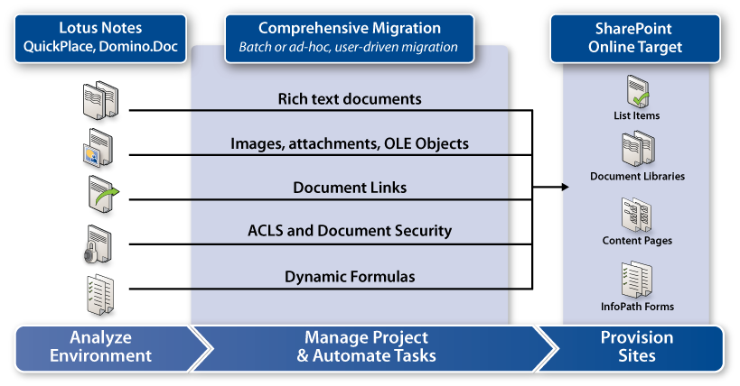
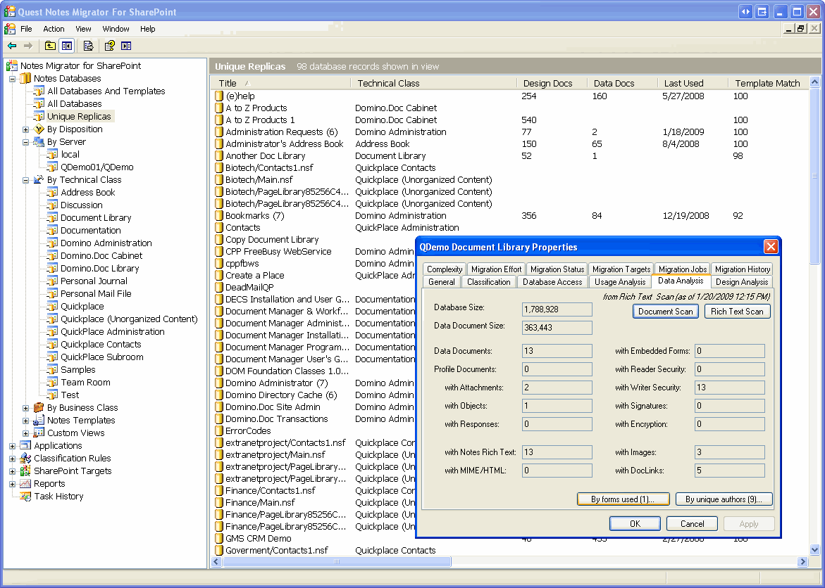

Quest’s Experience
Market-Leading Expertise in Lotus
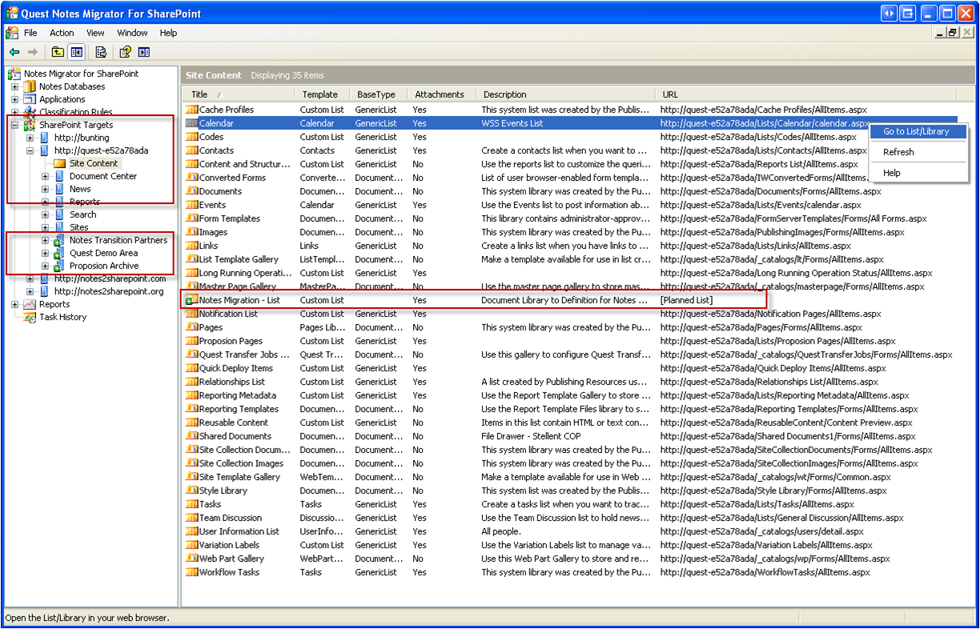
Notes Migration

- Migrated nearly 20 million mailboxes to Exchange
- Managed 32 million mailboxes in Exchange
- Migrated 5 million Notes and GroupWise users to Exchange
• Twice named Microsoft Global Independent Software Vendor (ISV) Partner of the Year

Introducing the Business Productivity Online Suite
Microsoft Online Services provide software delivered as a hosted service directly from Microsoft data centers, managed by Microsoft staff, and with a guaranteed 99.9 percent Service Level Agreement. These standardized solutions are designed so that partners can rapidly deploy services to their customers at a low, up-front investment with predictable, recurring costs.
The all-new Business Productivity Online Suite provides streamlined communications, simplified management, and business-class reliability and security. few as five seats at a time.

The Business Productivity Online Suite includes the following services, which can be purchased on a monthly subscription basis either separately or as part of a suite:

Microsoft Exchange Online, based on Microsoft Exchange Server 2007, offers businesses e-mail, calendaring, other messaging-based capabilities, and archiving. It also enables coexistence, which means new online users can interact with users on local servers.
(Introducing the Business Productivity Online Suite, Continued)
For More Information
For more information about Microsoft products and services, call the Microsoft Sales Information Center at (800) 426-9400. In Canada, call the Microsoft Canada Information Centre at (877) 568-2495. Customers who are deaf or hard-of-hearing can reach Microsoft text telephone (TTY/TDD) services at (800) 892-5234 in the United States or (905) 568-9641 in Canada. Outside the United States and Canada, please contact your local Microsoft subsidiary. To access information using the World Wide Web, go to www.microsoft.com

For more information about Microsoft Online Services, visit the Web site at
www.microsoft.com/online

Quest Software, Inc., a leading enterprise systems management vendor, delivers innovative products that help organizations get more performance and productivity from their applications databases, Windows infrastructure and virtual environments. Through a deep expertise in IT operations and a continued focus on what works best, Quest helps more than 100,000 customers worldwide meet higher expectations for enterprise
IT.

For more information about Quest Software BPOS migration products and services, visit the Web site at www.quest.com/bpos or e-mail sales@quest.com.

Microsoft Business Productivity Online Suite

- Microsoft Exchange Online
- Microsoft SharePoint Online
- Microsoft Office Communications Online
- Microsoft Office Live Meeting
- Microsoft Exchange Hosted Filtering

Microsoft SharePoint Online, based on Microsoft Office SharePoint Server 2007, provides a single integrated location where employees can efficiently collaborate with team members, find organizational resources, search, and manage content and workflow.

Microsoft Office Communications Online enables people to communicate easily with their colleagues across locations and time zones via instant messaging (text), voice, and video.

Microsoft Office Live Meeting is a hosted Web conferencing service that connects people in online meetings, training, and events through a reliable, enterprise-class hosted service.

Microsoft Exchange Hosted Filtering protects businesses’ inbound and outbound e-mail from spam, viruses, phishing scams, and e-mail policy violations.

About the Microsoft Business Productivity Online Suite
The Microsoft Business Productivity Online Suite provides businesses with virtually anywhere access to rich communication, collaboration, and productivity applications via subscription-based, Microsoft-hosted, online services. This hosted solution helps organizations offset the burden of managing and maintaining business systems, freeing information technology (IT) resources to focus on initiatives that can deliver competitive advantage to the business. The solution is part of the Microsoft’s Software-plus-Services delivery model to provide customers more choices than traditional, hosted, or on-premises solutions, allowing them to make deployment decisions that best fit the needs of their organization.

For more information about the partner opportunities provided by the Business Productivity Online Suite, see http://partner.microsoft.com/online.
© 2009 Microsoft Corporation. All rights reserved. This solution brief is for informational purposes only. MICROSOFT MAKES NO WARRANTIES, EXPRESS OR IMPLIED, IN THIS SUMMARY. Microsoft, SharePoint, Win32, and Windows are either registered trademarks or trademarks of Microsoft Corporation in the United States and/or other countries. The names of actual companies and products mentioned herein may be the trademarks of their respective owners.

Document published February 2009

