Overview  Market Opportunity  To reduce the administrative costs and burdens of managing messaging and collaboration on-premises, many companies are considering hosted solutions (“the cloud”).  Solution  Quest Notes Migrator for Exchange provides efficient, cost-effective migration to Exchange Online, including a direct migration of Notes e-mail, calendars, tasks, and personal address books.  Benefits  - Reduced project timelines – ability to migrate multiple users across multiple migration machines simultaneously.  - Reduced help desk and administrator work time – Notes Migrator automates manual administrative migration tasks and offers intuitive project management.  - Preserving network bandwidth – ability to schedule migration jobs when they’re of least impact to organization.  - Maintain business productivity – migration is totally transparent from end users and there is zero data loss and downtime of e-mail services. |  |  | “This move toward hosted support keeps Quest in line with Microsoft, and one step ahead of our competitors. We are committed to always providing the best and most up-to-date technology for customers who are clamoring for the lower rollout and run rate costs that BPOS provides.”  David Waugh, Vice President of Unified Communications and Collaboration  E-mail, instant messaging, and collaboration services are business-critical and demand high availability. Continually-evolving technologies and an increasing number of data security threats, as well as policy and regulatory requirements can make managing a messaging and collaboration system costly and complex. This creates a challenge in a time of diminishing IT budgets and headcounts.  To reduce the administrative costs and burdens of managing messaging and collaboration on-premises, many companies are considering hosted solutions (“the cloud”). One option is Microsoft’s Business Productivity Online Suite (BPOS): a set of hosted messaging and collaboration solutions including Microsoft Exchange Online, SharePoint Online, and Office Communications Online.  Quest Notes Migrator for Exchange provides efficient, cost-effective migration to Exchange Online, including a direct migration of Notes e-mail, calendars, tasks, and personal address books. Administrators have complete control over the migration process through project management and reporting capabilities. Notes Migrator for Exchange also offers enhanced scheduling; this allows components of the migration project to be scheduled when the impact to the organization will be minimal.

Solution Description
Quest Software helps organizations of any size expedite and simplify their migration from Lotus Notes to Microsoft Exchange Online.

Solution Components

Pre-Migration Assessment
Quest MessageStats Report Pack for Lotus Notes Migration enables you to plan the path of the migration by performing a pre-migration assessment of your Notes environment. You can identify the number of users and filter out unused or orphaned ones, preventing them from being migrated to the cloud.

Intuitive Project Management
Administrators have complete control over the entire migration project along with up-to-the-minute status on the migration progress.

Anytime Scheduling
Components of the migration project can be scheduled to run when it will be of least impact to the organization.

Parallel Migration
Multiple users can be migrated across multiple migration machines simultaneously. This will speed the entire migration process and reduce project costs.

Simplified Administration
Notes Migrator automates manual administrative tasks, which saves time and prevents errors.

Reduced Help Desk Calls
End-user data is migrated accurately and without user involvement ensuring a secure and reliable migration to the cloud.

Self-Service Desktop Migrator with Throttling
Migrates personal data, such as archives and encrypted data, from Notes to Exchange Online. Administrators can regulate end users’ self-service desktop migrations and avoid bottlenecks by scheduling various user collections to migrate during different migration windows, by date and time, and limiting the amount of users who can migrate at one time.

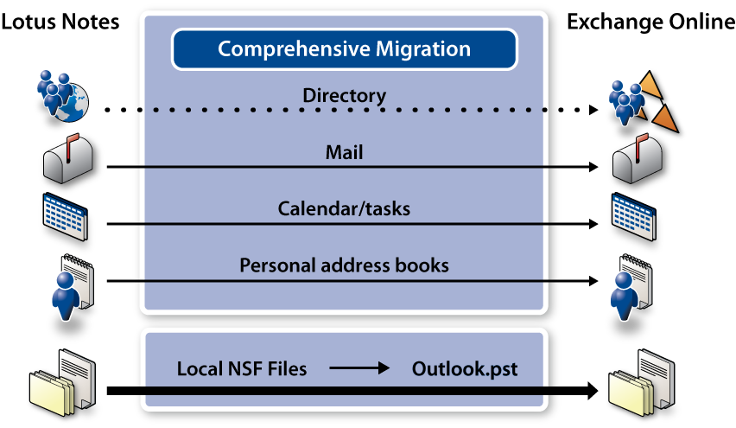

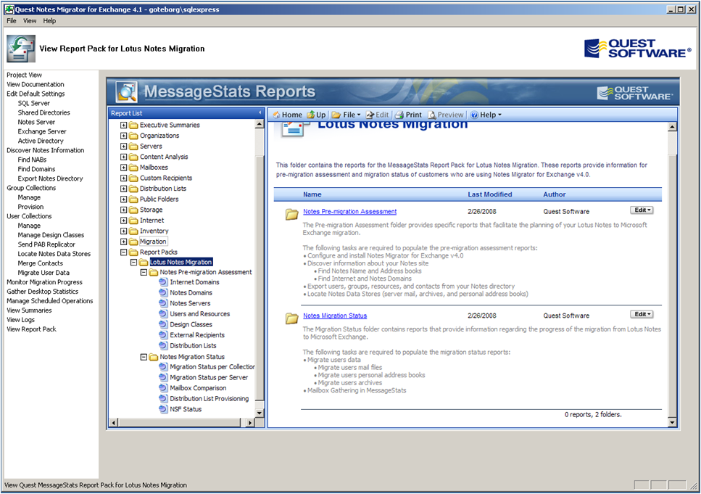
Quest’s Experience
Market-Leading Expertise in Exchange
Management and Migration
- Migrated nearly 20 million mailboxes to Exchange
- Managed 32 million mailboxes in Exchange
- Migrated 5 million Notes and GroupWise users to Exchange
• Twice named Microsoft Global Independent Software Vendor (ISV) Partner of the Year

Introducing the Business Productivity Online Suite
Microsoft Online Services provide software delivered as a hosted service directly from Microsoft data centers, managed by Microsoft staff, and with a guaranteed 99.9 percent Service Level Agreement. These standardized solutions are designed so that partners can rapidly deploy services to their customers at a low, up-front investment with predictable, recurring costs.

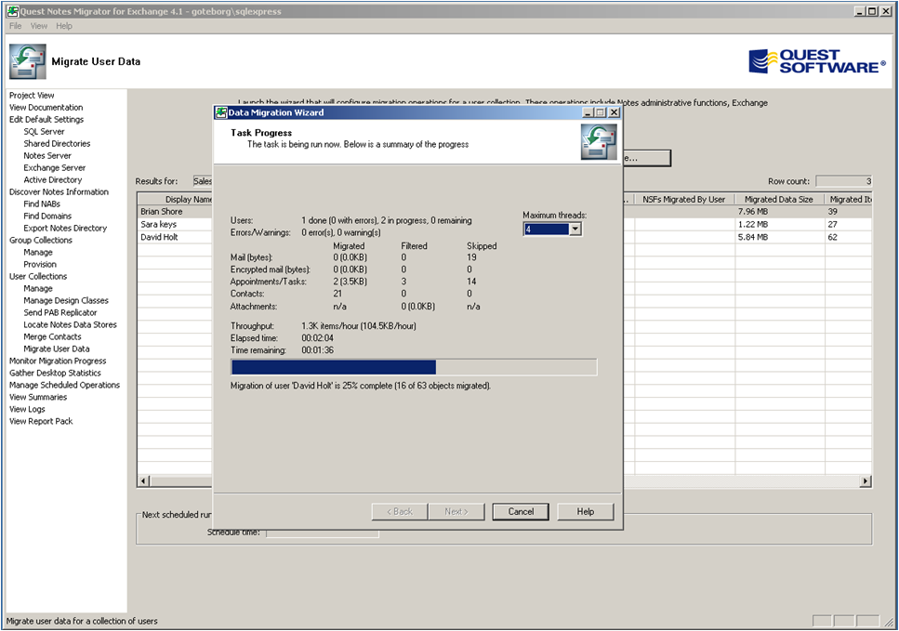
The all-new Business Productivity Online Suite provides streamlined communications, simplified management, and business-class reliability and security.

The customer can order this service for as few as five seats at a time.

The Business Productivity Online Suite includes the following services, which can be purchased on a monthly subscription basis either separately or as part of a suite:

Microsoft Exchange Online, based on Microsoft Exchange Server 2007, offers businesses e-mail, calendaring, other messaging-based capabilities, and archiving. It also enables coexistence, which means new online users can interact with users on local servers.
(Introducing the Business Productivity Online Suite, Continued)
For More Information
For more information about Microsoft products and services, call the Microsoft Sales Information Center at (800) 426-9400. In Canada, call the Microsoft Canada Information Centre at (877) 568-2495. Customers who are deaf or hard-of-hearing can reach Microsoft text telephone (TTY/TDD) services at (800) 892-5234 in the United States or (905) 568-9641 in Canada. Outside the United States and Canada, please contact your local Microsoft subsidiary. To access information using the World Wide Web, go to www.microsoft.com

For more information about Microsoft Online Services, visit the Web site at
www.microsoft.com/online

Quest Software, Inc., a leading enterprise systems management vendor, delivers innovative products that help organizations get more performance and productivity from their applications databases, Windows infrastructure and virtual environments. Through a deep expertise in IT operations and a continued focus on what works best, Quest helps more than 100,000 customers worldwide meet higher expectations for enterprise
IT.

For more information about Quest Software BPOS products and services, visit the Web site at www.quest.com/bpos or e-mail sales@quest.com.

Microsoft Business Productivity Online Suite

- Microsoft Exchange Online
- Microsoft SharePoint Online
- Microsoft Office Communications Online
- Microsoft Office Live Meeting
- Microsoft Exchange Hosted Filtering

Microsoft SharePoint Online, based on Microsoft Office SharePoint Server 2007, provides a single integrated location where employees can efficiently collaborate with team members, find organizational resources, search, and manage content and workflow.

Microsoft Office Communications Online enables people to communicate easily with their colleagues across locations and time zones via instant messaging (text), voice, and video.

Microsoft Office Live Meeting is a hosted Web conferencing service that connects people in online meetings, training, and events through a reliable, enterprise-class hosted service.

Microsoft Exchange Hosted Filtering protects businesses’ inbound and outbound e-mail from spam, viruses, phishing scams, and e-mail policy violations.

About the Microsoft Business Productivity Online Suite
The Microsoft Business Productivity Online Suite provides businesses with virtually anywhere access to rich communication, collaboration, and productivity applications via subscription-based, Microsoft-hosted, online services. This hosted solution helps organizations offset the burden of managing and maintaining business systems, freeing information technology (IT) resources to focus on initiatives that can deliver competitive advantage to the business. The solution is part of the Microsoft’s Software-plus-Services delivery model to provide customers more choices than traditional, hosted, or on-premises solutions, allowing them to make deployment decisions that best fit the needs of their organization.

For more information about the partner opportunities provided by the Business Productivity Online Suite, see http://partner.microsoft.com/online.
© 2009 Microsoft Corporation. All rights reserved. This solution brief is for informational purposes only. MICROSOFT MAKES NO WARRANTIES, EXPRESS OR IMPLIED, IN THIS SUMMARY. Microsoft, SharePoint, Win32, and Windows are either registered trademarks or trademarks of Microsoft Corporation in the United States and/or other countries. The names of actual companies and products mentioned herein may be the trademarks of their respective owners.

Document published February 2009

