Overview  Market Opportunity  Coca-Cola Enterprises (CCE) was looking to create an interactive employee portal where articles and multimedia content could be effectively shared by employees, and which could serve as a common platform for company communication. The application needed to house thousands of documents and videos while being accessed by over 10,000 remote workers who are limited to kiosk access.  Solution  Slalom Consulting partnered with Microsoft to design an intranet for CCE employees that was reflective of the company’s world-renowned brand. Slalom used Microsoft Online Services Business Productivity Online Suite, in conjunction with Microsoft Office SharePoint Server 2007 and third-party components to create a powerful yet intuitive portal that supports multiple languages in order to engage the company’s global staff.  This solution runs on the Dedicated version of the Suite, so it is hosted on dedicated servers within Microsoft data centers. Users now have a popular tool that improves communication, employee engagement, efficiency, and effectiveness, and frees the company’s IT department from system maintenance tasks.  Benefits  - Supports 70,000 users world-wide  - Acts as a strategic internal communication platform containing thousands of publishing items  - Provides team collaboration sites to share files, calendar items, and more |  |  | “Slalom Consulting provided the technical expertise in SharePoint 2007 and MOSS that allowed CCE to leverage Microsoft’s leading edge technology resulting in the quick deployment of a top class intranet site. Slalom’s involvement coupled with Microsoft’s hosting services was crucial in helping us successfully deploy both new technology and new functionality for our global employees”  - John Key, Director of Communications & Collaboration Technologies, CCE  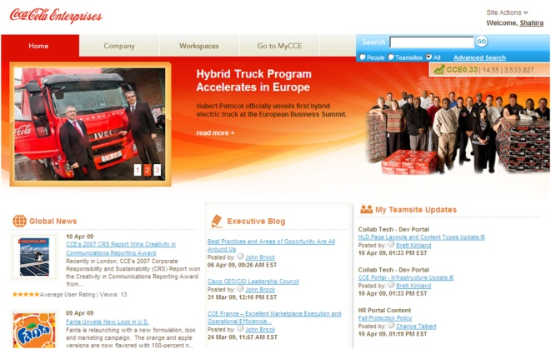  Coca-Cola Enterprises (CCE) is the world's largest marketer, producer, and distributor of Coca-Cola products. The company had an existing employee intranet site, but employee feedback and usage rates indicated that the user experience needed improvement. They wanted to create a world-class employee portal that not only reflected the company’s brand, but could offer intuitive usability and navagation, powerful search capabilities, detailed usage metrics, and collaborative tools including an employee directory, team sites, and executive communications that would significatly improve employee productivity.  Slalom Consulting partnered with Microsoft to develop a custom intranet portal that was based on the Dedicated version of the Microsoft® Online Services Business Productivity Online Suite. In just over four months, they successfully deployed CCE’s next-generation employee portal that supports the company’s global workforce with multiple language, search, video on demand, and social networking capabilities. The new employee portal is currently servicing over 70,000 users across the globe and has become a key platform for improving communication, employee engagement, efficiency, and effectiveness.

Solution Description
Slalom Consulting worked with Microsoft to develop a highly customized employee portal for Coca Cola Enterprises. The hosted solution was built on the Dedicated version of the Microsoft Online Services Business Productivity Online Suite, allowing CCE to provide its employees with a world-class portal while freeing the company from system and server maintenance responsibilities.

Solution Components
Engaging User Interface
An important aspect of the project was to provide an intuitive interface that was easy to use and reflected the company’s style and design. The new portal not only provides a clean design with a home page that sports easy navigation and news, blogs, and polls, but additional customizations offer powerful search capabilities, a user-submitted glossary, and built-in portal help.

Collaborative Team Sites
Leveraging the collaborative capabilities of Microsoft Office SharePoint® Server 2007, the solution enables users to create public and private sites. It also streamlines common site processes with a site creation wizard and team site directory where users can request access.

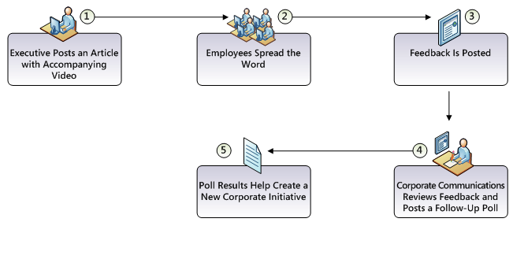
Articles and Executive Communications
The employee’s home page in the portal is designed to list new communications, both in the form of articles posted by personnel, as well as special blogs that enable the workforce to get news directly from the executive team.

Company-Wide Communication
The new employee portal provides a wealth of information and the means to simplify how employees communicate and improve team collaboration.

One example of its use is provided below. In this scenario, an executive uses the portal to describe the company’s aim to minimize the environmental footprint of their business. By combining articles with video and blogs, the entire company can become engaged in their efforts.

Executive Posts an Article with Accompanying Video
A high-level executive uses the employee portal to post an article that includes a video about the company’s commitment to minimize their environmental footprint by water stewardship, sustainable packaging and recycling, and energy conservation. Using SharePoint, the executive also posts details in his blog.

Employees Spread the Word
Employees who read the article and watch the video are excited to hear the announcement. Interest in the program expands as coworkers use the custom “Send to Colleague” feature to share the video across the company.

Feedback Is Posted
The executive’s blog entry receives numerous comments from employees. The posted video receives additional feedback via the company’s Microsoft Exchange Server feedback mailbox.

Corporate Communications Reviews Feedback and Posts a Follow-Up Poll
The company’s Corporate Communications department reviews the comments and feedback, noting that many employees are excited about the conservation efforts. Many employees mention they are especially interested in doing “their own part” to help the environment.

Due to the strong employee response to the posting, Corporate Communications posts an employee poll on the portal to collect feedback from employees, asking if they would like additional information and guidance on what they can personally do to minimize their environmental footprint and be a responsible corporate citizen.

Poll Results Help Create a New Corporate Initiative
Poll results show that a large majority of the workforce would like additional tools and tips on energy conservation, water conservation, and recycling for their workplace and at home.

Based on feedback received from employees, a communication from the company’s executives is posted that outlines a new initiative to educate and involve employees in CCE’s Corporate Responsibility and Sustainability program’s goals and commitments. The new article is well received and highly rated.
Solution Development and Implementation
Slalom Consulting was the core technical development and performance testing entity for the project, providing expert level SharePoint insight and support to CCE, functional QA vendor resources, and to Microsoft Consulting Services.

The following steps summarize the key development milestones for this project and describe the major tasks that were completed in order to achieve each milestone.

Step 1: Requirements Analysis and Solution Planning
- Review of initial requirements and design
- Solution component and architecture planning – included structuring of solutions based on common functionality and purpose to facilitate management and future enhancements

Step 2: Solution Validation and Development Planning
- Establishment of iterative development methodology with three separate development iterations
- Iteration 1 – Portal Development Iteration A
- Iteration 2 – Portal Development Iteration B
- Iteration 3 – Team Site Iteration
- Finalization of technical framework components to be used for development
- .NET Framework 3.5, C#, Microsoft Visual Studio®
- XML, XSD, XLST
- CSS, HTML, AJAX
- JavaScript and MSBuild scripts
- SQL
- MS-DOS® Batch
- Microsoft Web Application Stress (WAS) tool
- System Monitor
- Updating and modification of requirements and design based on Slalom development best practices and dedicated Suite customization and deployment requirements
- Finalization of “Release 1” scope
- Baselining of designs and requirements

Step 3: Portal Development Iteration A
- Iteration requirements freeze
- Design, documentation, development, and testing of:
- Infrastructure components
- Shared assemblies, including namespace nomenclature that can be leveraged by any developer
- Common components – common Web parts created and stored in the Site Collection Gallery for use on each site
- Home page components, which were based on the publishing infrastructure of SharePoint
- Distribution mechanism for company news and announcements
- Code refactoring
- Iteration code drop
- Functional, QA, performance testing, and bug fixing

Step 4: Portal Development Iteration B
- Iteration requirements freeze
- Design, documentation, development, and testing of:
- Article User Rating and Article Views
- Customizable search and search results
- User editable profiles
- Media Web Parts
- Third-party components
- Company page components – based on the publishing Infrastructure of SharePoint
- Enhancements and modifications of:
- Infrastructure components
- Share assemblies
- Common components
- Home page components
- Deployment script development
- Portal master pages, page layouts, and style sheet development
- Code refactoring
- Functional, QA, performance testing, and bug fixing
- Final code drop (WSP solution packages)

Step 5: Portal Go-Live Preparation and Deployment
- Microsoft code review
- Code updates (based on review)
- Global Employee Portal deployment
- Portal deployment support

Step 6: Team Site Development Iteration
- Iteration requirements freeze
- Design, documentation, development, and testing of:
- Team site wizard
- Site provisioning
- Team site components
- Portal change requests
- Enhancements and modifications of the Global Navigation component
- Team site, page layouts, and style sheet development
- Deployment script development
- Code refactoring
- Functional, QA, performance testing, and bug fixing
- Final code drop
- Solution knowledge transfer
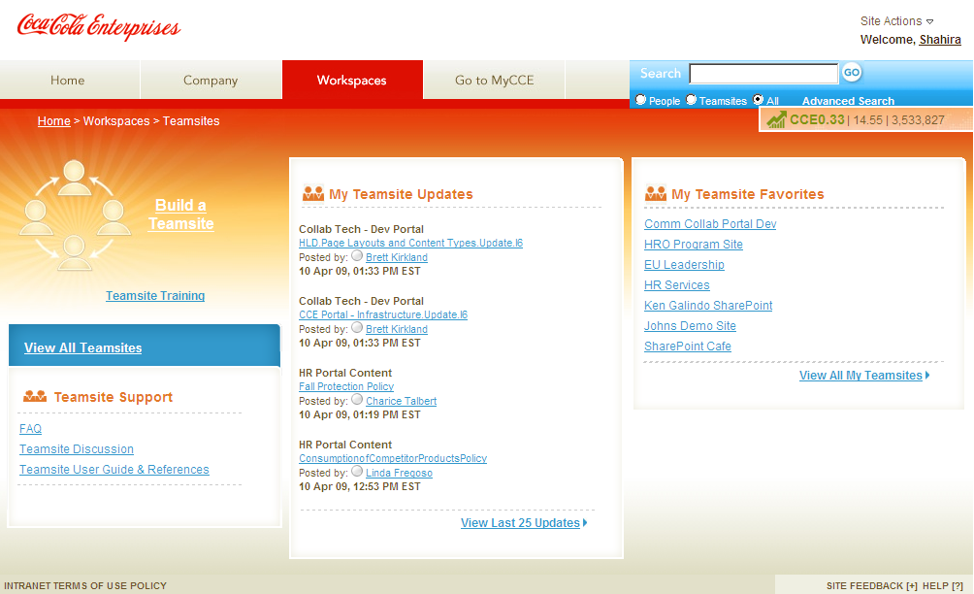
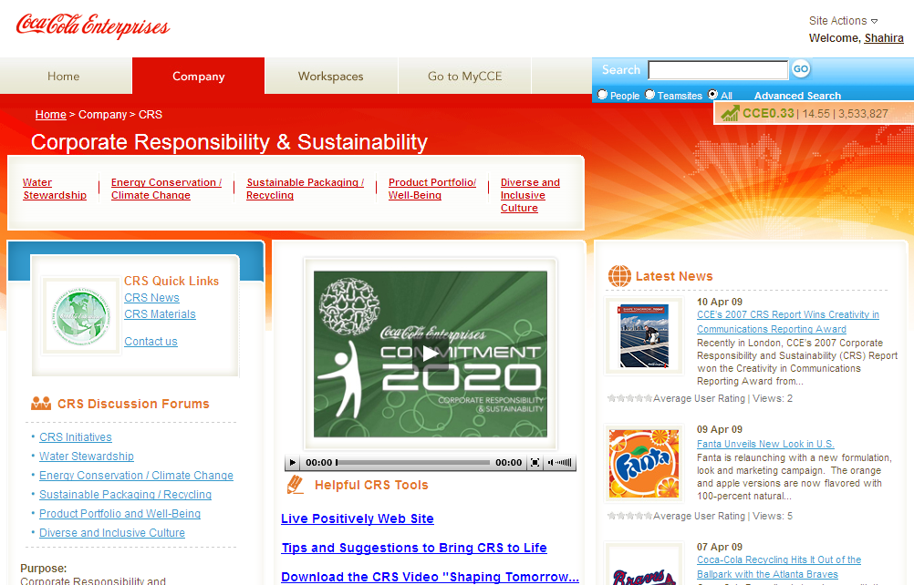
Benefits
Partner Benefits
- Experience delivering enterprise portals within the Suite environment
- Ability to deliver a highly visible product in a tight timeframe
- Gained experience and insight in developing SharePoint customizations

Customer Benefits
- 70,000 users world-wide can access a feature rich, multi-language employee portal and collaboration platform
- Company obtains best-of-breed technology and custom functionality
- Zero-maintenance: the hosted solution provides company with dedicated high-end servers in Microsoft data centers

Introducing the Business Productivity Online Suite
Microsoft Online Services provides software delivered as a hosted service directly from Microsoft data centers, managed by Microsoft staff, and with a guaranteed 99.9 percent Service Level Agreement. These standardized solutions are designed so that partners can rapidly deploy services to their customers at a low, up-front investment with predictable, recurring costs.

The all-new Business Productivity Online Suite provides streamlined communications, simplified management, and business-class reliability and security.
The customer can order this service for as few as five seats at a time.

The Business Productivity Online Suite includes the following services, which can be purchased on a monthly subscription basis either separately or as part of a suite:

Introducing the Business Productivity Online Suite, (Continued)

Microsoft Exchange Online, based on Microsoft Exchange Server 2007, offers businesses e-mail, calendaring, other messaging-based capabilities, and archiving. It also enables coexistence, which means new online users can interact with users on local servers.
For More Information
For more information about Microsoft products and services, call the Microsoft Sales Information Center at (800) 426-9400. In Canada, call the Microsoft Canada Information Centre at (877) 568-2495. Customers who are deaf or hard-of-hearing can reach Microsoft text telephone (TTY/TDD) services at (800) 892-5234 in the United States or (905) 568-9641 in Canada. Outside the United States and Canada, please contact your local Microsoft subsidiary. To access information using the World Wide Web, go to www.microsoft.com

For more information about Microsoft Online Services, visit the Web site at
www.microsoft.com/online

Coca-Cola Enterprises is the world's largest marketer, producer and distributor of Coca-Cola products, operating in 46 U.S. states and Canada. For more information about the company, visit their Web site at http://www.cokecce.com

Slalom Consulting is a national business and technology consulting firm. Their services include program and project management, business process improvement, and software development, as well as offering specialized solutions such as CRM, cloud computing, and user strategy and insight. For more information about Slalom Consulting, visit their Web site at www.slalomconsulting.com
Microsoft Business Productivity Online Suite

- Microsoft Exchange Online
- Microsoft SharePoint Online
- Microsoft Office Communications Online
- Microsoft Office Live Meeting
- Microsoft Exchange Hosted Filtering

Microsoft SharePoint Online, based on Microsoft Office SharePoint Server 2007, provides a single integrated location where employees can efficiently collaborate with team members, find organizational resources, search, and manage content and workflow.

Microsoft Office Communications Online enables people to communicate easily with their colleagues across locations and time zones via instant messaging (text), voice, and video.

Microsoft Office Live Meeting is a hosted Web conferencing service that connects people in online meetings, training, and events through a reliable, enterprise-class hosted service.

Microsoft Exchange Hosted Filtering protects businesses’ inbound and outbound e-mail from spam, viruses, phishing scams, and e-mail policy violations.

About the Microsoft Business Productivity Online Suite
The Microsoft Business Productivity Online Suite provides businesses with virtually anywhere access to rich communication, collaboration, and productivity applications via subscription-based, Microsoft-hosted, online services. This hosted solution helps organizations offset the burden of managing and maintaining business systems, freeing information technology (IT) resources to focus on initiatives that can deliver competitive advantage to the business. The solution is part of the Microsoft’s Software-plus-Services delivery model to provide customers more choices than traditional, hosted, or on-premises solutions, allowing them to make deployment decisions that best fit the needs of their organization.

For more information about the partner opportunities provided by the Business Productivity Online Suite, see http://partner.microsoft.com/online.
© 2009 Microsoft Corporation. All rights reserved. This solution brief is for informational purposes only. MICROSOFT MAKES NO WARRANTIES, EXPRESS OR IMPLIED, IN THIS SUMMARY. Microsoft, SharePoint, and Visual Studio are either registered trademarks or trademarks of Microsoft Corporation in the United States and/or other countries. The names of actual companies and products mentioned herein may be the trademarks of their respective owners.

Document published May 2009

