 | 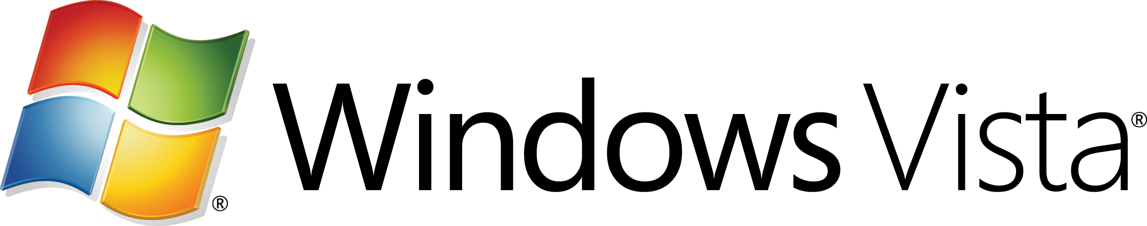
An Overview of Group Policy Preferences
By Jerry Honeycutt
Published November 2007
Abstract
Group Policy preferences enable IT professionals to configure, deploy, and manage operating system and application settings they previously were not able to manage using Group Policy. Examples include mapped drives, scheduled tasks, and Start menu settings. For many types of settings, using Group Policy preferences is a better alternative to configuring them in Windows images or using logon scripts. This white paper introduces this new Microsoft® Windows Server® 2008 feature, and describes how you can use Group Policy preferences to better deploy and manage computer and user preferences.

The information contained in this document represents the current view of Microsoft Corporation on the issues discussed as of the date of publication. Because Microsoft must respond to changing market conditions, it should not be interpreted to be a commitment on the part of Microsoft, and Microsoft cannot guarantee the accuracy of any information presented after the date of publication.
This white paper is for informational purposes only. MICROSOFT MAKES NO WARRANTIES, EXPRESS OR IMPLIED, IN THIS DOCUMENT.
Complying with all applicable copyright laws is the responsibility of the user. Without limiting the rights under copyright, no part of this document may be reproduced, stored in or introduced into a retrieval system, or transmitted in any form or by any means (electronic, mechanical, photocopying, recording, or otherwise), or for any purpose, without the express written permission of Microsoft Corporation.
Microsoft may have patents, patent applications, trademarks, copyrights, or other intellectual property rights covering subject matter in this document. Except as expressly provided in any written license agreement from Microsoft, the furnishing of this document does not give you any license to these patents, trademarks, copyrights, or other intellectual property.
© 2007 Microsoft Corporation. All rights reserved. Microsoft, Active Directory, Windows, Windows Server, Windows Vista, and the Windows logo and are either registered trademarks or trademarks of Microsoft Corporation in the United States and/or other countries.
The names of actual companies and products mentioned herein may be the trademarks of their respective owners. Microsoft Corporation • One Microsoft Way • Redmond, WA 98052-6399 • USA

Contents
Contents 2
Overview 3
Preferences vs. Policy Settings 4
Group Policy Preference Items 7
Windows Settings 8
Control Panel Settings 11
Group Policy Preferences Features 17
Common Options 17
Targeting Control 18
Process Variables 20
Settings Report 22
Deploying Group Policy Preferences 23
Windows Deployment Strategies 24
Thick Imaging 25
Thin Imaging 25
Benefits of Group Policy Preferences 27
Summary 29
Glossary 30

Overview
During your career as an IT professional, you’ve likely mapped network drives for users. You probably configured them using logon scripts. This required you to write and debug the logon script, store the script in a central location, and then run the script by configuring User objects in Active Directory® directory service or by creating a Group Policy object (GPO). Think about all the other settings you’ve configured using logon scripts or similar methods. A simple, central system to configure and deploy these settings without requiring you to make scattered changes that are easily forgotten and seldom documented would certainly help reduce costs and make your job easier, wouldn’t it?
Organizations typically deploy two types of settings: managed and unmanaged. Managed settings are policy settings that you enforce. You don’t allow users to change policy settings. Policy settings reduce support costs by enforcing standard configurations, help prevent productivity loss, and protect an organization’s assets. Group Policy is the best technology for delivering policy settings to computers running Microsoft Windows®, and if your organization is like most with Microsoft infrastructures, you’ve already adopted Group Policy.
Unmanaged settings are preferences. In contrast to policy settings, you allow users to change preferences after you’ve deployed them. By explicitly deploying preferences rather than accepting the default operating system settings, you create configurations that are more compatible with your IT environment and are specifically tailored to your organization and how its people use their computers. Additionally, deploying some preferences for users is a necessity in locked-down environments, where users can’t change many settings. Organizations deploy preferences a variety of ways, but the most common are default user profiles, registration entry (.reg) files, and logon scripts. Including preferences in Windows images is also common. In any case, most methods for deploying preferences are decentralized and unwieldy.
In contrast to the less IT-friendly methods for deploying preferences, Group Policy preferences add to Group Policy a centralized system for deploying preferences. It provides the means to simplify deployment, reduce configuration errors, and reduce IT costs. Rather than using the steps described earlier to deploy mapped drives, for example, you simply create a Group Policy object and edit its Drive Maps preference item. This white paper describes Group Policy preferences—its features, the differences between policy settings and preferences, and the many benefits of using this new technology.
In this white paper:
- Preferences vs. Policy Settings
- Group Policy Preference Items
- Group Policy Preferences Features
- Deploying Group Policy Preferences
- Windows Deployment Strategies
- Benefits of Group Policy Preferences

Preferences vs. Policy Settings
Windows Server 2008 includes the new Group Policy preferences built-in to the Group Policy Management Console (GPMC). Additionally, administrators can configure preferences by installing the Remote Server Administration Tools (RSAT) on a computer running Windows Vista Service Pack 1 (SP1). RSAT, currently in beta and expected to release shortly after Windows Server 2008, includes the updated GPMC.
The most common question about Group Policy preferences is, “How are preferences different from policy settings?” Understanding this concept is crucial to taking full advantage of Group Policy preferences. Table 1 summarizes the differences between them, and the “Glossary” section defines more terminology used throughout this and other Group Policy white papers that cover preferences.
Table 1. Preferences vs. Settings
 | Group Policy Preferences | Group Policy Settings
Enforcement | - Preferences are not enforced  - User interface is not disabled  - Can be refreshed or applied once | - Settings are enforced  - User interface is disabled  - Settings are refreshed
Flexibility | - Easily create preference items for registry settings, files, and so on  - Import individual registry settings or entire registry branches from a local or a remote computer | - Adding policy settings requires application support and creating administrative templates  - Cannot create policy settings to manage files, folders, and so on
Local Policy | - Not available in local Group Policy | - Available in local Group Policy
Awareness | - Supports non-Group Policy-aware applications | - Requires Group Policy-aware applications
Storage | - Original settings are overwritten  - Removing the preference item does not restore the original setting | - Original settings are not changed  - Stored in registry Policy branches  - Removing the policy setting restores the original settings
Targeting and Filtering | - Targeting is granular, with a user interface for each type of targeting item  - Supports targeting at the individual preference item level | - Filtering is based on Windows Management Instrumentation (WMI) and requires writing WMI queries  - Supports filtering at a GPO level
User Interface | - Provides a familiar, easy-to-use interface for configuring most settings | - Provides an alternative user interface for most policy settings

The key difference between preferences and policy settings is enforcement. Group Policy strictly enforces policy settings. First, Group Policy writes those settings to the Policy branches of the registry, and the access control lists (ACLs) on those branches prevent Standard users from changing them. When a Group Policy-aware application or operating system feature looks for a potentially managed setting, it first looks for the policy setting. If the policy setting doesn’t exist, it looks for the setting elsewhere in the registry. Second, Group Policy-aware applications and operating system features typically disable the user interface for settings that Group Policy is managing, which prevents users from changing them. Finally, Group Policy refreshes policy settings at a regular interval, which is every 90 minutes, by default, but which is configurable by a Group Policy administrator.
In contrast to Group Policy settings, Group Policy does not strictly enforce preferences. Group Policy does not store preferences in the Policy branches of the registry. Instead, it writes preferences to the same locations in the registry that the application or operating system feature uses to store the setting. The implication of this is twofold. First, Group Policy preferences support applications and operating system features that aren’t Group Policy-aware. Second, Group Policy preferences do not cause the application or operating system feature to disable the user interface for the settings they configure. The result is that after deploying preferences using Group Policy, users can still change those settings. Additionally, Group Policy refreshes preferences using the same interval as Group Policy settings by default. However, you can prevent Group Policy from refreshing individual preferences by choosing to apply them only once. This configures the preference one time and allows the user to change it permanently.
Group Policy filtering is substantially different from Group Policy preference item-level targeting. You filter GPOs using WMI filters, and those filters determine whether Group Policy applies to the entire GPO. You cannot filter individual policy settings within a GPO. Of course, you can create GPOs based upon your filtering requirements to work around this limitation, but that might lead to a large set of GPOs to manage. On the other hand, Group Policy preferences support item-level targeting—you can target individual preference items within a GPO. For example, a single GPO can contain two preference items, both of which configure power policies. You can target the first preference item at desktop PCs and the second at mobile PCs. Additionally, while Group Policy filtering requires you to write sometimes complex WMI queries, item-level targeting provides a friendly user interface.
Figure 1 provides a decision path for choosing whether to deploy an item using Group Policy settings or preferences. The most important factor is whether or not you want to enforce the item. To configure an item without enforcing it, use preferences. The next factor is whether the application or feature is Group Policy-aware. To enforce items for which no policy setting is available, you can deploy them as preference items and then disable the Apply once and do not reapply option. For more information, see “Common Options.”
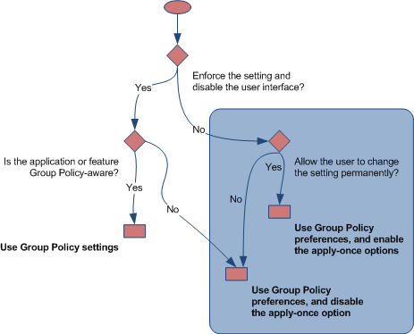
Figure 1. Preferences vs. policy settings

Group Policy Preference Items
Figure 2 shows the computer and user Group Policy preference extensions. Within each GPO you can add multiple preference items to each preference extension, and target them individually. Within a single GPO, for instance, you can add multiple preference items to the Drive Maps preference extension, and then target each preference item at different departments.
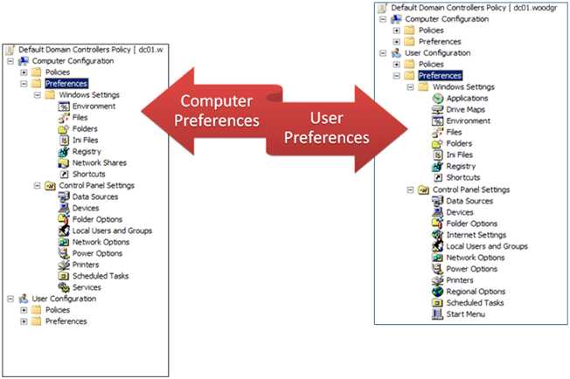
preference extensions
Figure 2. Preference extensions
Notice in Figure 2 that some preference extensions are in the Windows Settings folder while others are in the Control Panel Settings folder. Preferences in the Windows Settings folder contain settings that you most likely wrote scripts to configure in the past. These include managing environment variables, files, folders, and registry settings. Preferences in the Control Panel Settings folder contain settings that users can configure through Control Panel. Examples include folder options, power policies, and scheduled tasks.
In general, the Computer Configuration and User Configuration nodes contain mostly the same preference extensions. However, the same preference extension in the Computer Configuration node might contain different properties than the same extension in the User Configuration node. Unique to the Computer Configuration node are the Network Shares and Services preference extensions. Unique to the User Configuration node are the Applications, Drive Maps, Internet Settings, Regional Options, and Start Menu nodes.
The following sections describe each preference extension in more detail.

Windows Settings
Table 2 describes each Group Policy preference extension in Windows Settings. The first column contains a sample preference item for each extension, and the second column provides an overview of the extension.
Table 2. Preference Extensions in Windows Settings
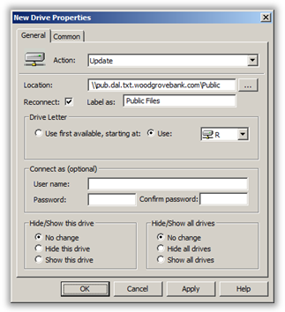 | Drive Maps  The Drive Maps preference extension provides the ability to create, replace, update, and delete network drive mappings. This extension enables you to map network drives without writing logon scripts. Additionally, mapped network drives deployed using the Drive Maps preference extension work more consistently than those deployed using logon scripts.  You can deploy multiple Drive Maps preference items within a single GPO. You can also target individual Drive Maps preference items to specific departments, locations, and so on. Using Group Policy preferences to deploy mapped network drives provides just as much flexibility as scripting but with less work and with fewer problems.
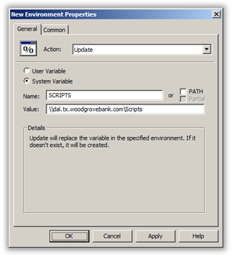 | Environment  The Environment preference extension enables you to manage user and system environment variables or update the path. Combined with item-level targeting, the Environment preference extension provides a powerful way to configure variables for different scenarios using a single GPO.  A powerful example for the Environment preference extension is to define variables that other preference items use. For example, you can define the location of a file repository using the Environment preference extension; then, you can use the variable in other preference items rather than hard-coding the path. This leaves you a single GPO to update when the path changes, rather than having to find the path in other locations.  For more information about variable expansion in Group Policy preferences, see the section “Process Variables.”
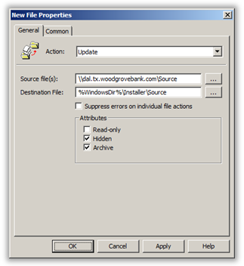 | Files  The Files preference extension gives you the ability to create, replace, update, and delete files on the destination computer. This extension supports wildcards in file paths, so you can easily copy groups of files using a single GPO. It supports environment variables, too, allowing you to create a preference item that is easier to maintain than one containing hard-coded paths.  A common scenario for using the Files preference extension is to copy configuration files to users’ profile folders. For example, you can copy a custom dictionary or application files to the AppData folder within each user profile. Copying shortcuts using the Files preference extension is not recommended, however, because the Shortcuts extension provides a user interface for this purpose and is more flexible.
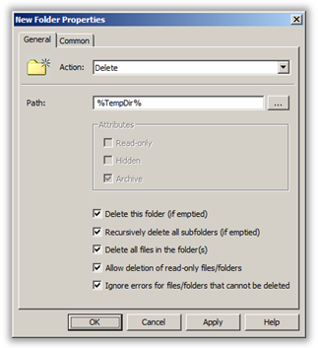 | Folders  The Folders preference extension is similar to the Files extension, but it allows you to create, replace, update, delete, and even clean up folders on targeted computers. Like the Files preference extension, it supports environment variables. It does not support wildcards in folder paths, however.  As an example, you can use the Folders preference extension to regularly clean up temporary folders. The extension is flexible and can handle most requirements. You can recursively remove subfolders, allow or disallow removal of read-only files and folders, and choose whether or not to remove the root folder or just its contents. For example, you can use this extension to remove temporary folders that some applications create in the root of the system drive or to clean up the Windows temporary folder on a regular basis.
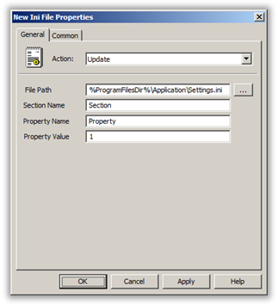 | Ini Files  The Ini File preference extension provides the ability to create, update, replace, and delete individual properties from .ini flies.
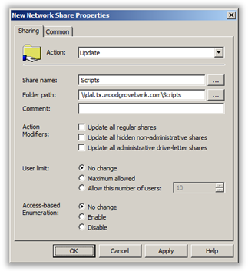 | Network Shares  Although Windows does not provide a way to centrally manage network shares on multiple computers, the Network Shares preference extension supports managing network shares on multiple, targeted computers (see the section “Targeting Control”). Additionally, the Network Shares extension allows you to manage Access-based Enumeration (ABE), which prevents users from seeing subfolders for which they lack permission to access, and configure user limits.
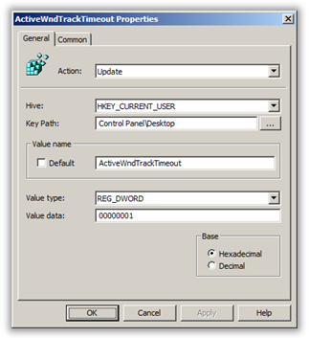 | Registry  The Registry preference extension provides a flexible and easy-to-use way to create, replace, update, and delete registry settings on multiple computers. To use Group Policy settings to configure arbitrary registry settings, you must create an Administrative template. With the Registry extension, you can use three different preference types to add Registry preference items to a GPO and organize them:  - Registry Item. Configure an individual registry setting, including the REG_SZ, REG_DWORD, REG_BINARY, REG_MULTI_SZ, and REG_EXPAND_SZ types.  - Collection Item. Create a folder in which to organize Registry items, similar to how Windows organizes settings in them. However, you don’t have to organize these folders in the same hierarchy as the registry keys and subkeys. Instead, you can organize settings by department, location, and so on.  - Registry Wizard. Import one or more registry settings from the local computer or from a remote computer. You can select individual registry settings or entire registry branches.  Using the Registry preference extension is a great way to deploy settings without having to write scripts. For example, you can deploy settings for a third-party application or an application that isn’t Group Policy-aware. However, using the Registry extension to deploy settings for which Group Policy preferences already provide a user interface is discouraged.
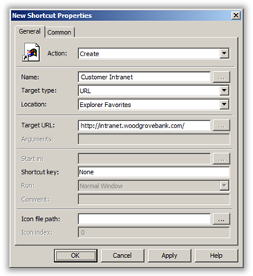 | Shortcuts  Using the Shortcuts preference extension, you can create, replace, update, and delete three types of shortcuts on multiple, targeted users and computers (see the section “Targeting Control”):  - File System Object. Traditional shortcuts that link to programs and documents. For example, you can add a custom shortcut for an application to the Start menu.  - URL. Shortcuts to Web pages. For example, you can add a shortcut to a departmental intranet site to the user’s Favorites menu.  - Shell Object. Objects that appears in the shell namespace, including Control Panel, Recycle Bin, and so on. For example, you can add the Control Panel to the user’s desktop.  The Shortcuts preference extension supports creating shortcuts in numerous locations, including the desktop, Start menu, Favorites folder, Quick Launch toolbar, and so on. You can also specify the full path and name of a folder in which to create the shortcut.

Control Panel Settings
Table 3 describes each Group Policy preference extension in Control Panel Settings. The first column shows a sample preference item for each extension, and the second column provides an overview of the extension.
Table 3. Preference Extensions in Control Panel Settings
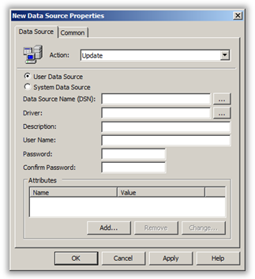 | Data Sources  Group Policy provides a setting for distributing applications, but it does not provide a setting for configuring the Open Database Connectivity (ODBC) data sources used by many of them. The Data Sources preference extension provides a way to create, replace, update, and delete data sources for users and computers. Additionally, user data sources roam with users from computer to computer, further simplifying their deployment. Using the Data Sources extension reduces the complexity and cost of managing business applications for which you must configure data sources.
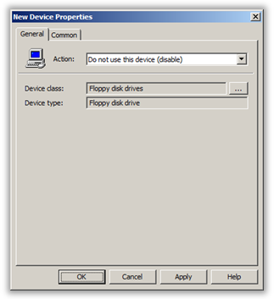 | Devices  Organizations with high-security or compliance requirements often must restrict the use of removable media. The Devices preference extension provides a targeted method for disabling specific device classes for users or computers. For example, you can disable the USB ports, floppy drives, and other removable media for users who work with sensitive information, such as customer records or intellectual property. Standard users cannot change these settings. This preference extension gives you more control over the information that leaves your organization.  The Devices extension does not prevent users from installing devices. Rather, it enables or disables devices after they are present on the computer. On the other hand, Group Policy can prevent users from installing specific types of devices. Additionally, the Devices extension works on all supported platforms.
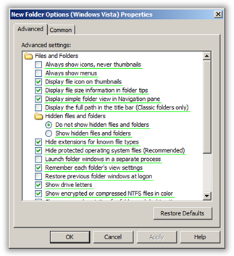 | Folder Options  The Folder Options preference extension supports two types of items:  - Folder Options. Configure Windows Explorer folder options for Windows XP or Windows Vista. Folder options include whether or not Windows Explorer shows hidden files, displays file extensions for known file types, and so on. The figure in the left column shows the Folder Options preference item for Windows Vista.  - Open With. Configure associations between file extensions and file types. Two scenarios are common. First, you can break file associations to prevent programs from running accidentally or maliciously (many e-mail viruses rely on file associations to run). Second, you can associate file extensions with different programs, depending on the user’s requirements.
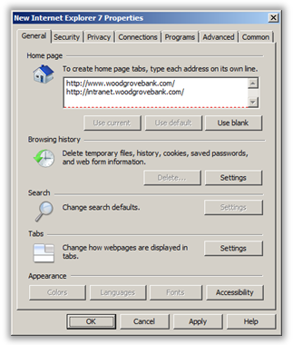 | Internet Settings  The Internet Settings preference extension allows you to configure Internet Explorer options for Windows Internet Explorer 5, Internet Explorer 6, and Internet Explorer 7 (shown in the left column). You can configure most of the settings that are available in the Internet Options control panel. For example, you can configure different home pages for users in different departments, and you can configure a high security level for users who work with sensitive information. The Internet Settings extension also allows you to configure advanced options.  Many of these settings are available as Group Policy settings that are strictly enforced. Using the Internet Settings preference extension, you can create a default Internet Explorer configuration that users can later change. Additionally, you can configure individual settings using this preference extension rather than configuring entire groups of settings.
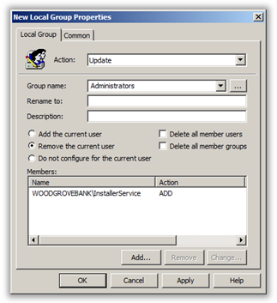 | Local Users and Groups  The Local Users and Groups preference extension supports configuring local user accounts and groups for multiple, targeted computers (see the section “Targeting Control”). It supports these preference types:  - Local User. You can create, update, replace, or delete users account from local computers. For example, you can change the password for or disable the local Administrator account.  - Local Group. You can create, update, replace, or delete groups from the local computer. The Local Group preference type provides a number of options for configuring local groups, too. For example, you can add or remove a logged-on user to or from the group. Usefully, you can add or remove specific domain accounts to and from local groups, as shown in the figure in the left column.
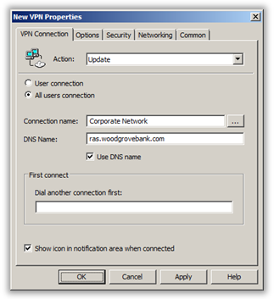 | Network Options  The Network Options preference extension enables you to configure the following types of network connections:  - VPN Connections. Configure Virtual Private Network (VPN) connections, including their options, security settings, and connection type. The left column shows a VPN connection.  - DUN Connections. Configure basic Dial-Up Networking (DUN) connections for a single user or all users.  For example, you can create a VPN Connections preference item to connect to the corporate network. Then, you can target that item specifically at mobile PCs within a specific department.
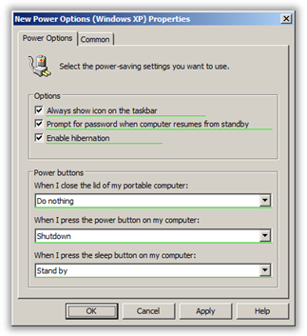 | Power Options  Use the Power Options preference item to configure power options and power schemes for computers running Windows XP. Power options include settings like what happens when users close the lid on their mobile PCs. Power schemes include timings for when Windows turns of the monitor and hard disks and when the operating system puts the computer to sleep or hibernation.  Although Windows Vista supports power options settings in Group Policy, those settings are strictly enforced. By configuring power options using the Power Options extension, you can create a default configuration that users can later change as necessary.
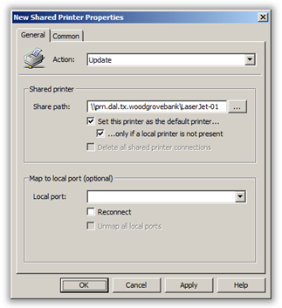 | Printers  Like configuring mapped network drives, configuring printer connections is a common task that administrators typically perform by writing logon scripts. The Printers preference extension enables you to easily create, update, replace, or delete shared printers, TCP/IP printers, and local printers to multiple, targeted users or computers (see the section “Targeting Control”). The figure in the left column is an example of configuring a shared printer using a Shared Printer item. Using preference targeting, you can deploy printer connections based on location, department, computer type, and so on.  Windows Vista Group Policy provides native support for deploying printers. However, it only supports shared printers and requires Active Directory schema extensions. In contrast, using the Printers extension supports shared, local, and TCP/IP printers on Windows XP with SP2 and Windows Vista. It also allows you to set the default printer and map shared printers to local ports.
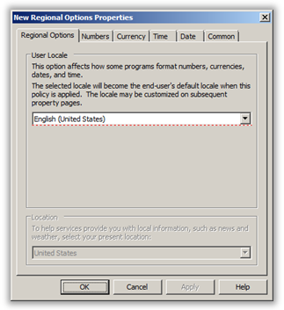 | Regional Options  Use the Regional Options preference extension to configure the user locale, including number, currency, time, and date formats.
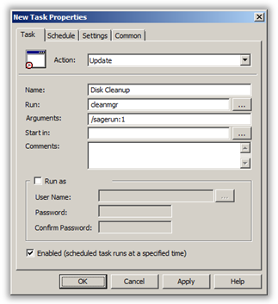 | Scheduled Tasks  The user interface for Scheduled Tasks preference items matches Scheduled Tasks in Windows. The Scheduled Tasks preference extension provides a centralized mechanism for scheduling tasks for targeted users and computers (see the section “Targeting Control”). The example in the left column shows a scheduled task that runs the Disk Cleanup Wizard.  The alternative is to run command-line tools or scripts that schedule tasks. This preference extension makes it very easy to manage scheduled tasks using Windows Vista’s powerful new Task Scheduler.
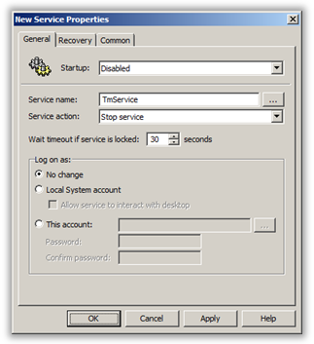 | Services  The Services preference extension enables you to configure services the following ways:  - Startup. Optionally change the startup type to Automatic, Manual, or Disabled.  - Service action. Optionally start, stop, or restart a service.  - Log on as. Configure the account that the service uses.  - Recovery. Configure the service’s recovery options.  For example, you can use the Services preference extension to ensure that certain services are disabled and stopped, and ensure that other services run automatically, and start them if required.
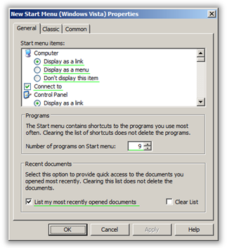 | Start Menu  The Start Menu preference extension enables you to configure Start menu options for users. It supports both Windows XP and Windows Vista Start Menu preference items. For instance, you can configure the Start menu for mobile PCs so that it always displays the Connect To menu. Easily configure the Start menu to reflect how your organization’s employees use their computers.

Group Policy Preferences Features
Most Group Policy preference extensions support the following actions for each preference item:
- Create. Create a new item on the targeted computer.
- Delete. Remove an existing item from the targeted computer.
- Replace. Delete and recreate an item on the targeted computer. The result is that Group Policy preferences replace all existing settings and files associated with the preference item.
- Update. Modify an existing item on the targeted computer.
The following sections describe additional Group Policy preferences features. These features include the Common tab, which each preference extension supports. Targeting is a feature that makes preferences a particularly powerful way to deploy configurations. The following sections also describe Group Policy preferences support for process variables and reporting.

Common Options
Every Group Policy preference item has a Common tab, shown in Figure 3, which you can use to configure additional options that control the behavior of the item.
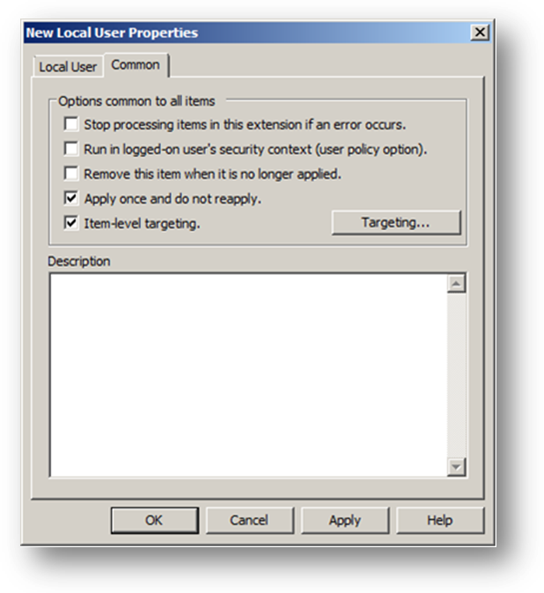
Document preference item, including its purpose
Configure targeting items, like location, application presence, and so on
Allow user to change without refreshing
Choose whether to continue after errors
Run the item using the user’s credentials
Figure 3. Common tab for preference items
The following list describes the options on the Common tab:
- Stop processing items in this extension if an error occurs
By default, errors do not prevent Group Policy preferences from processing the remaining preference items in the same extension. If you want preferences to stop processing additional items if an error occurs, enable this option. If you enable this option and an error occurs, processing stops for the current GPO only. Other GPOs continue to process normally.
- Run in logged-on user's security context (user policy option)
By default, Group Policy preferences process preference items using the local System account. As a result, these items can only access system environment variables and local resources. To access user environment variables and network resources, including network drives, you must enable this option to process the item using the logged-on user’s account.
- Remove this item when it is no longer applied
Unlike policy settings, Group Policy does not remove preferences when the GPO is removed from the user or the computer. Choosing this option changes the default behavior: when the GPO is removed from the user or the computer, Group Policy removes the preference items it contains from the user or the computer.
- Apply once and do not reapply
Group Policy refreshes preference items during the regular refresh interval, which is every 90 minutes, by default. As a result, Group Policy eventually restores preference items, even though users can change the settings they create. Choose the Apply once and do not reapply option to run the item one time without running it again. This option prevents Group Policy from refreshing the item, allowing users to change settings without losing those changes. In user configurations, Group Policy preferences will apply these settings once on each computer they use. In computer configurations, Group Policy preferences will apply these settings once for the computer, regardless of how many users share the computer.
- Item-level targeting
Targeting determines to which users and computers a preference item applies. Enable this option, and then click the Targeting button to configure targeting items for the preference item. For more information about targeting, see “Targeting Control.”

Targeting Control
You can filter GPOs using WMI filters; however, filters affect the entire GPO. If you want to filter individual policy settings in a GPO, the work-around is usually to create separate GPOs for individual settings, and then to filter each GPO. In many organizations, this leads to hundreds, if not thousands, of GPOs that become unwieldy to maintain and have significant performance impact.
On the other hand, Group Policy preferences supports item-level targeting. Item-level targeting determines the users and computers to which Group Policy applies individual preference items within a GPO. You can target different preferences items within a single GPO at computers in different locations, for example.
When you click the Targeting button on the Common tab, you see the Targeting Editor shown in Figure 4, including a list of targeting items available. You can apply one or more targeting items to a preference item. You can also choose a logical operation to use for joining targeting items, as shown in the figure. Add collections, which are essentially parentheses that group targeting items, and you can create fairly complex logic to determine the users and computers to which a preference item applies.
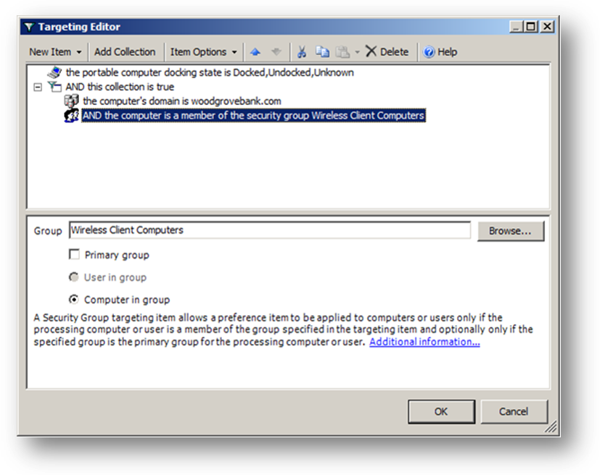
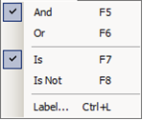
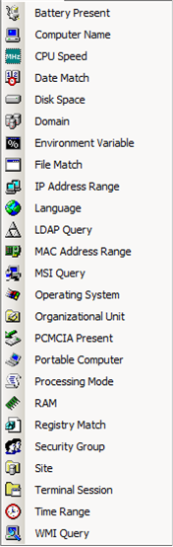
Targeting items and their relationships
Security Group target item
Figure 4. Targeting Editor
Group Policy preference items provide the muscle to configure users and computers, but targeting items provide the intelligence to choose a limited selection of users and computers. The following are real-world examples of how you can use Group Policy targeting items:
- Mobile computers. You want to configure VPN connections for mobile users, but you want to apply those VPN connections only to mobile PCs. You can limit the preference item to only mobile PCs by using the Portable Computer targeting item.
- Performance-based configuration. You have a requirement to configure certain settings based on the performance characteristics of each computer. Faster computers with plenty of free disk space receive one preference item, while slower computers or those with low amounts of free disk space receive another. You can use the CPU Speed and Disk Space targeting item to target each preference item as required.
- Operating system version. You identify a setting that Windows Vista stores in a different location than Windows XP. Create two preference items, one for each operating system. Then, filter each preference item using the Operating System targeting item.
- Software prerequisites. You want to configure an application’s settings, but you want to ensure that the application is installed on the computer before configuring it. You can use a combination of the File Match and Registry Match targeting items to check for a specific version of a binary file or an entry in the Uninstall registry key to create a robust way to verify that the application is installed.

Process Variables
Group Policy preferences support environment variables. In fact, it adds numerous environment variables to the process environment. For example, it adds environment variables that identify the location of special folders, such as the desktop, Favorites, and Start menu folders.
You can use any of these or process environment variables in any preference item or targeting item that contains text properties, and Group Policy preferences will resolve them when applying the setting to the user or computer. Although you can manually type variable names in text properties, the easiest way to use variables that Group Policy preferences defines is to press F3 to display the Select a Variable dialog box, shown in Figure 5. The combination of environment variables and targeting enables you to create highly dynamic configurations by creating targeting items that use environment variables, and use environment variables in preference items.
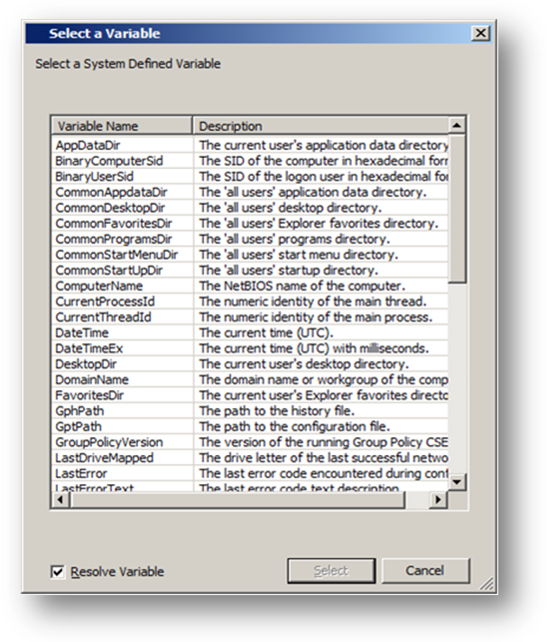
Figure 5. Select a variable

Settings Report
Group Policy preferences fully support settings reports in the Group Policy Management Console (GPMC). Figure 6 shows a sample settings report that contains a Group Policy preference.
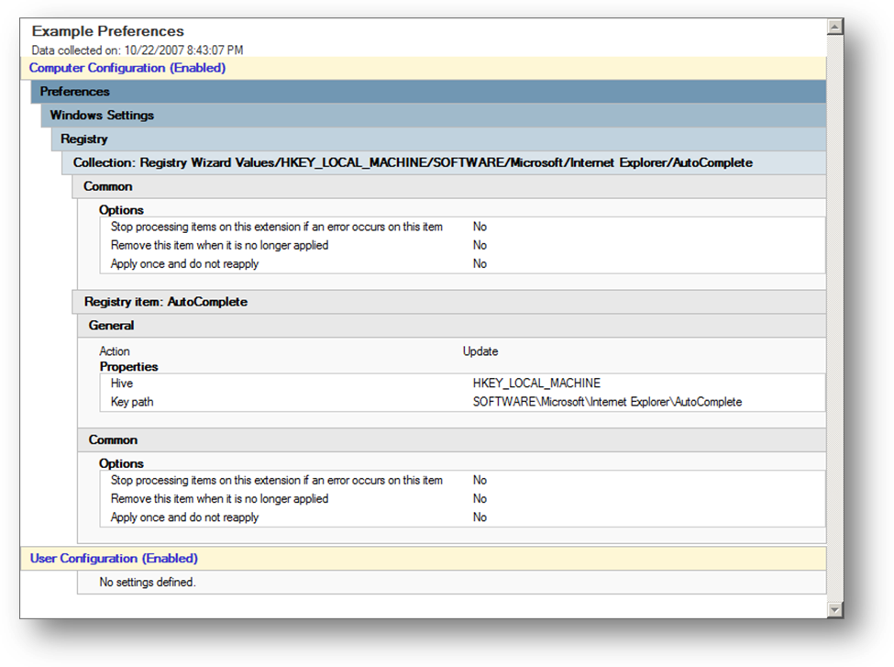
Figure 6. Settings report

Deploying Group Policy Preferences
Group Policy preferences do not require you to install any services on servers. Windows Server 2008 includes Group Policy preferences by default as part of the Group Policy Management Console (GPMC). Administrators will also be able to configure and deploy Group Policy preferences in a Windows Server 2003 environment by installing the Remote Server Administration Tools (RSAT) on a computer running Windows Vista with SP1. Both RSAT and Windows Vista SP1 will be available in the first quarter of 2008.
Although you don’t have to install any services to create GPOs that contain Group Policy preferences, you must deploy the Group Policy preferences client-side extension (CSE) to any client computer to which you want to deploy preferences. The CSE will be available as a separate download from Microsoft. It supports the following Windows versions:
- Windows XP with SP2
- Windows Vista
- Windows Server 2003 with SP1
Windows Server 2008 already includes the CSE.

Windows Deployment Strategies
Most companies share a common goal: create a standard PC configuration based on a common operating system image. They want to apply this image to any computer in any geographical region at any time, and then customize that image quickly.
In reality, most organizations build and maintain many images—sometimes even hundreds of them. By making technical and support compromises and disciplined hardware purchases, and by using advanced scripting techniques, some organizations have reduced the number of images they maintain to between one and three. These organizations tend to have the sophisticated software distribution infrastructures necessary to deploy applications—often before first use—and keep them updated.
Business requirements usually drive the need to reduce the number of images that an organization maintains. Of course, the primary business requirement is to reduce ownership costs. The following list describes costs associated with building, maintaining, and deploying disk images:
- Development Costs. Development costs include creating a well-engineered image to lower future support costs and improve security and reliability. They also include creating a predictable work environment for maximum productivity balanced with flexibility. Higher levels of automation lower development costs.
- Test Costs. Test costs include testing time and labor costs for the standard image, the applications that might reside inside it, and applications applied after deployment. Test costs also include the development time required to stabilize disk images.
- Storage Costs. Storage costs include storage of the distribution points, disk images, migration data, and backup images. Storage costs can be significant, depending on the number of disk images, the number of computers in each deployment, and so on.
- Network Costs. Network costs include moving disk images to distribution points and to destination computers. As the size of image files increases, costs increase. Large images have more updating, testing, distribution, network, and storage costs associated with them. Even though you only update a small portion of the image, you must distribute the entire file.
Of the two image strategies described in the following sections, Microsoft recommends the thin-image strategy to combat and lower these costs. The section “Thin Imaging” describes this strategy and how Group Policy preferences make implementing it much easier. Figure 7 provides an overview of the two strategies.
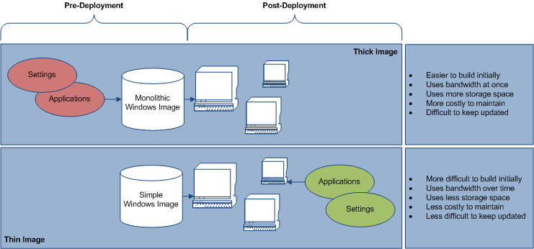
Figure 7. Imaging strategies

Thick Imaging
Thick images are monolithic images that contain core applications and other files. Part of the image-development process is installing core applications prior to capturing the disk image, as shown in Figure 7. Most organizations that use disk imaging to deploy operating systems are building thick images.
The advantage of thick images is simplicity. You create a disk image that contains core applications and preferences and thus have only a single step to deploy the disk image and core applications to the destination computer. Thick images can also be less costly to develop initially, because advanced scripting techniques are not often required to build them. In fact, you can build thick images using Microsoft Deployment with little or no scripting. Finally, in thick images, core applications are available on first start.
The disadvantages of thick images are maintenance, storage, and network costs. These costs rise quickly with thick images. For example, updating a thick image with a new version of an application or changing preferences requires you to rebuild, regression-test, and redistribute the image. Thick images require more storage and use more network resources in a short span of time to transfer. Additionally, if you have different configuration requirements for different groups of users, you often must build custom images for each group.

Thin Imaging
The key to reducing image count, size, and cost is compromise. The more you put into an image, the less common and bigger it becomes. Big images are less attractive to deploy over a network, more difficult to update regularly, more difficult to test, and more expensive to store. By compromising on what you include in images, you reduce the number of images you maintain and you reduce their size. Ideally, you build and maintain a single, worldwide image that you customize post-deployment.
Thin images contain few if any core applications or preferences. You install applications and configure preferences separately from the disk image, as shown in Figure 7. Installing applications and configuring preferences separately from the image usually takes more time at the PC and possibly more total bytes transferred over the network, but spread out over a longer period of time than a single large image transfer. You can mitigate the network transfer by using trickle-down technology that many software distribution infrastructures provide, such as Background Intelligent Transfer Service (BITS).
Thin images have many advantages. First, they cost less to build, maintain, and test. Second, network and storage costs associated with the disk image are lower, because the image file is physically smaller. The primary disadvantage of thin images is that post-installation configuration can be more complex to develop initially, but this is offset by the reduction in costs to maintain images and build successive images. Deploying applications and preferences outside of the disk image often requires scripting and usually requires a software distribution infrastructure. Another disadvantage of thin images is that core applications aren’t available on first start, which might be necessary in high-security scenarios.
If you choose to build thin images that do not include applications and preferences, you should have a systems-management infrastructure, such as Microsoft Systems Management Server (SMS) or Microsoft System Center Configuration Manager (SCCM), in place to deploy applications. To use a thin-image strategy, you will use this infrastructure to deploy applications after installing the thin image.
You should also have an infrastructure for deploying preferences, and Group Policy preferences are a perfect fit for this purpose. Instead of configuring preferences in the disk image, you can create generic images that you don’t have to update when you need to update preferences. Additionally, if different user groups require different configurations, you don’t have to create custom images for each group. Instead, you can deploy a generic image to each group, and then use item-level targeting to configure each group’s users and computers independently, achieving the same result as creating multiple disk images.

Benefits of Group Policy Preferences
The following list summarizes the benefits of using Group Policy preferences in your environment:
- Improving IT Productivity
Group Policy preferences extends the Group Policy feature set with over 20 new extensions, helping you get more done with tools that are already very familiar to you. It also enables you to configure and deploy settings at a central source, rather than repackaging and redeploying the settings when you update configurations. You simply edit the GPO that contains the preference items you want to update. Preferences provide a central location from which you can completely manage user and computer configurations.
- Reducing Need for Logon Scripts
Although Group Policy preferences might not eliminate the need for logon scripts, it significantly reduces their need. The most common tasks performed by logon scripts are installing printers, mapping network drives, configuring registry settings, and copying files and folders. Often, these tasks require complex scripting, testing, and debugging.
- Limiting Configuration Errors
Configuration errors during and after deployment are often a significant source of support calls and escalations that lead to higher deployment costs. Group Policy preferences significantly help reduce these costs. First, preferences allow you to configure items with a higher level of precision than other tools. For example, you can configure a single Internet Explorer option without touching other settings. Other deployment methods often change more options than you intend. Second, you can configure items without knowing their details—where to find them in the registry or what they represent. Instead, Group Policy preferences collects preference items using clear, familiar, easy-to-use dialog boxes that prevent you from needing to know how Windows stores the value in the registry. You can configure a Start menu setting by selecting an option in a preference item instead of having to know what value to store in the registry and where to store it. And, Group Policy preferences all but eliminate the need to use default user profiles to deploy settings. Often you deploy far more with a default user profile than you need to deploy, and this can lead to unreliable configurations.
- Enhancing End-User Satisfaction
More consistent, reliable configurations make users happy by maintaining or even increasing their productivity. Additionally, using Group Policy preferences to configure users and computers, you can make using Standard user accounts more palatable to users. Group Policy preferences use the local System account by default, enabling it to configure settings that users can’t configure. By configuring these settings on behalf of users, you can often avoid the issue altogether—which is proactive IT.
- Minimizing Image Maintenance
Using Group Policy preferences with a thin-image strategy, you can significantly reduce the time and cost of maintaining disk images. Instead of updating images to reflect configuration changes, you can deploy a generic image and then update Group Policy preferences. This approach reduces engineering and testing time—and costs—significantly.
- Reducing Overall Image Count
Group Policy preferences, in combination with a thin-image strategy, helps you reduce the number of disk images you must develop and maintain. If you build thick images, you often create unique images for different groups of users in the organization. Instead, you can build and deploy a generic image for each group, and then configure users and computers uniquely by targeting preference items.

Summary
Using Group Policy preferences comes at no added cost but provides innumerable advantages for any organization. It improves IT productivity. It reduces deployment costs by helping organizations reduce image count and reduce the cost of maintaining images. It reduces configuration errors during and after deployment. It reduces, if not eliminates the need for complex logon scripts. It allows you to fine-tune settings for users and computers throughout your organization.
Importantly, most IT professionals can begin using Group Policy preferences with absolutely no additional training.
To learn more about Group Policy preferences, visit http://www.microsoft.com/grouppolicy/. Download the Windows Server 2008 Release Candidate 1 (RC1) or the Remote Server Administration Tools (RSAT) beta from the Connect Web site at http://connect.microsoft.com/. Evaluate Group Policy preferences and begin planning for it now.

Glossary
action | In Group Policy, the operation performed by a preference item, either creating, replacing, updating, deleting, or migrating configuration settings for users or computers (some types of preference items do not have a choice of actions).
Administrative templates | Provide policy setting information for the items that appear under the Administrative Templates folder in the console tree of the Local Group Policy Editor and when editing a Group Policy object using the Group Policy Management Console.
Group Policy client-side extension | A component responsible for processing a specific portion of Group Policy.
Group Policy Management Console (GPMC) | The administrative tool used to manage and edit domain-based Group Policy objects. The GPMC is a Microsoft Management Console (MMC) snap-in.
Group Policy Management Editor | The editor window used to edit domain-based Group Policy in the Group Policy Management Console.
Group Policy object (GPO) | A collection of Group Policy settings.
Group Policy preferences | Group Policy extensions that appear under the Preferences node in the Group Policy Management Editor window of the Group Policy Management Console.
Group Policy settings | Computer-specific and user-specific settings that administrators can apply using Group Policy.
Group Policy settings reference | A spreadsheet that contains a complete list of all of the Group Policy settings for every Windows SKU.
local Group Policy object (LGPO) | A non-network GPO that can be used to configure a limited array of Group Policy settings.
preference extension | Any Group Policy extension that appears under the Preferences node in the Group Policy Management Editor window of the Group Policy Management Console.
preference item | An object containing Group Policy settings related to a preference extension in a Group Policy object (GPO). Each preference extension allows you to create one or more types of preference item. Each type has different properties. A GPO can contain multiple preference items for each preference extension.
preference item-level targeting | Using targeting items to change the scope of a preference item, so that it applies only to selected users or computers.
preference properties | Options within an individual preference item.
targeting item | An object that changes the scope of a preference item so that it applies only to selected users or computers.

