
Bing for Educators
Step-by-Step

Get to know Bing

Explore the Home Page
 | With learning in mind, the Bing home page features an engaging photo with hidden hyperlinks to learn more about the subject. Point to different areas of the photo to reveal intriguing facts. In the lower right corner, click the arrows to see more photos. Want to find out who took the photo? Point to the copyright symbol © in the lower right corner of the image.

Start searching
- Go to Bing.com.
- Enter your search term. As you start typing, Bing automatically suggests search terms based on what you’ve entered. Press the down arrow on your keyboard to choose a suggested term.
Notice the search results include handy links on the top of the page that help you sort through categories, such as Images, Video, and Wikipedia, and on the left side to Related Searches and your Search History.
Enhance your search
On the Bing home page, Bing.com, click Explore at the top left of the page.

The Bing Explore page reveals many ways to enhance your search with:
  - Videos: Quickly find news and how-to videos to enhance your lessons.
  - Visual Search: Browse through over 100 visual galleries ranging from movies, books, and cars, to animals, geography, and chemical elements. Each search topic has a set of related sorting categories.
  - News: Reduce the clutter and go straight to the most current news on the Web.
  - Wikipedia: Find fast facts in enhanced Wikipedia articles.
  - Translator: Instantly translate web pages and other text into another language.

Preview a site on the search results page
On a search results page, point to a search result and an expansion button will appear on the right. Point to the expansion button and a quick preview box will appear with more information about that Web page. It’s a great way to find the result that best fits your needs without actually clicking every link.

Preview a video on the search results page
Bing provides a short preview of a video in video search results. Now you can preview a video shown in search results just by pointing to it. To view the full-length video, click the video that you want to watch.
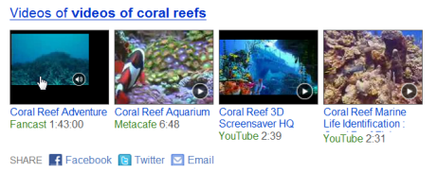

Define words and find synonyms
- Go to Bing.com.
- In the search box, type define or definition or what is followed by the word that you want to define.

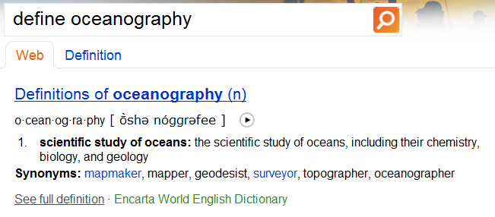

Translate text and web pages
- Go to Bing.com/explore, and in the Get more from Bing section, click Translator. Or go directly to MicrosoftTranslator.com.
- Using the drop-down lists, adjust the languages from and to which you want translate.

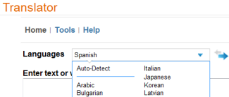

- Enter the text or URL you want to translate in the first box, then press Enter or click Translate.

Compute math expressions
Find basic mathematical operators, exponents, roots, factorials, modulo, percentages, logarithms, trigonometry functions, and mathematical constants.

- Go to Bing.com.
- In the search box, type the equation that you want to solve or the constant that you want to find the value of.
The following examples show some of the things you can type in the search box.
- Get answers to arithmetic problems and basic calculations. For example:
- 5 + 3 / 1 - (6 * 2)
- sqrt 9
- sin 100 * 50
- 32% of 54
- Solve simple algebraic equations. For example:
  - 4x=19
  - 2y^2 + 5y + 10 = 40
  - Solve 2x + 7 = 4


Convert units of measurements
Bing can convert units of measurements for distance, weight, time, volume, and temperature. You can also include mathematical expressions in some conversion questions to get a calculated, converted answer.

Try some of these examples in the search box:
- How many seconds in a day
- What is 50 degrees F in Celsius
- How many kilometers in a light year
Filter search results using SafeSearch
Bing SafeSearch helps keeps offensive and inappropriate content out of your search results. You can adjust your computer’s setting or ask your network administrator to change SafeSearch settings for your whole school by using Microsoft Internet Security and Acceleration Server.

To change your computer’s SafeSearch settings:

- Go Bing.com.
- Click Preferences at the top right of the page.
- In the SafeSearch section, click one of the following options:
  - Strict filters out adult text, images, and videos from your search results.
  - Moderate filters adult images and videos but not text from your search results. This is the default setting.
  - Off doesn't filter adult content from your search results.
- Click Save settings .

To configure a Microsoft Internet Security and Acceleration Server (ISA) blocking rule:

- Right-click Firewall Policy, point to New, and click Access Rule.
- Type in a friendly rule name and then click Next.
- In the Rule Action dialog, select Deny and then click Next.
- In the Protocols dialog, click Add to select the protocols this rule should apply to and then click Next.
- In the Access Rule Sources dialog, click Add.
- Select All Protected Networks, click Add, and then Close.
- In the Access Rule Destinations dialog, click Add.
- Click New, and then URL Set.
- Click Add and then Next.
- In the New URL Set Rule Element dialog, type in a friendly name.
- Click Add and then set the path to http://*.explicit.bing.net/*.
- Click OK.
- In the Access Rule Destinations dialog, click Add.
- In the Add Network Entities dialog, open URL Sets and select the URL Set you just created.
- Click Add and then Next.

Discover Bing Maps and Map Apps

Start mapping
- Go to Bing.com and click Maps, or go directly to Bing.com/maps.
- Bing automatically displays a map of your locale, based on the settings of your browser. To change the map location, type the location into the search box and press enter or click the magnifying glass.
- You can zoom in or out, from the neighborhood level to the world level, by clicking the - or + buttons at the bottom of the page.
- You can shift the map north, south, east or west by clicking the arrows on the compass.
- Bing automatically chooses a map style based on your zoom level. To change the map style, click  and select either Road map, Aerial Map, or Bird’s eye map.

Get directions
Click the Get directions icon  on any Bing Maps page to start planning your route.
- Get driving directions between two or more points: Enter a start point and an end point in the appropriate boxes, and then click Driving from the drop-down list of travel methods. Click Add to route to add another destination to your route.
- Find walking directions: Enter a start point and an end point, and then click Walking in the drop-down list of travel methods.
- Set route options: Click Options to adjust the route based on time, distance, or traffic.
- Rearrange route: Move your mouse to the point on the route that you want to change. When the pointer changes to a hand with a green dot , click and hold the left mouse button, and then drag the route to pass by the point that you want. You can also or drag the start or end point to a new point on the map.
- Remove changes to your route: If you rearranged your route and you don’t like the changes, in the left pane, click Remove next to the change that you want to remove.
- Print your directions: Print the map, directions, or both by clicking the Printer icon  in the left pane.
- Send your directions: At the bottom of the left pane, click the Share icon  to e-mail the directions to someone.

Read Today’s Front Page
The Bing Map App for Today’s Front Page serves up over 100 front pages from newspapers around the world.

- Go to Bing.com/maps.
- Click the Map Apps arrow 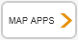 in the left pane, and then click Today’s front pages.
- Hover over a pushpin on the map to explore today’s front pages from that location.
- Click the newspaper image to start reading.
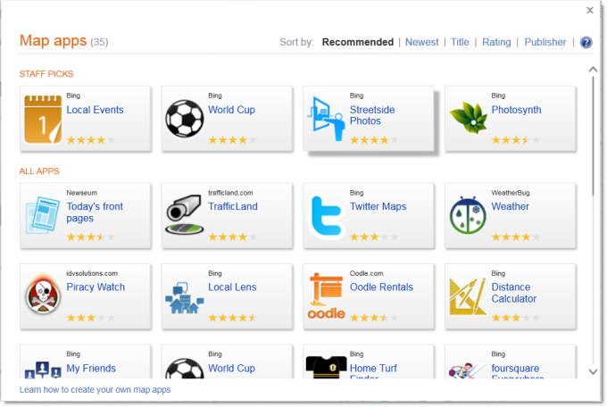

Bing Translation
If the search results aren’t speaking your language, you can view an automatic translation. For example, you can translate the front page of a French newspaper into English using Bing Translation.

Stargaze with WorldWide Telescope
The Bing Map App for the Worldwide Telescope helps you explore the sky above you and the universe beyond.

- Go to Bing.com/maps.
- Click the Map Apps arrow , and then click WorldWide Telescope.
  - To place a telescope somewhere in the world, click Start Here, then click any location on the map.
  - Click  to reveal information about a particular object in the screen.
  - Choose a collection and then click fly to.
  - To start a new search, click back to earth.
Get involved with Global Action Atlas
The Bing Global Action Atlas Map App showcases relief and support efforts that seek to help people in need, protect plants and animals, preserve diverse cultures, and more.

- Go to Bing.com/maps.
- Click the Map Apps arrow , and then click Global Action Atlas.
  - Type a keyword or the location name you want to view and click Find Projects.
  - You can refine your search by selecting or deselecting project categories and sub-categories, such as Conservation, Humanitarian, Cultures, Exploration, Climate Change, and Energy.
  - Use your mouse to roll over pushpins on the map to learn more about a specific Global Action Atlas project.
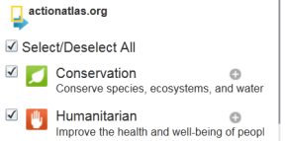

Dive into Microsoft® Photosynth®
The Bing Photosynth Map App serves up thousands of Photosynths—collections of photos uploaded by the community and stitched together to create 3D scenes that you can view and move around in. Using PhotoSynth, you can explore the details of places, objects, and events in ways you can’t with other media.

- Go to Bing.com/maps.
- Click the Map Apps arrow , and then click Photosynth.
  - To explore a Photosynth on the map, use your mouse to hover over a on the map to see details about that synth. Click the image thumbnail and then click dive in.
  - To search for a Photosynth, click Explore more Photosynths and then search through the Microsoft PhotoSynth gallery.

Make Bing yours

Make Bing your home page
- On the Bing home page, Bing.com, click Make Bing your homepage on the top right of the page.
- In the Add or Change Home Page dialog box, do one of the following:
  - To make the current webpage your only home page, click Use this webpage as your only home page.
  - To start a home page tab set or to add the current webpage to your set of home page tabs, click Add this webpage to your home page tabs.
- Click Yes to save your changes.

Make Bing your Internet Explorer default search provider
- Go to www.microsoft.com/IE to download Internet Explorer 8. If you already have Internet Explorer 8 installed, go to step 2.
- Click Get add-ons, or go to the Add-ons Gallery at http://IEaddons.com.
- On the left side, click Search. Find Bing Search and click Add to Internet Explorer.
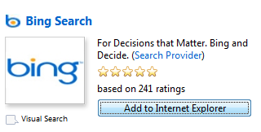
- In the pop-up window, select Make this my default search provider to set Bing as your IE search default, then click Add. (Note, if you already have Internet Explorer 8 installed, click Updgrade.)
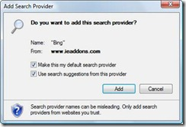

Student-Optimized Browser
As an option, you can install the student browser add-on. Go to http://IEaddons.com. On the left side, click Optimized Browsers. Find Student Browser and click Add to Internet Explorer.

Install the Bing App for iPhone
With Bing on your iPhone, you can search maps or the web with your voice, and flick through photo previews with image search.

- With your iPhone, click on the App Store icon.
- Type Bing in the search box.
- Click on the Bing search result.
- Click Free, and then Install.
- Type in your iTunes password and click OK.

Install Bing on your mobile phone
Give the updated Bing a try now by visiting m.bing.com with your mobile phone. It’s available in 31 countries for many current web-enabled phones. For more information about Bing for mobile products, go to Bing.com/mobile.On your mobile phone, go to m.bing.com\download.

More Information on Bing
K-12 teachers: For more information about Microsoft resources for teachers, go to www.microsoft.com/education and www.microsoft.com/teacherguides.
Faculty: For more information about Microsoft resources for professors, go to www.microsoft.com/bingeducation.
For more videos and information about Bing, go to www.discoverbing.com/.
For more help on Bing services, go to http://help.live.com/help.aspx?project=wl_searchv1&market=en-us.
For more information about Microsoft resources for teachers, go to www.microsoft.com/teachers.

