

Enterprise Content Management in Microsoft SharePoint® Server 2010

Microsoft® SharePoint® Server 2010 is the Business Collaboration Platform for the Enterprise & the Web that enables you to connect & empower people through a rich, integrated set of features that can be deployed as Intranet, Extranet or Internet-facing solutions.  Enterprise Content Management (“ECM”) with SharePoint Server 2010 helps manage all document and information users, and ensure compliance. Without ECM, organizations risk content chaos, compliance issues (and fines), and spiraling costs of people and technology  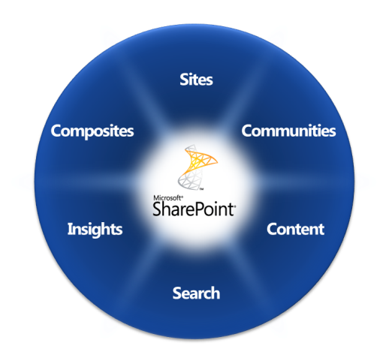  SharePoint Server 2010 brings together the important workloads in a single platform, reducing the need for organizations to buy and integrate point solutions. As a platform, SharePoint Server provides rich customization via Microsoft® SharePoint® Designer 2010 or Microsoft .NET programming, and a vibrant partner ecosystem which offers specialized solutions for customers who need to go broader or deeper in specific workloads. SharePoint Server helps organizations:  - Drive participation-Avoid chaos and end-user resistance  - Ensure Compliance-Control unmanaged content including Social content to avoid risk  - Save Costs - Avoid high costs of point solutions, especially where not needed  www.microsoft.com/office/sharepointserver |  | Starting from the bottom of this diagram, SharePoint Server 2010 is based on a broad platform and rich partner community; content can be searched or browsed, and accessed via Microsoft® Office Client or custom applications on the desktop, browser or mobile device.  Drive Participation  ECM in SharePoint Server provides users with both a platform and solutions for developing, using, and managing documents, with familiar Microsoft® Office Client applications deeply integrated for document viewing and editing.  ECM systems rely on one key dependency, more than technology, feature set, or amount of information managed: User Adoption. The people expected to integrate an ECM system into their workflow and processes must see ECM as a useful and valuable tool that integrates into their daily work. Overall SharePoint Server provides:  - Easy to use integrated tools for managing, finding, and sharing to enhance productivity  - Easy to add and identify document metadata to track, find, and share documents  - Automated metadata capture where possible and, if user input is needed, inputs are non-invasive and built into standard save and upload functions.

  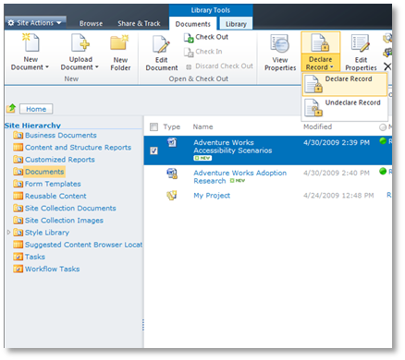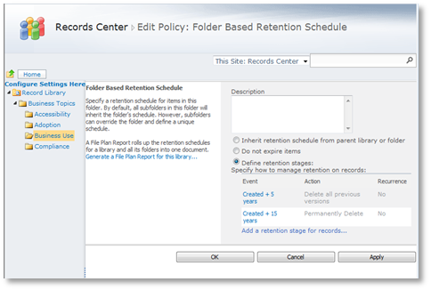Enterprise Content Management compliance, retention, and record identification are all accessible through SharePoint Server pages across any type of SharePoint Server-managed content.  Ensure Compliance  SharePoint Server provides “Compliance Everywhere.” All the expected tools – retention, legal holds, etc. – are all available through SharePoint Server, as well as the Office Client, for compliance managers to identify and set policies at a document (or groups of documents) level.  However, control and management does not sacrifice access and usability. SharePoint Server provides a broad-reaching set of tools and features to users across the organization that not just enables user interaction, but delivers participation by providing a platform solution tightly integrated with the Office Client applications used by many every day.  Compliance officers can manage access and retention policies in-place for documents (or groups of documents) from the SharePoint Server page or Office Client application already open in front of them. Documents can be limited to specific users or groups of users to provide read-only access (or no access at all). This protects access to valuable information and limits business risk in lost or leaked information. |  | Additionally, the scope of content managed is greater with SharePoint Server– not just documents, records, and other comment types of information, but all social computing blogs, wikis, comments, ratings, and user-created taxonomy (a.k.a. “folksonomy”) information published via SharePoint Server can be managed for retention, compliance, and archiving.  Save Costs  SharePoint Server provides a platform for comprehensive, integrated ECM. While some offerings provide broad coverage or deep point solutions, SharePoint Server provides both a broad set of offerings as well as cost-effective integration across ECM functions managed by SharePoint Server or other solutions.  While individual ECM solutions often need to be integrated with each other, SharePoint Server provides a common platform for all ECM functions provided by SharePoint Server, as well as from third-party software providers, reducing complexity, management time, and saving costs.  For More Information  Learn more about Enterprise Content Management in SharePoint Server 2010 at:  - SharePoint Server home: sharepoint.microsoft.com/product/capabilities/ecm/Pages/default.aspx  - SharePoint Server 2010 home: office.microsoft.com/en-us/SharePoint 2010server/HA102063591033.aspx  - Microsoft’s ECM Team Blog: blogs.msdn.com/ecm/  - ECM resources on MSDN: msdn.microsoft.com/en-us/office/bb402966.aspx  This document is for informational purposes only. MICROSOFT MAKES NO WARRANTIES, EXPRESS OR IMPLIED, IN THIS SUMMARY.  The example companies, organizations, products, domain names, e-mail addresses, logos, people, places, and events depicted herein are fictitious. No association with any real company, organization, product, domain name, e-mail address, logo, person, place, or event is intended or should be inferred.  © 2006 Microsoft Corporation. All rights reserved. Microsoft, Active Directory, Excel, FrontPage, Groove, the Office logo, SharePoint, SQL Server, Visual Studio, Windows, and the Windows logo are either registered trademarks or trademarks of the Microsoft group of companies in the United States and/or other countries. All other trademarks are property of their respective owners.


