
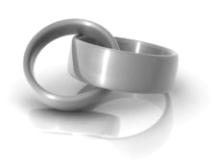
RSVP by June 6 at dobson@live.ca or (123) 555-6789
Sarah Dobson

Jake Thomas
together with their parents
invite you to share in their joy
as they exchange marriage vows

Saturday, the twenty-eighth of June
Two thousand and eight
at five o’clock in the evening
at Gravenhurst Dock

1 Muskoka Drive
Gravenhurst, ON

Reception dinner to follow

together with their parents
invite you to share in their joy
as they exchange marriage vows

Saturday, the twenty-eighth of June
Two thousand and eight
at five o’clock in the evening
at Gravenhurst Dock

1 Muskoka Drive
Gravenhurst, ON

Reception dinner to follow

Sarah Dobson

Jake Thomas
RSVP by June 6 at dobson@live.ca or (123) 555-6789

