HORSE  10  COW  20 | 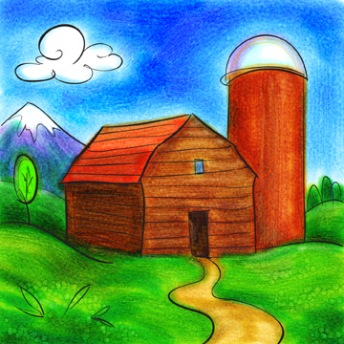  BARN  20 | HORSE  40 |   STOP SIGN  5
TRACTOR  20 | BOAT  30 | WATERFALL  50 | CEMETERY  30
RED CAR  10 | POLICE  30  HORSE  10 | TRAIN  40  YIELD SIGN  10 | MOTORBIKE  20  DOG  10
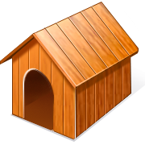  DOG HOUSE  20 | TURKEY  50

