

Pre-flight checklist for
Application Center 2000
AC_PreFlightCheck.doc (1.0)
7/29/2026

© Copyright Microsoft Corporation, 2001. All Rights Reserved

TABLE OF CONTENTS

Introduction 1
Assumptions 1
Setup 2
Verifying prerequisites 2
Application Center 2000 Setup 3
Initial configuration 7
Creating Application center cluster with NLB 7
Prerequisites 7
Cluster creation step by step 11
Creating Application Center cluster with a 3rd party load balancing device 15
Prerequisites 15
Cluster creation step by step 16
Adding cluster members 17
Front and back end network adapters 21
Virtual, dedicated and backend IP addresses 21
Step 1 pre-flight checks: Visibility 23
Visibility inside the cluster 23
From the controller 23
From all members 23
Visibility outside the cluster 23
From the internal client 23
From the external client 24
Step 2 pre-flight checks: Monitoring 25
Performance counters 25
Events 27
Monitors 29
Step 3 pre-flight checks: Replication 30
Preparation 30
On the cluster controller 30
On the external client 35
File replication 36
COM+ replication 37
Registry replication 43
Metabase replication 46
Step 4 pre-flight checks: Request forwarding 48
Preparation 48
Static content – not forwarded 49
Dynamic content – forwarded by default 51
Dynamic content – not forwarded when RF is turned off 51
Step 5 pre-flight checks: Cluster under load 53
Preparation 53
On the Client 53
Cluster under load 55
Replication under load (optional) 55
Step 6 pre-flight checks: Component load balancing 56
Configuration 56
Component cluster creation 56
Deployment of the COM+ Applications from the web cluster controller 58
Adding a second member to the component cluster 60
On the web cluster controller 60
Mark the COM+ components as load balanced 60
Add component servers for load balancing 61
Deploy changed COM+ applications on the web cluster 62
On the external client 63
The configuration under load 64
Step 7 pre-flight checks: Remote administration 65
Administering the whole configuration from the web cluster controller console 65
Connect to the component cluster 65
Add additional IIS snap-ins 65
Add component snap-ins 65
Administering the whole configuration from a remote machine 66
In Summary 67

Introduction
This document is intended to help validate the operational consistency of Application Center in your environment.

Assumptions
The following assumptions are made:
- The user is familiar how to operate the Application Center MMC.
- The user is familiar with COM+ UI and IIS UI.
- The user is familiar with the registry editor.
- The user is familiar with Web Application Stress Tool (Homer).

Setup

Verifying prerequisites
When installing Application Center 2000, there are a few prerequisites to check for. The first is to make sure that Windows 2000 SP1 or later is installed. This can be done by right clicking on ‘My Computer’ and selecting ‘Properties.’ The ‘General’ tab should indicate that SP1 or later is installed.

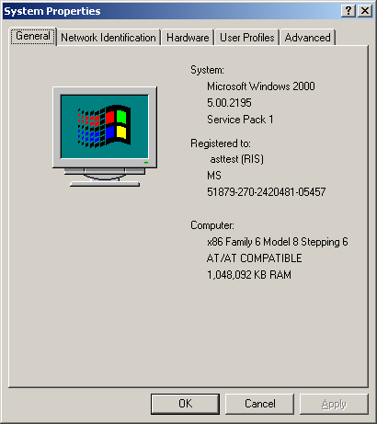

Application Center 2000 Setup
Install Application Center 2000 on all computers. The initial install process will be the same for all the machines. Insert the Application Center 2000 CD in the CD-ROM drive or just click on setup.hta if the CD is already there. You will see the welcome screen:

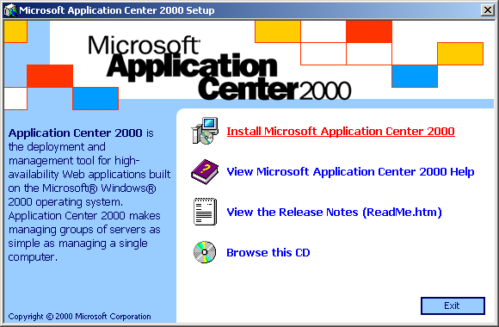

Click ‘Setup Microsoft Application Center 2000’ to start the installation. We have already verified that SP1 has been installed so click on ‘Install Microsoft Windows 2000 Post-Service Pack 1 fixes’ in order to install some required hotfixes. After the hotfixes have been installed, the machine will reboot.

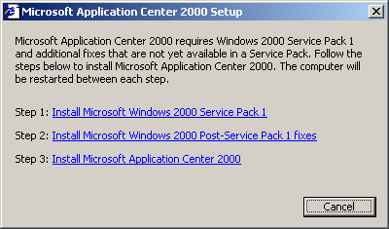
After the reboot has completed, re-start the install by clicking on setup.hta once again. This time, click on ‘Install Microsoft Application Center 2000’ to continue the install. You will get the Setup wizard dialog. Click ‘Next’ to continue.

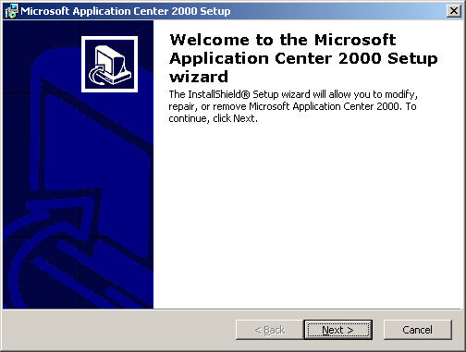

Accept the licensing agreement and click ‘Next’.

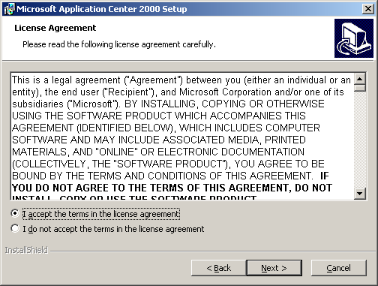

Leave defaults for the User and Org, enter CD key and click ‘Next’.

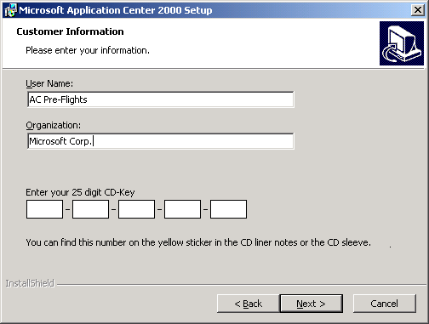

Do a ‘Typical’ setup and click ‘Next’.

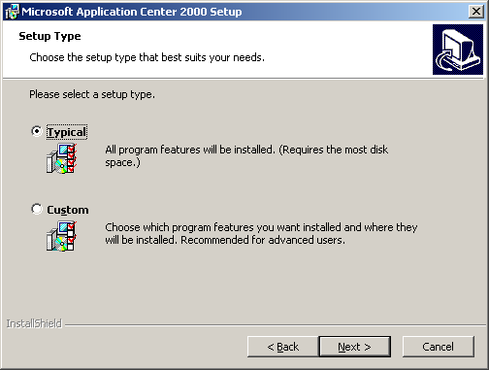

Click ‘Install’ to copy the files over.

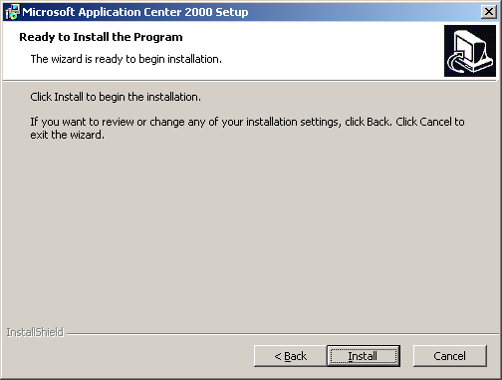

When setup has completed, click ‘Finish’. Reboot when it tells you to do so.

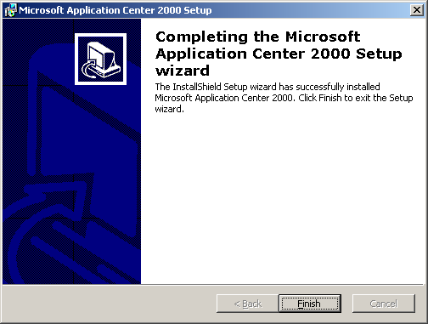

Initial configuration
The initial test configuration consists of a web cluster and two client machines (external and internal clients). The first client is connected to the external network (internet) and the second client is connected to the internal network (intranet). If the web cluster is for intranet use only, both machines should be connected to intranet. The web cluster may consist of two or more machines. For load balancing the web cluster we can use Windows 2000 Network load balancing (NLB) or a separate load balancing device such as Cisco Local Director, F5 Networks BigIP, or Alteon switches. Building a web cluster in these two cases is different and will be described separately.

Creating Application center cluster with NLB

Prerequisites
To create an Application Center cluster with NLB for load balancing, all machines should have Windows 2000 Server or greater installed. All machines must have two network adapters: one connected to internet/intranet (front end NIC) and one connected to a private network or intranet (back end NIC). In typical conditions on the backend network the following services should be available: domain controller, DHCP server, DNS server, and WINS server. Two static IP addresses should be bound to the front end NIC of the cluster controller (the second IP will become the VIP – cluster virtual IP address) and one static IP address should be bound to the front end NIC of each member. The back end NIC can use either static IP or an IP address provided by DHCP server. The configuration looks like the shown on the next figure.
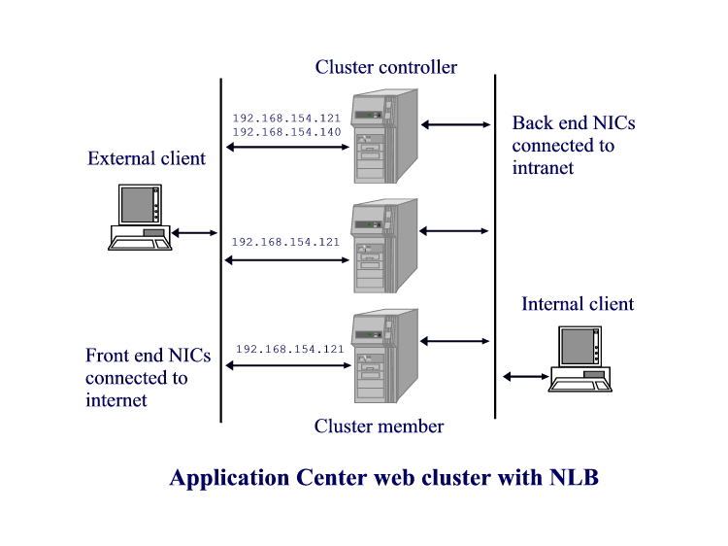
NOTE: All elements of the network infrastructure (switches, routers, hubs and firewalls) are omitted for simplicity. All IP addresses are for example purpose only.

Check this from the command prompt window using ipconfig command on the machine that will be your cluster controller:

D:\>ipconfig

Windows 2000 IP Configuration

Ethernet adapter Local Area Connection:

Connection-specific DNS Suffix . :
IP Address. . . . . . . . . . . . : 192.168.154.140
Subnet Mask . . . . . . . . . . . : 255.255.255.0
IP Address. . . . . . . . . . . . : 192.168.154.121
Subnet Mask . . . . . . . . . . . : 255.255.255.0
Default Gateway . . . . . . . . . :

Ethernet adapter Local Area Connection 2:

Connection-specific DNS Suffix . : ACSLAB.
IP Address. . . . . . . . . . . . : 172.29.136.253
Subnet Mask . . . . . . . . . . . : 255.255.240.0
Default Gateway . . . . . . . . . : 172.29.128.1

D:\>

Another way to confirm that the cluster controller computer has 2 static IP addresses assigned to the frontend NIC: Click on Start, Settings, Network and Dial-Up Connections, <connection name>, Internet Protocol (TCP/IP), Properties, Advanced.

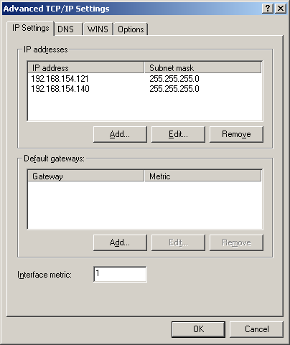

Another way to confirm that all machines have dynamic addresses assigned to the backend NIC: Click on Start, Settings, Network and Dial-Up Connections, <connection name>, Internet Protocol (TCP/IP), Properties.

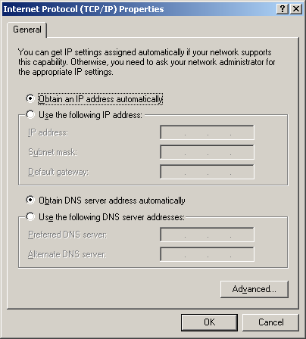

Confirm that the web cluster member computer has at least 1 static IP address assigned to the front end NIC: Go to Start, Settings, Network and Dial-Up Connections, <connection name>, Internet Protocol (TCP/IP), Properties.

Cluster creation step by step
On the cluster controller:
1. Open Application Center UI: left click on Start, Programs, Administrative Tools, Application Center. When Application Center UI appears on the screen, right click on Application Center, choose Connect. Enter localhost as a server name as shown on the next figure.

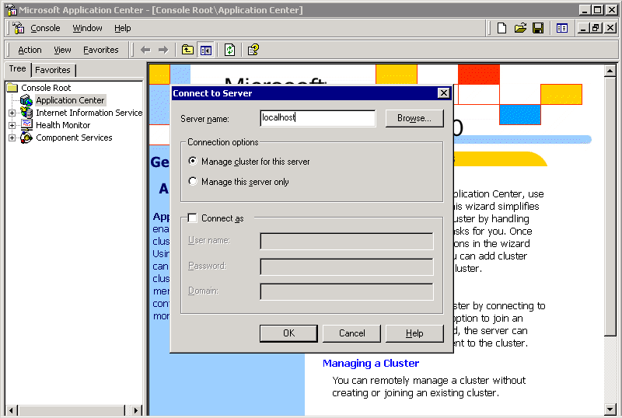

You will get a message letting you know that the computer is not a cluster member.

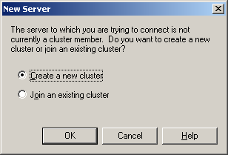

Click ‘OK’ to launch the New Cluster Wizard, click ‘Next’ when the screen ‘Welcome to the New Cluster Wizard’ displays.

2. The Wizard will analyze the Server Configuration and then ask for a cluster name and description. Enter some valid values and then click ‘Next.’

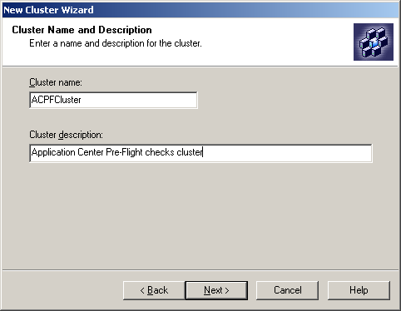

3. Select ‘General/Web Cluster’ for the cluster type and then click ‘Next.’

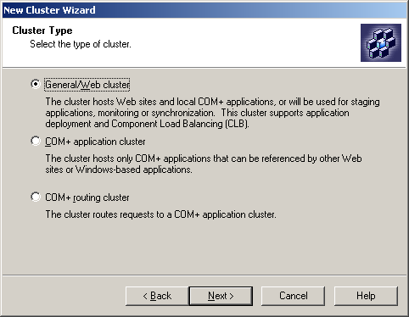

4. Select ‘Network Load Balancing’ to distribute incoming requests and then click ‘Next.’

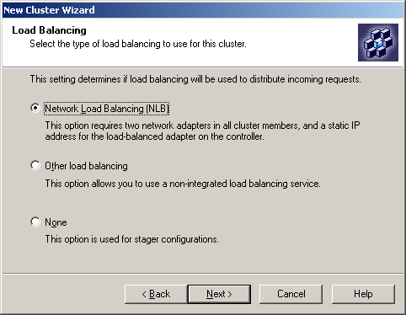

5. On “Load balancing Options” dialog, choose the proper network card. The card using DHCP will be used as the Management traffic network adapter. The card with 2 static IP addresses will be used as the Load Balanced network adapter. The default selections should be correct. Click ‘Next.’

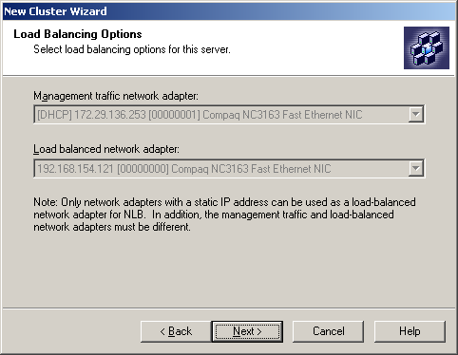

6. You can leave the email information dialog blank. Click ‘Next.’

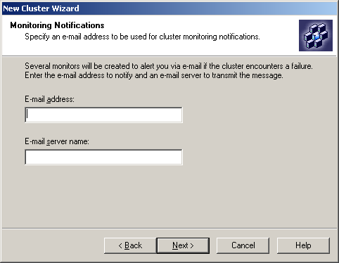

7. Click ‘Finish’ and wait for the cluster to be created.

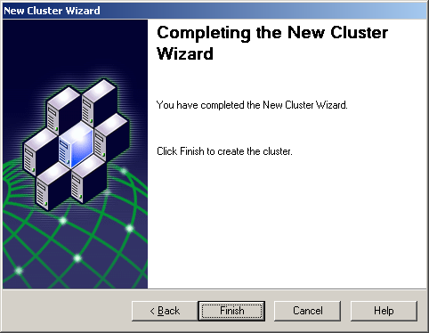

8. At this point we have single node Application Center web cluster that uses NLB for load balancing.
Now you can skip to the Adding members section.

Creating Application Center cluster with a 3rd party load balancing device

Prerequisites
To create an Application Center cluster with a 3rd party load balancing device all that is required is to have Windows 2000 Server or higher on all machines. It is recommended that all machines have two network cards: one connected to internet/intranet (front end NIC) and one connected to intranet (backend NIC). In typical environment the following resources should be available in the backend network: domain controller, DHCP server, DNS server, and WINS server. One static IP address should be bound to the front end NICs of all machines. The backend NICs can have static IPs or to use IP addresses provided by DHCP server. The configuration looks is shown in the next figure.

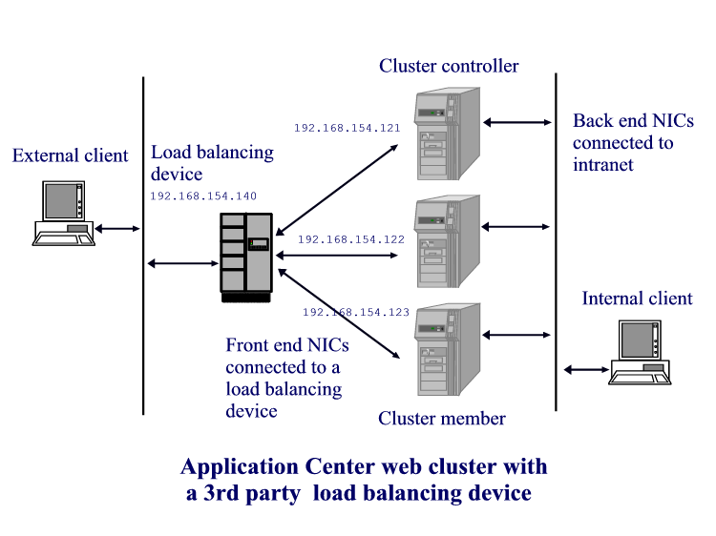
NOTE: Normally between the load balancing devices and the machines of the cluster is a hub that is not shown on this figure. Other elements of the network infrastructure such as switches, routers, hubs and firewalls are omitted for simplicity.

Cluster creation step by step
On the cluster controller follow steps 1, 2 and 3 from previous section.
4. Select “Other load balancing” on the next window and click Next:

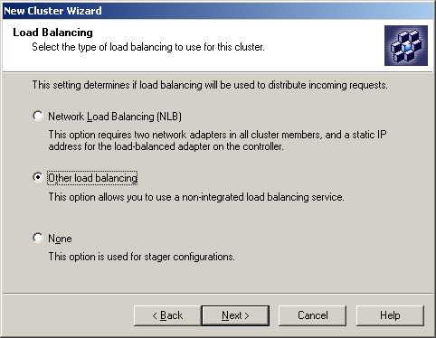

5. Choose the backend NIC for the management traffic:

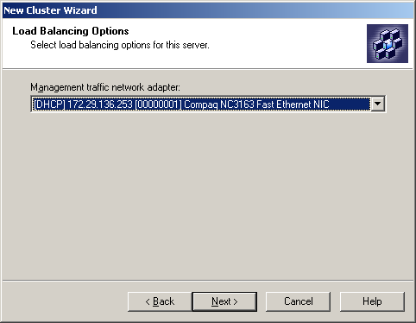

6. Fill out your e-mail address and e-mail server name or just click Next button on the next window “Monitoring Notifications”.

7. Click Finish button on the last window of the New Cluster Wizard. After some time the new cluster is created and Application Center UI appears on the screen.

At this point we have a single node Application Center web cluster using a separate load balancing device.

Adding cluster members
1. In the Tree View pane of the MMC expand the Application Center node, then the cluster name (ACCluster) and then Members.

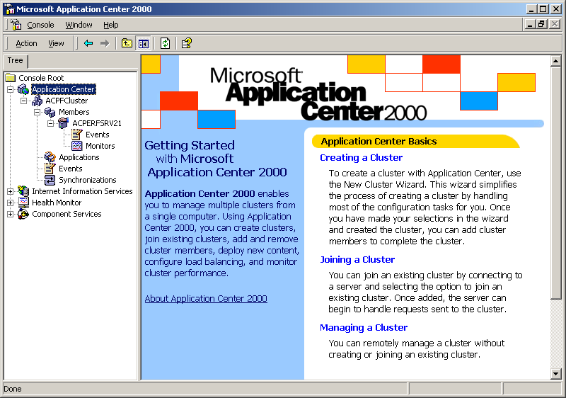

2. Right click on the ‘Members’ node and choose ‘All Tasks’, ‘Add cluster member…’. This launches the ‘Add Cluster Member Wizard’. Click ‘Next’ to continue with the wizard.

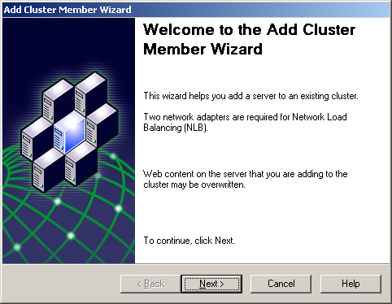

3. Enter the computer name of the machine to be added to the cluster and then enter valid credentials.

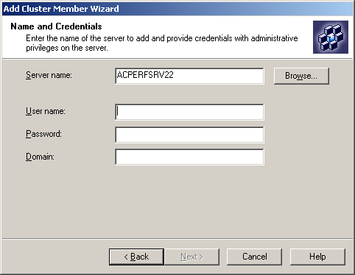

4. On the Cluster Member Options dialog, leave the default values as entered and click ‘Next’.

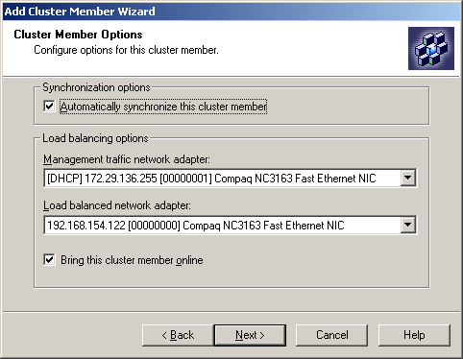

5. Click the ‘Finish’ button on the last window of the ‘Add Cluster Member Wizard’. Application Center will now replicate all settings to the member. Then the new member is added to the cluster.

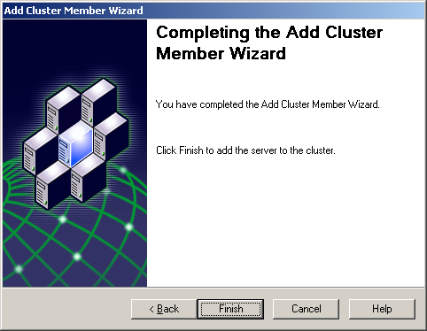

At this point we have a two-node Application Center web cluster.

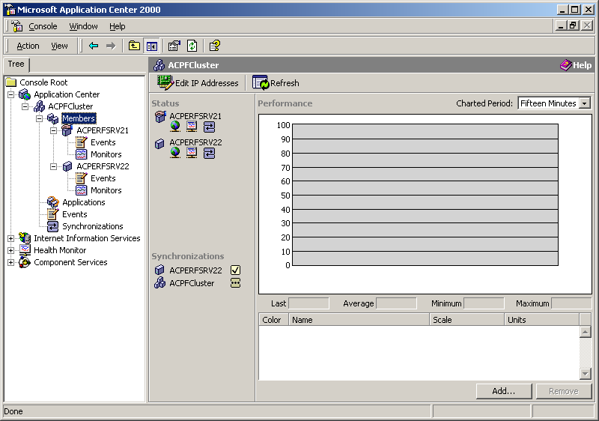

(Optional) You may add more machines to the cluster by following this procedure again.

Front and back end network adapters
To operate normally Application Center recommends two network adapters on each machine. For NLB cluster two network card are a requirement. The front end NIC is used to handle the traffic from/to the clients for the web site(s). The front end NIC is connected to the internet/intranet if the load balancer is NLB. In case of a separate load balancing device front end NICs are connected to this device, in most of the cases via hub. Back end NICs are used for intracluster communication: heart beats, replication, obtaining of performance data. They also handle the traffic to backend databases and/or component servers.

Virtual, dedicated and backend IP addresses
The front end NIC of each machine has at least one static IP. This address can be used to access this particular machine from the front end. In this document it is called the dedicated IP. If NLB is used for load balancing all front end NICs have an additional static IP. This IP is used to access the cluster. If separate load balancing device is used – it has a static IP itself. In this document we will refer to the cluster IP address as virtual IP. If the web cluster hosts more than one web site it will have more than one virtual IP: one for each web site.

To determine the virtual IP address of an NLB cluster, right click on the cluster name (ACPFCluster) and select ‘Properties.’ The IP address is listed. In our example, the virtual IP is 192.168.154.140.

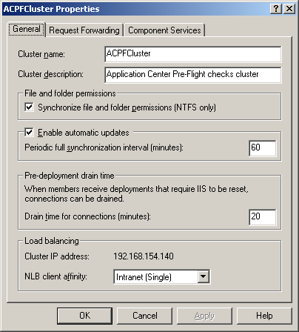

To determine the dedicated IP address of a cluster member, right click on the computer name and select ‘Properties.’ In this example, the dedicated IP of our cluster controller is 199.199.24.69.

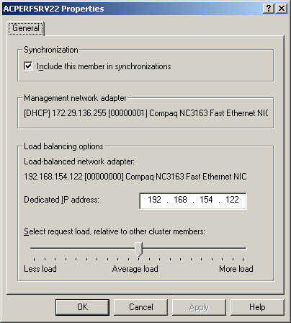

Step 1 pre-flight checks: Visibility

Visibility inside the cluster
This step verifies server name resolution and connectivity.

From the controller
Open a command prompt window; use the ping command to verify visibility of the machines inside the cluster. Each ping should succeed with IP replies as described below.

- Ping the members using theirs computer names:

D:\>ping -a ACPERFSRV22

Pinging ACPERFSRV22 [172.29.136.255] with 32 bytes of data:

Reply from 172.29.136.255: bytes=32 time<10ms TTL=128
Reply from 172.29.136.255: bytes=32 time<10ms TTL=128
Reply from 172.29.136.255: bytes=32 time<10ms TTL=128
Reply from 172.29.136.255: bytes=32 time<10ms TTL=128

Ping statistics for 172.29.136.255:
Packets: Sent = 4, Received = 4, Lost = 0 (0% loss),
Approximate round trip times in milli-seconds:
Minimum = 0ms, Maximum = 0ms, Average = 0ms

D:\>

The name should be resolved to the backend NIC (DHCP or static) IP (marked with bold).

- Ping the controller using its dedicated IP.
- Ping the virtual IP.

From all members
Open command prompt window, use ping to verify visibility of the machines inside the cluster. Each ping should succeed with IP as described below.

- Ping the controller using its computer name. The name should be resolved with the backend NIC (DHCP or static) IP.
- Ping the members one after one using their computer names. The names should be resolved with the IPs assigned to the corresponding back-end NIC.
- Ping the virtual IP.

Visibility outside the cluster

From the internal client
Open command prompt window, use ping to verify visibility of the machines inside the cluster. Each ping should succeed with IP as described below.

- Ping the controller using its name. The name should be resolved with the backend NIC (DHCP or static) IP.
- Ping the members one after one using their names. The names should be resolved with the IPs assigned to the corresponding back-end NICs.

From the external client
Open command prompt window, we will use ping again to verify visibility of the machines inside the cluster. Each ping should succeed with IP as described below.

- Ping the controller using its dedicated IP.
- Ping each member using the dedicated IPs.
- Ping the virtual IP.
- Open IE (or any Internet browser) and make HTTP request using cluster controller dedicated IP (i.e. http://192.168.154.121). The default web page of the default web site should be visible (on a fresh machine – “This page is under construction”). Refresh the page (F5 for IE) several times.
- Do the same using dedicated IPs of the cluster members. The default web page of the default web site should be visible. Refresh the page several times.
- Do the same using virtual IP of the cluster. The default web page of the default web site should be visible. Refresh the page (F5 for IE) several times.

Step 2 pre-flight checks: Monitoring
Step two does a basic verification of Application Center’s monitoring system and database access.
NOTES:
- If Application Center is installed without MSDE option, the monitoring functionality will be significantly reduced and performance counters will not be accessible. If this is the case skip this check and proceed to next step.
- All operations below are conducted on the cluster controller using Application Center MMC.

Performance counters
In the Application Center MMC, click on the Cluster Controller name. Click on the ‘Add’ button in the lower, right hand corner.

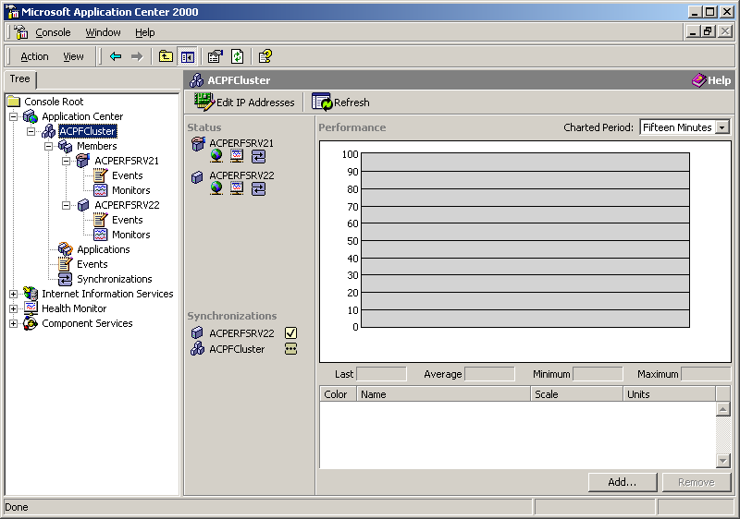

Click on ‘Processor Utilization’ and then click ‘Add’. Add another counter for ‘Memory Available Bytes’. Click the ‘Close’ button to return to MMC.

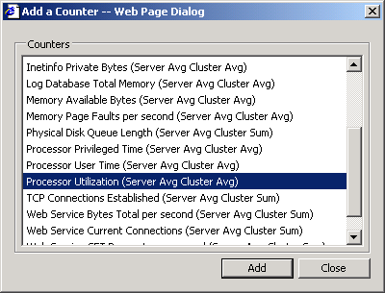

Both performance counters should be displayed in the lower right panel.

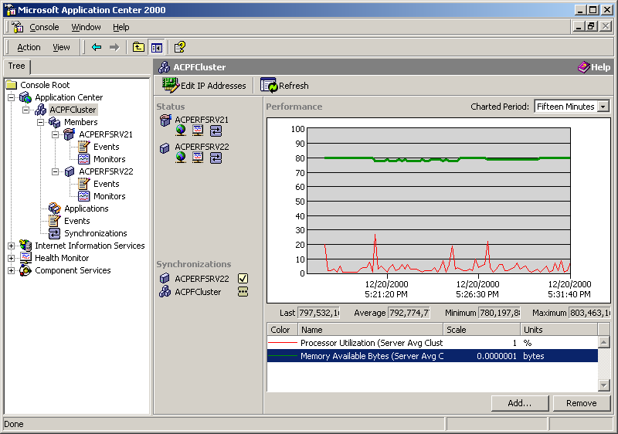

Click on the name of the cluster member(s). Add the same two performance counters. Verify that they are displayed correctly. Note that performance counters history is displayed. This is just one difference between Application Center and Performance Monitor where Application Center adds value. In Performance Monitor view you can see the chart of the performance counters from the current moment, in Application Center the charts display the whole history. This is because Application Center stores the performance counters into a database. In addition at the chart level all performance information is a roll-up of all member servers.

Events
Click on Events node under the Applications node to display events on all members. Verify that events from the event logs are displayed.

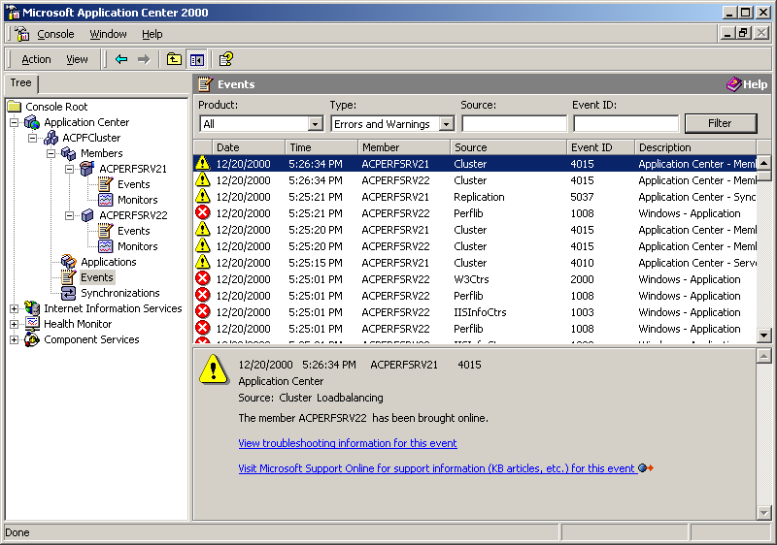

Set the filters for Product, Type, and Source as shown on below. Click on ‘Filter.’ Verify that Application Center event system filters the events properly.

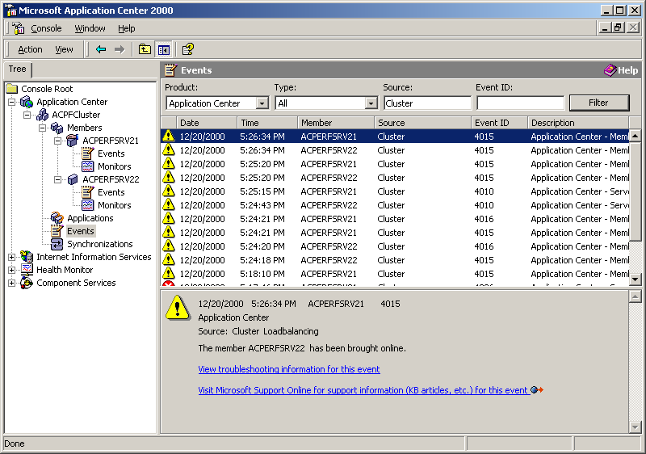

This is another place where Application Center adds value. In Events Viewer you can see the events from one machine only. Application Center combines all events from all machines in the cluster in one view. In addition the filtering system allows the user to see a selected group of events.

Restore the filters to their initial state (All, Errors and Warnings, blank, blank). Click on ‘Filter.’
Repeat the actions above for the cluster member(s). This can be done by clicking on the ‘Events’ node under the corresponding server name.

NOTE: Filtering events with the ‘Filter’ button just changes the view. Events can be excluded all together from the event database by right clicking on the top level event node and change the properties.

Monitors
Click on the ‘Monitors’ node under the cluster controller name. Click on ‘Check Now’. Verify that all default monitors are green or disabled. Repeat the same procedure for the cluster member.

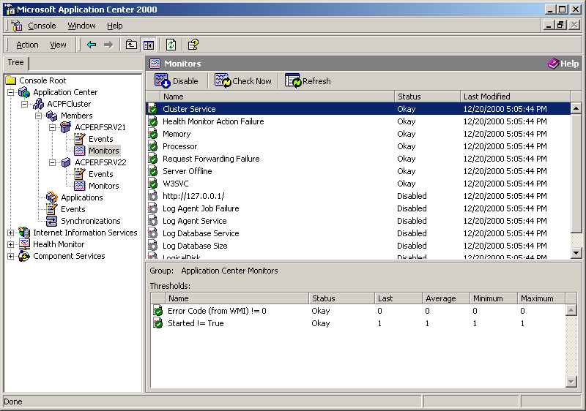

Step 3 pre-flight checks: Replication
This step performs basic replication tests. The goal is to verify that the major replication engines are properly installed and functioning normally.

Preparation
This phase describes how to install a simple set of web pages and COM components, how to create a simple virtual web directory and how to declare them as Application Center resources. They will be used to perform basic replication tests.

On the cluster controller
Look for ACPF.EXE in the \Support sub directory of the Application Center 2000 CD. Create a directory named C:\ACPF, start this self extracting executable and expand it there. This will expand a set of directories, web pages, batch files, configuration files and executables.

The setup of the test website and COM+ components will be done automatically by running the following set of batch files (C:\ACPF\Files must be the current directory). Go to a command window and execute the scripts in sequence:

1. First, create two COM+ applications and install six COM+ components by running C:\ACPF\Files\PFSetupCOM.BAT
C:\ACPF\Files>PFSetupCOM.BAT

=========================
COM+ Test Setup Routine
=========================

COM+ Test Setup -> GetCurrentDirectory() succeeded: C:\ACPF\Files
Log file name:
Setup info file name: PFCOMSetup.INF
CoInitializeEx() succeeded
SetComputerProp(TransactionTimeout, 60) succeeded
NewApplication(AC_PF_VB) succeeded
NewApplication(AC_PF_VC) succeeded
InstallComponent(AC_PF_VB, \ACPF\Components\PFComponent.dll) succeeded
InstallComponent(AC_PF_VC, \ACPF\Components\TestCOM.dll) succeeded
SetAppProp(AC_PF_VB, Activation, Local) succeeded
SetAppProp(AC_PF_VC, Activation, Local) succeeded
COM+ Test Setup routine finished!

C:\ACPF\Files>

2. Create a web virtual directory under the default web site by running C:\ACPF\Files\PFSetupWeb.BAT
C:\ACPF\Files>PFSetupWeb.bat

Finished Parsing Inf file
Validating commands....done
================================
IIS Test Setup
================================

IIS://LocalHost/W3SVC/1/Root EXECUTE Create IISWebVirtualDir ACPFWeb
IIS://LocalHost/W3SVC/1/Root/ACPFWeb SET EnableDirBrowsing to TRUE
IIS://LocalHost/W3SVC/1/Root/ACPFWeb SET AccessRead to TRUE
IIS://LocalHost/W3SVC/1/Root/ACPFWeb SET AccessWrite to TRUE
IIS://LocalHost/W3SVC/1/Root/ACPFWeb SET AccessScript to TRUE

********IIS Test Setup PASSED*********
C:\ACPF\Files>

By running these scripts we have:
- Created two COM+ applications named AC_PF_VB and AC_PF_VC.
- Installed PFComponent.dll in the first one and TestCOM.dll in the second one.
- Created a virtual web directory named ACPFWeb under DefaultWebSite.

The web site has several sets of pages:
- PFWelcome.ASP – creates simple COM component, calls a method to obtain the server name, and releases the component. It returns a short text message with the name of the server.
- PFStatic1.HTM – PFStatic5.HTM – set of five HTML pages displaying short text messages.
- PFDynamic1.ASP – PFDynamic5.ASP – set of five ASP pages displaying a short text message and the machine name.
- PFDynaCOM1.ASP – PFDynaCOM5.ASP – set of five ASP pages. Each page randomly creates one of five COM components, calls a method and releases the component. These COM components are registered in COM+ application. The page returns short text message with the name of the server and the name of the created COM component.

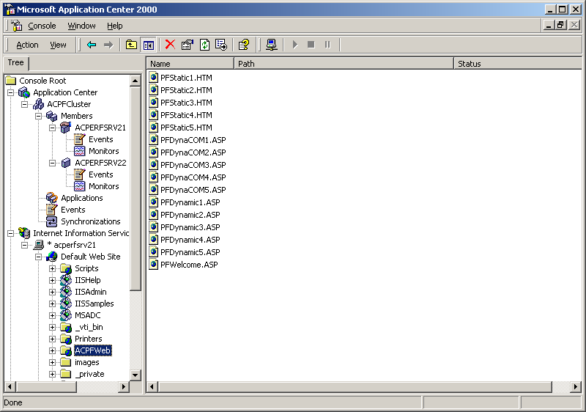

We have created two COM+ applications (AC_PF_VB and AC_PF_VC) with a total of six registered COM+ components:

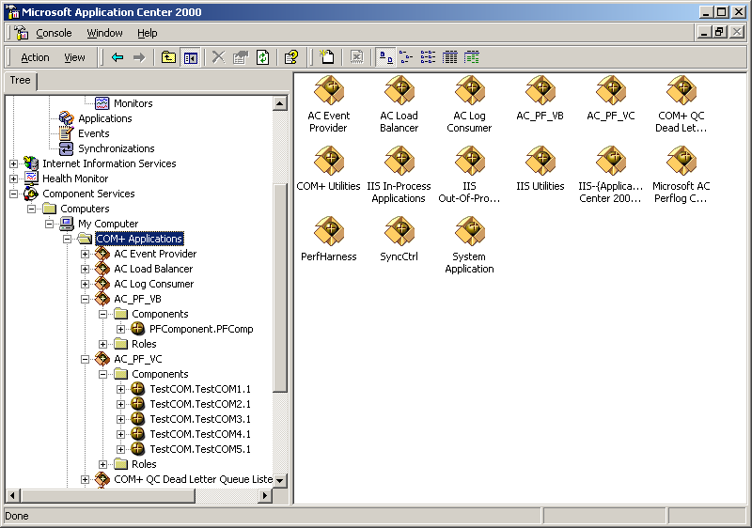

Next, create an Application Center application by clicking on ‘Applications’ in the Application Center MMC. Click ‘New’ in the top right panel and give the application a name.

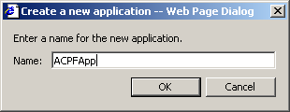

In the bottom right panel, change the resource type to ‘COM+ Applications” and then click ‘Add’. Add the AC_PF_VC and AC_PF_VB applications.

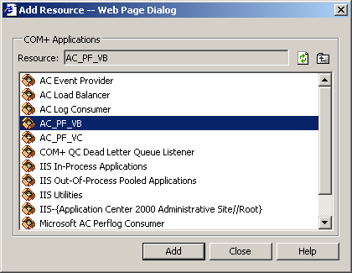

Change the resource type to ‘File System Paths’ and click ‘Add’. Add c:\ACPF\Files as a resource.

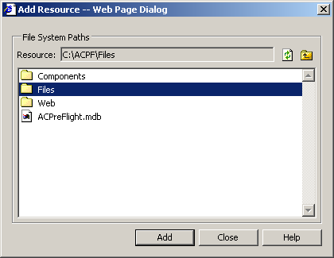

NOTE: It is not necessary to add the Web directory as we will be adding the web virtual directory in the next step.
Change the resource type to ‘Web Sites and Virtual Directories’ and click ‘Add’. Add the ACPFWeb directory.

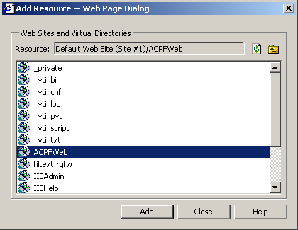

Both COM+ applications, the virtual directory and the file directory are now registered as resources in the ACPFApp application:

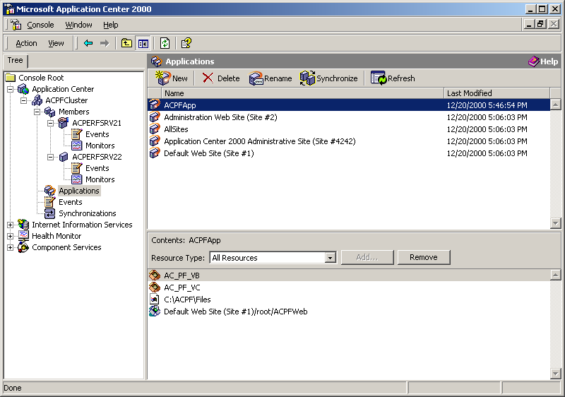

On the external client
Open the web browser. Connect to the cluster controller using the dedicated IP:

http://<controller_dedicated_IP>/ACPFWeb/PFWelcome.asp

Verify that the web site is created and the page is properly displayed. Refresh the screen several times.

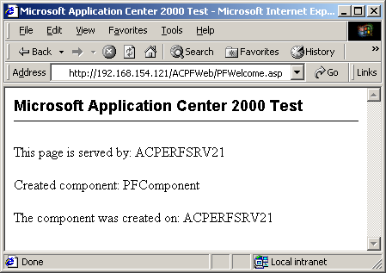

NOTE: By default, automatic synchronization is ON for all resources other than COM+ and ISAPI filters. It is expected behavior to see the web site files replicated on the member servers without doing an explicit synchronize command.

File replication
Select Applications, highlight ACPFApp, and click on Synchronize. Click ‘OK’ to confirm the synchronization.

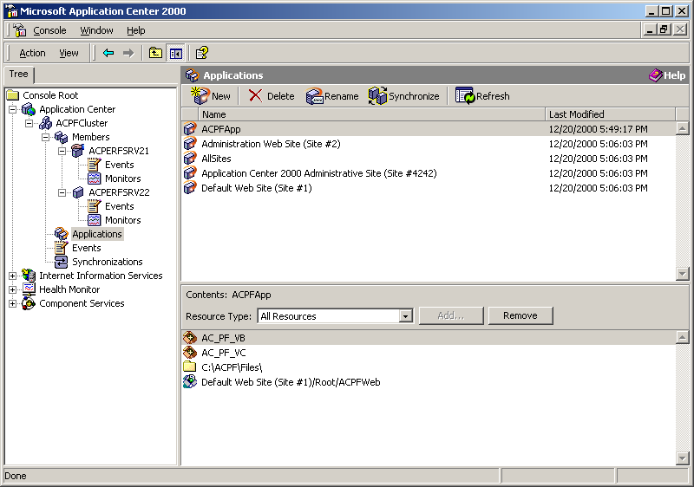

Click on the ‘Synchronization’ node. Monitor the synchronization in this view.
Click on the cluster controller name to see CPU utilization and status of the synchronization.

When the synchronization is finished – verify that the c:\ACPF\Files directory with all files is replicated on the member computer.

On the cluster controller, use Notepad to create a new file in the c:\ACPF\Files directory. Verify that the new file is automatically replicated to the member computer.

COM+ replication
Deploy the ACPFApp application. Select Applications in MMC, right click, and choose ‘New Deployment’ to the launch the New Deployment Wizard. Click ‘Next.’

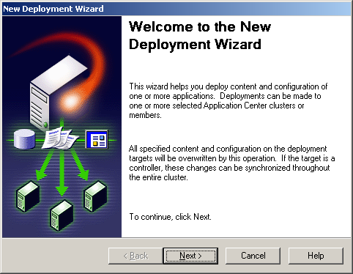

Give a name to the deployment and choose ‘Deploy content inside the current cluster. Click Next:
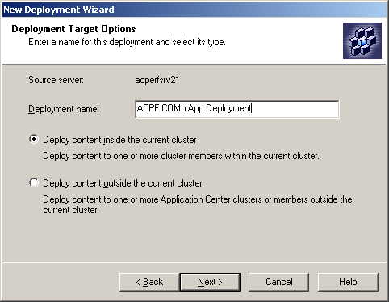
Highlight the member name to deploy to and click ‘Next’:

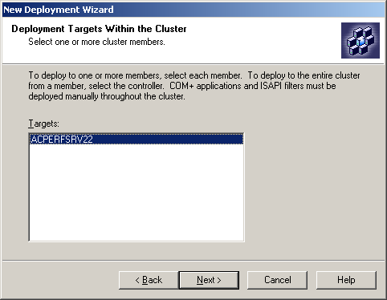
Click on the radio button of ‘Deploy one or more applications:’, select the ‘ACPFApp’ application to be deployed, click ‘Next’:
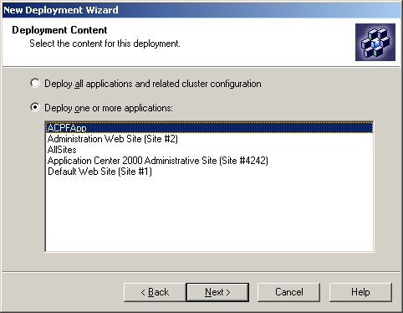
On the next window select ‘Deploy COM+ applications’ and click ‘Next’:
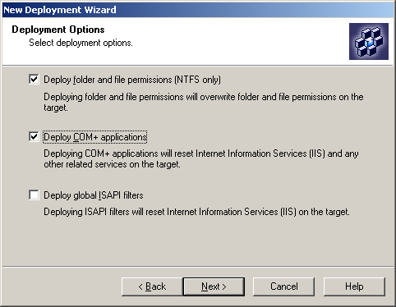
Click ‘No, reset connections immediately’ and click ‘Next’:

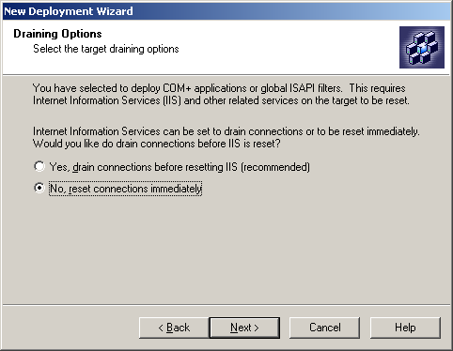

Click ‘Finish’ to start the deployment:

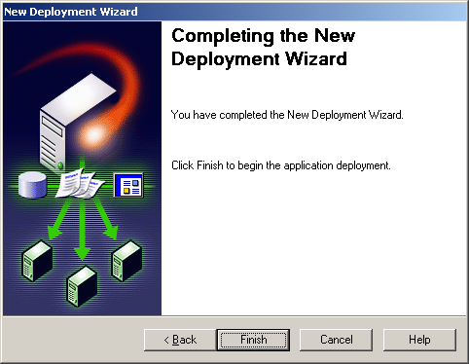

Click on the cluster controller name and watch on the right pane to see the process of the deployment on central pane in the right side of the deployment name.

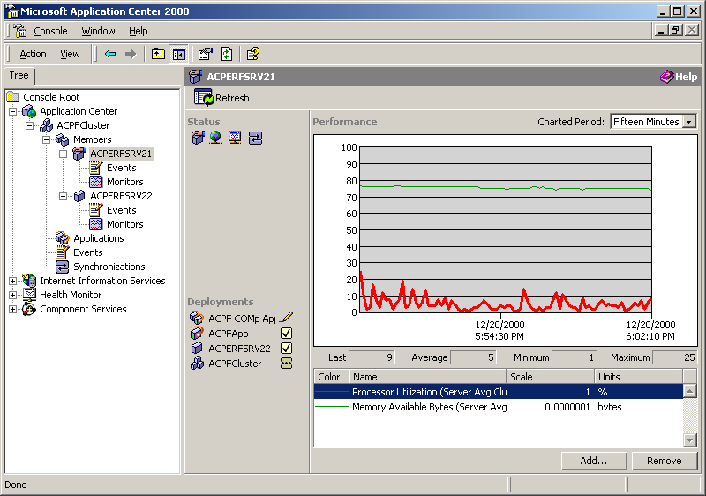

Also displayed are the performance counters we set up during step 2.

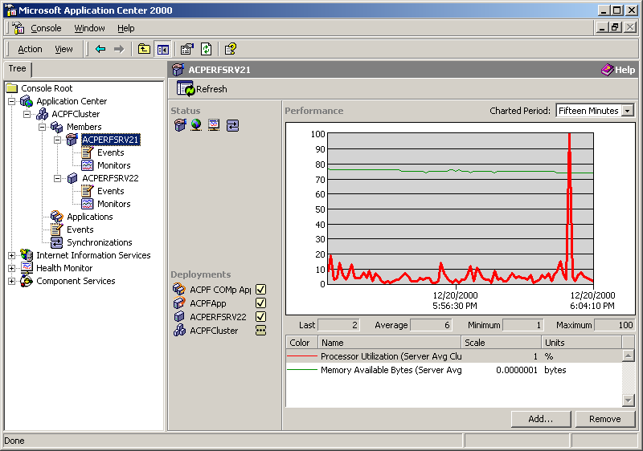

Click on the Synchronizations view under cluster name on the left pane and verify that the deployment succeeded.

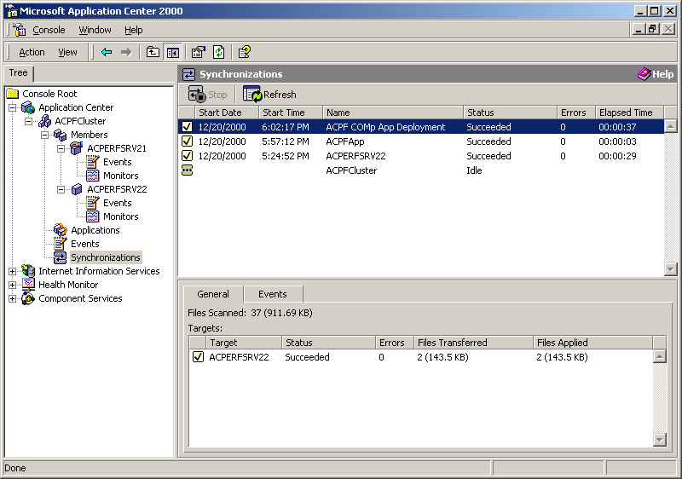
Once deployment is finished, verify on the member computer that both COM+ applications were replicated. Open the Component Services MMC and view the COM+ applications and all COM+ components on the member machine. This can be done remotely from Application Center MMC console. To do this:
- Select and expand ‘Component Services’ in the left pane.
- Select ‘Computers’, right click, ‘New’, ‘Computer’.
- In the window enter the cluster member name and click on ‘OK’.
- Expand the computer member name as shown on the next figure.

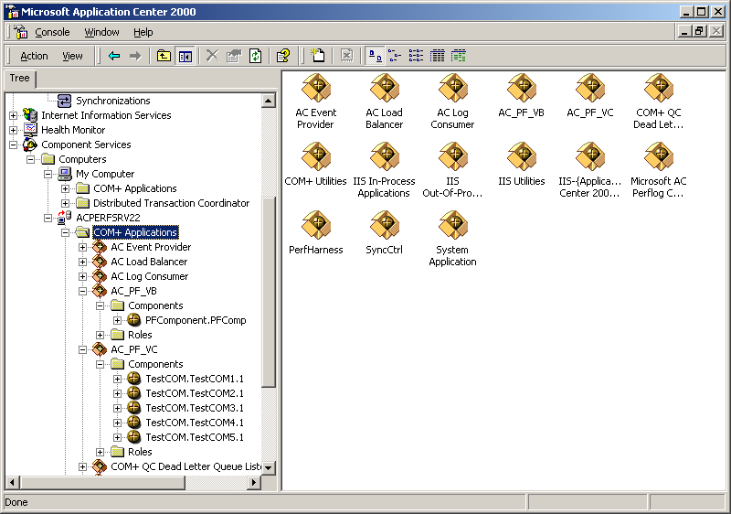

Registry replication
On the cluster controller, start the registry editor (regedit.exe), create a key (HKey_Local_Machine\Software\SomeKey for example), and add a DWORD and a string. Set some initial values to the entries as shown on the next figure:
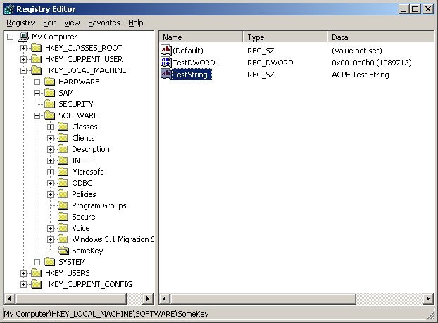
Add this registry key as a resource in our Application Center application ACPFApp by selecting ‘Applications’ in the Application Center MMC, clicking on ‘ACPFApp’, and then selecting ‘Registry Keys’ as the Resource Type in the lower right panel.
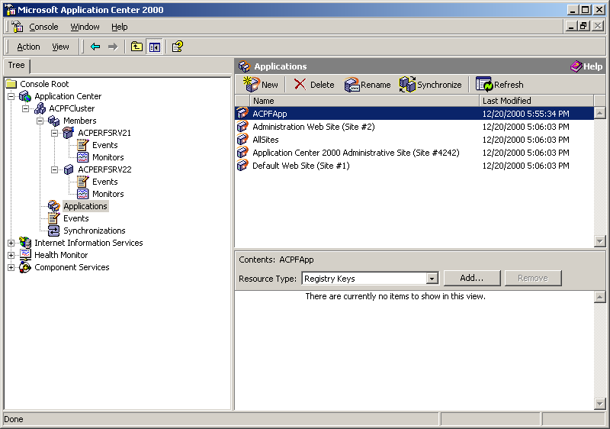
Click the ‘Add’ button and then select the key you created in the Add Resource window.

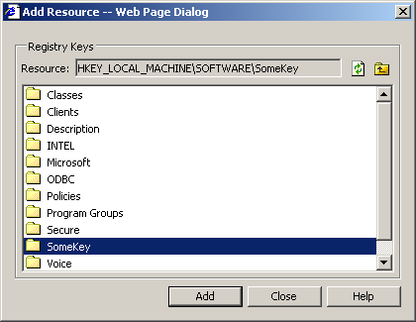
Click ‘Close’ when you have added your resource. Synchronize the ACPFApp application by clicking on the ‘Synchronize’ button.

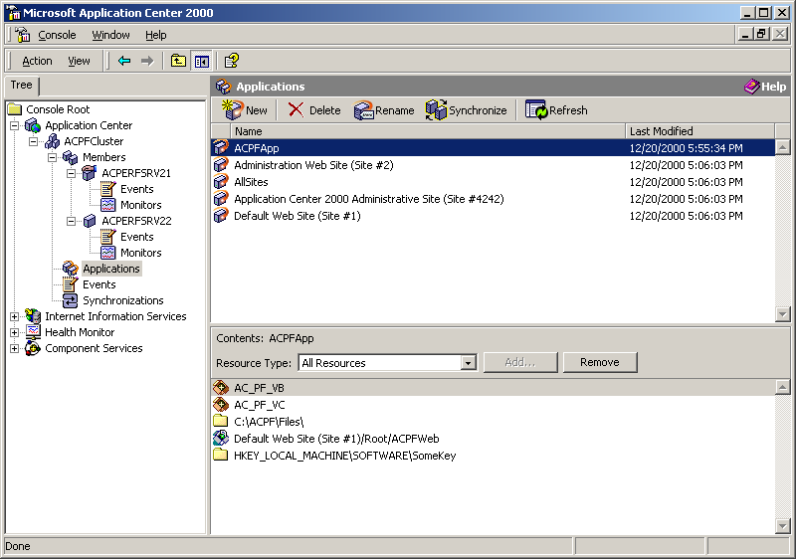

When it is done – verify that the registry key with all values is replicated to the member computer by running regedit.exe on the member and locating the key. This can be done remotely from the cluster controller. To do this use already started registry editor:
- Select ‘Registry’ menu on the upper left corner.
- Select ‘Connect Network Registry …’.
- In the window enter the cluster member name and click on ‘OK’.
- Expand the computer member name as shown on the next figure.

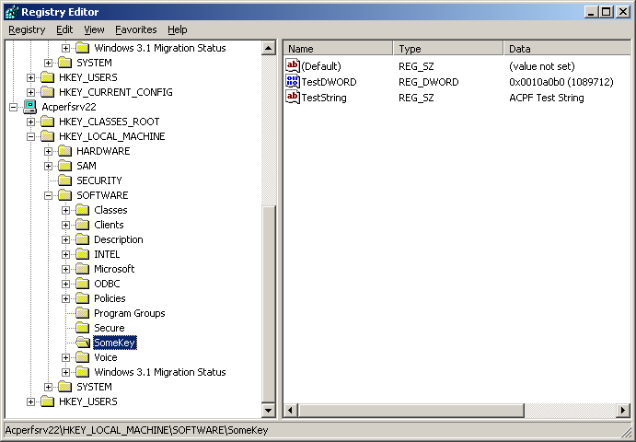

Add one value, change one of the others and synchronize the cluster again. When synchronization is finished – verify that the new values are replicated on all members.

Metabase replication
On the cluster controller, go to the Internet Information Services node of MMC. Right click on the ACPFWeb virtual directory, and select ‘Properties.’ Change the Execute permission properties to ‘Scripts and Executables’. Click ‘OK’ on the warning message.

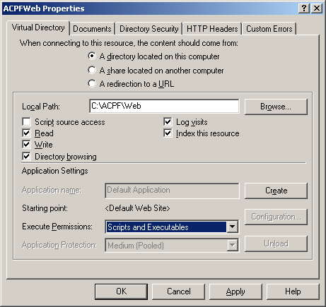

Synchronize the cluster. When it is done, verify on the cluster member that the setting has replicated by checking the ACPFWeb virtual directory properties in its IIS MMC module. Go to the member, open IIS console and verify that the changes were replicated. This can be done remotely from Application Center MMC console. To do this:
- Select and expand Internet Information Services node of MMC.
- Right click, ‘Connect’.
- In the window enter the cluster member name and click on ‘OK’.
- Expand the computer member name as shown on the next figure.
- Right click on the ACPFWeb virtual directory, and select ‘Properties.’
- Verify that the changes were replicated.

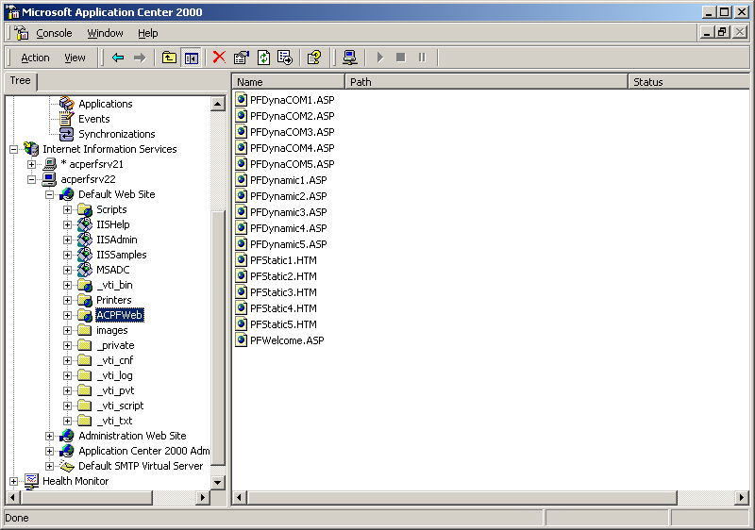

Restore the permissions back and synchronize. When synchronization is finished – verify on all members that the new permissions are replicated.

Step 4 pre-flight checks: Request forwarding
Step 4 tests and demonstrates how request forwarding works.

Preparation
First verify that the cluster is accessible by opening a web browser on the client. Connect to the cluster using the virtual IP:

http://<cluster_virtual_IP>/ACPFWeb/PFWelcome.asp

Verify that the page is properly displayed.

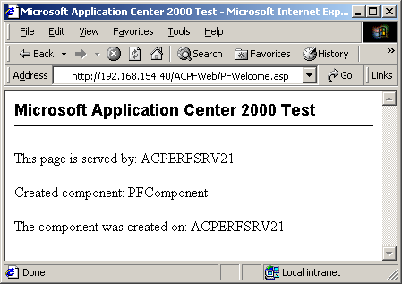

Set NLB affinity to None. We do this to insure that no session “stickiness” is maintained to force the Request Forwarder into action. Right click on the cluster name and select ‘Properties.’ Set NLB client affinity to ‘Custom (none).’ Click ‘OK’ and the changes will be automatically replicated to the member.

NOTE: Setting affinity to ‘None’ and leaving Request Forwarder enabled is NOT a recommended configuration. It is done here strictly for demonstration purposes. Never do this on a production system, as it will cause increased CPU consumption and network traffic.

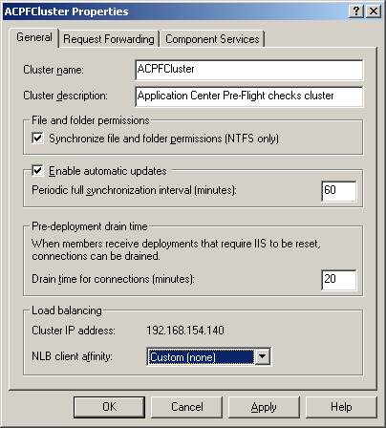

Static content – not forwarded
From the web browser on the external client connect to the cluster using the virtual IP:
http://<cluster_virtual_IP>/ACPFWeb/PFStatic1.htm
Verify that the page is properly displayed. Close and restart the browser 5-10 times, reloading the PFStatic1.htm page each time.

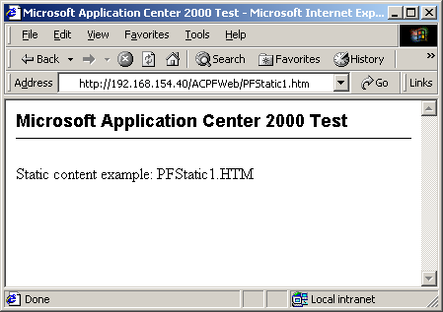

Open the IIS log file on both cluster controller and member (C:\WINNT\system32\LogFiles\W3SVC1 …) to verify that the page is opened on different machines.

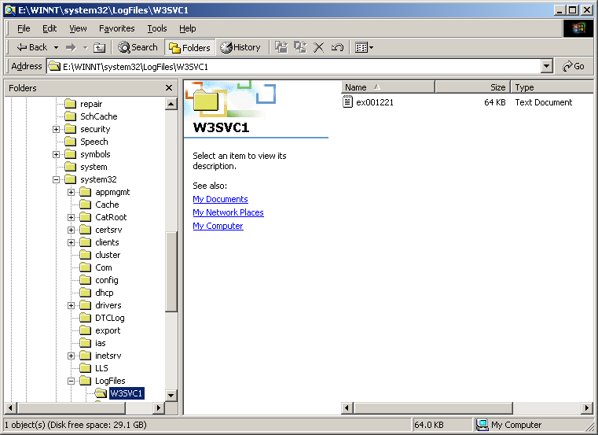

The logs should show the page being served up from both cluster machines.

Dynamic content – forwarded by default
From the web browser on the client connect to the cluster using the virtual IP:

http://<cluster_virtual_IP>/ACPFWeb/PFDynamic1.asp

Verify that the page is properly displayed. The page returns short text with the server name. Refresh the browser several times. The name of the server will always be the same. Even when the request is load balanced to another server, Application Center will forward it to the initial server.

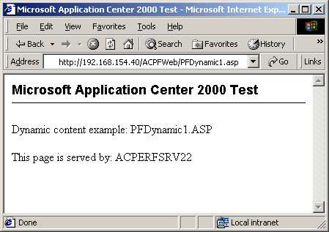

Dynamic content – not forwarded when RF is turned off
On the cluster controller open Application Center MMC and turn request forwarding OFF. To do this right click on the cluster name and select ‘Properties’. On the Properties window, click on the ‘Request Forwarding’ tab and deselect ‘Enable Web request forwarding’. Click ‘OK.’

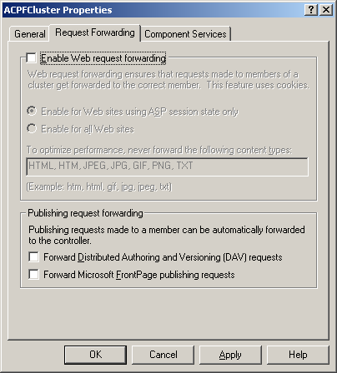

From a web browser on the external client connect to the cluster using the virtual IP:
http://<cluster_virtual_IP>/ACPFWeb/PFDynamic1.asp
Verify that the page is properly displayed. The page shows the server name. Close and restart the browser 5-10 times, reloading the PFDynamic1.htm page each time. The page will show different server names.

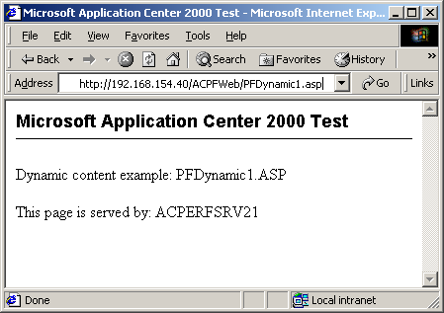

NOTE: Normally you would probably set the cluster affinity to ‘Single’ and turn Request Forwarding ON after verifying that the system is working properly. For now, leave the settings as they are, with cluster affinity set to ‘Custom (None)’ and Request Forwarding disabled.

Step 5 pre-flight checks: Cluster under load
All major features of an Application Center web cluster have now been tested. The next level of testing is to apply load and to verify how they work under load.

Preparation

On the Client
Install Web Application Stress Tool from http://webtool.rte.microsoft.com/. Look for ACPF.EXE in the \Support sub directory of the Application Center 2000 CD. Create a directory named C:\ACPF, start this self-extracting executable and expand it there. This will expand a set of directories, web pages, batch files, configuration files and executables, including the sample script ACPreFlight.MDB. The script creates all the pages described in step 3 in a loop, randomly selecting COM components to be created.

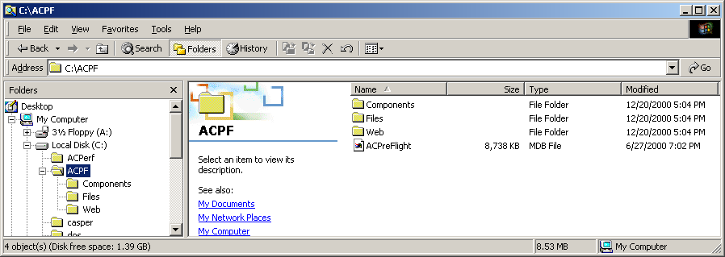

Start the Web Application Stress Tool and open the script ACPreFlight.MDB. Open the ACPreFlight node in the tree and click on ‘ACPreFlight’. Be sure to change the server name to the virtual IP address of the cluster as shown on the next figure.

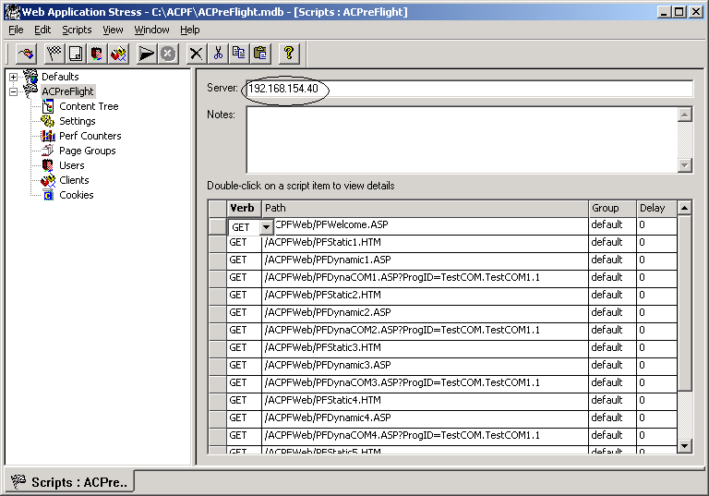

Click on ‘Settings’ and change the duration of the test to the time you desire (for example from 1 to 10 minutes).

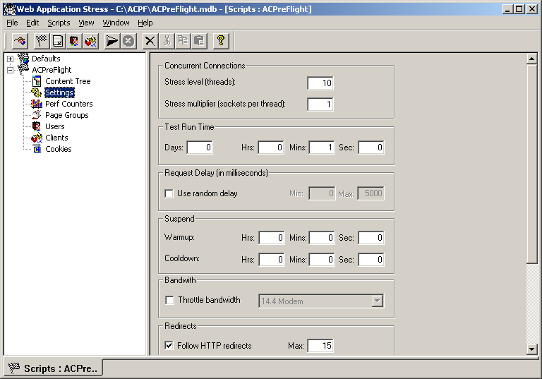

Each test below is executed under load. This means:
- Start the script;
- Perform the action;
- Watch performance monitors on Application Center MMC for CPU utilization and requests per second for the cluster controller and all members;
- Wait to the end of the script;
- Take a look at the Web Application Stress Tool report file: number of requests, requests per second, socket errors and error codes.

Cluster under load
- Verify on the cluster controller and all members that CPU utilization goes up. For this purpose use performance charts set during step 2.
- Verify how load-balancing works – CPU utilization should be approximately the same on all members and a little bit higher on the cluster controller.
- Set one of the machines offline: select the computer name in Application Center MMC, right click, Set Offline, click on ‘Take offline now’ (under normal conditions the current connections should be drained.):
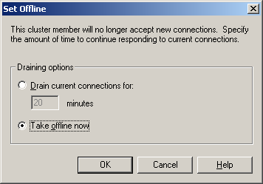
Click on ‘Members’ and verify in the right pane that this machine is offline. Click on the name of this computer and watch CPU utilization. It should go to near zero. CPU utilization on the other machines should be higher. Bring the machine back online.

Replication under load (optional)
Repeat all actions from step 3 under load. Watch CPU utilization and other performance counters, especially pages per second.

Step 6 pre-flight checks: Component load balancing
In this step an Application Center component cluster will be created and tested. This is a second tier cluster hosting the COM+ components, to be invoked by ASPs in the web cluster.

Configuration
The configuration consists of an external client, Application Center web cluster and Application Center component cluster. On the web server COM+ dynamic load balancing is enabled and all servers from the second cluster are declared as component servers. On both sets of machines the actual components are installed. When the client computer opens an ASP page from the test set, the page creates a COM component. Component load balancing, running on the machines of the web cluster, decides on which machine from the component cluster to create the component based on how loaded the machines from the component cluster are.

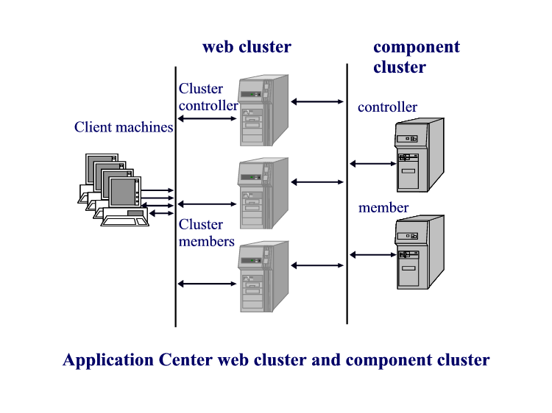

Component cluster creation
If you have not already done so, install Application Center on the machines for the component cluster. Create a single node Application Center cluster on the new cluster controller. To do this open Application Center MMC on the component cluster controller. Right click on Application Center, enter ‘localhost’ as the Server Name, and click ‘OK’. Choose ‘Create a new cluster’ to launch the New Cluster Wizard and follow the steps described in Initial Configuration. Enter ‘ACPFComCluster’ as the cluster name:
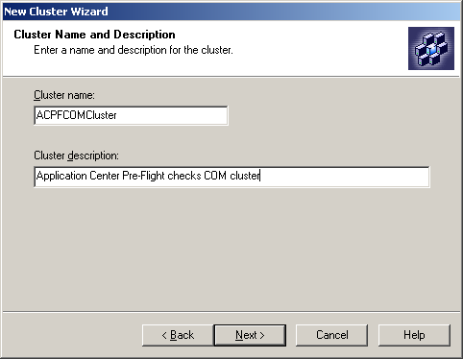

Select COM+ application cluster in Cluster type window:

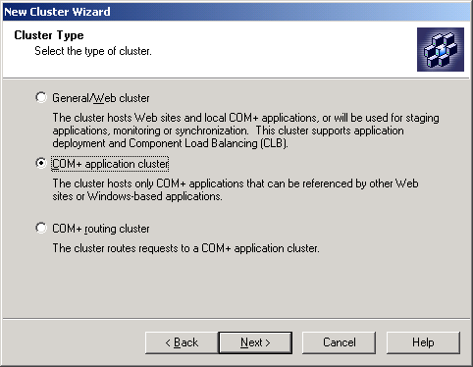

Follow the defaults to finish the New Cluster Wizard.

Deployment of the COM+ Applications from the web cluster controller
Next we’ll create and deploy the 2 COM+ applications from the web cluster controller to the new COM+ cluster. On the web cluster controller:
- From the web cluster controller, right click on ‘Applications’ and select ‘New Deployment…’
- Fill in a deployment name and select ‘Deploy Content Outside the current cluster’ as it is shown on the next figure. Click ‘Next’.
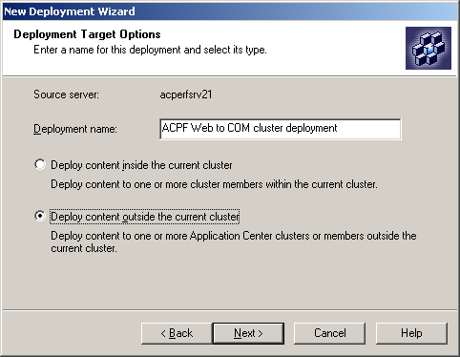
- Type in the credentials and click ‘Next.’
- In the Target edit box, type in the name of the COM+ cluster controller. Click ‘Add’ then click ‘Next.’
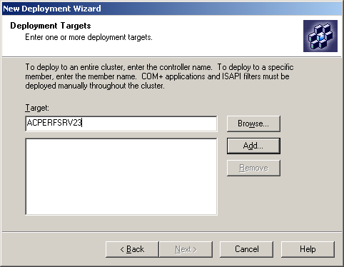
- Deploy the ‘ACPFApp’ app and click ‘Next’
- Select ‘Deploy COM+ Applications’ and click ‘Next’.
- Then select ‘No, reset connections immediately’ and then click ‘Next.’
- Click ‘Finish’ to deploy the app.

Watch the deployment progress from ‘Synchronizations’ view to the moment when the deployment succeeds:

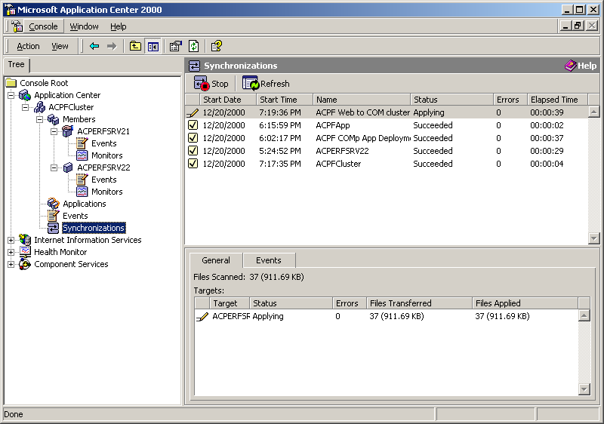

The machine that was just configured is the cluster controller for a single node component cluster. At this point on the component cluster, we have one Application Center application with two COM+ applications registered as resources.

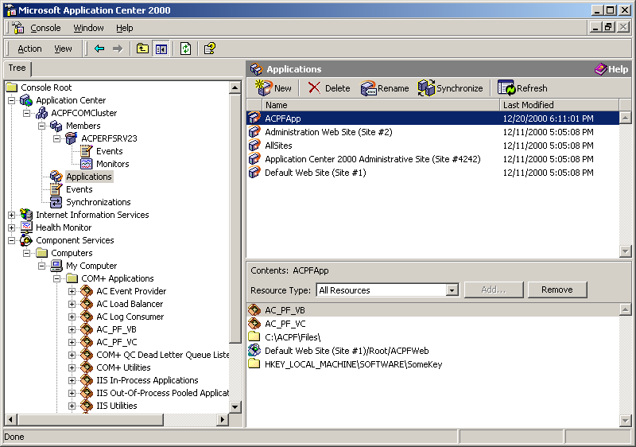

Adding a second member to the component cluster
On the component cluster controller using Application Center MMC add the second machine as member of the component cluster. When this is complete – verify on all members that the COM+ applications are replicated and all COM+ components are installed:

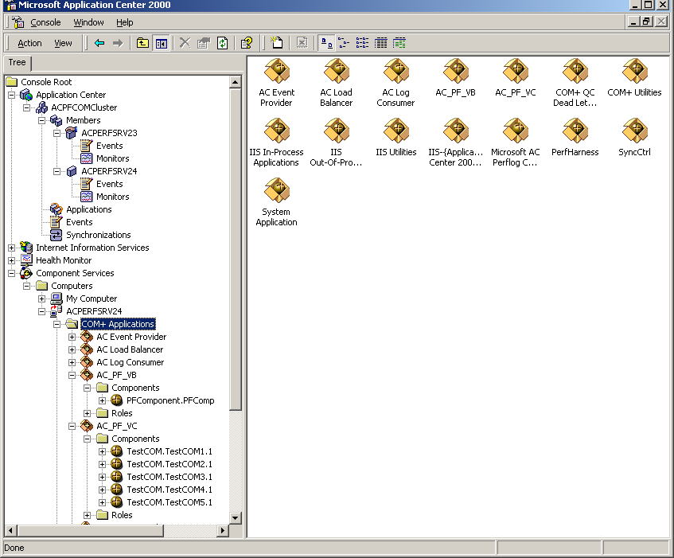

On the web cluster controller

Mark the COM+ components as load balanced
Using Application Center MMC Component services snap-in select PFComponent.PFComp from AC_PF_VB application. Right click and select ‘Properties.’ Select the ‘Activation’ tab. Select the ‘Component supports dynamic load balancing’ radio button as shown on the next figure:

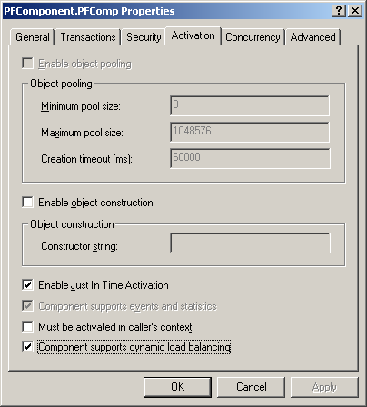

Click OK. Repeat the same with the five components in AC_PF_VC application. Marking all components to support dynamic load balancing can be done automatically by running a batch file:

C:\ACPF\Files\PFSetupCOMDLB.BAT

NOTE: Be sure to make these changes on the WEB cluster controller only, NOT on the component cluster controller!

Add component servers for load balancing
The next step is to add the name of the component cluster server to the web cluster controller for load balancing.
- Right click on ‘ACPFCluster’ and select ‘Properties’.
- Click on the ‘Component Services’ tab.
- Click ‘Add…’ to browse for computers.
- Add the name of the COM+ cluster controller.
- Repeat the last two for the component cluster member(s).
- Click on ‘OK’ (see next figure).

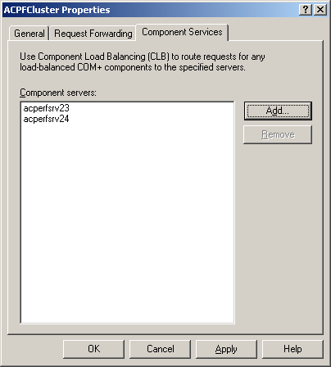

Deploy changed COM+ applications on the web cluster
On the web cluster controller, deploy the ACPFApp application. This deployment is necessary because we changed load balancing attribute only on the cluster controller and COM+ settings are not automatically replicated. How to do this was described in step 3, COM+ replication. Just enter different deployment name:

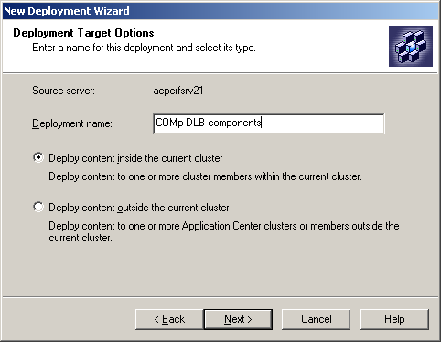

Watch the end of the deployment after clicking on the web cluster controller name:

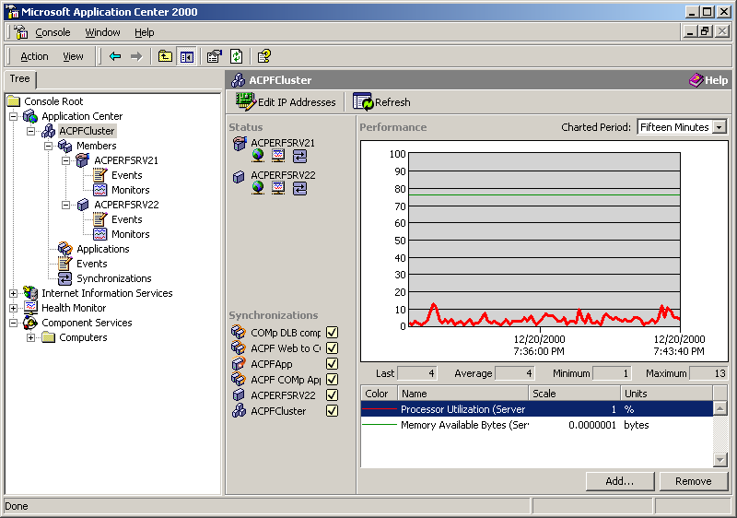

At this point the whole configuration is ready. It consists of a front end web cluster and a back end component cluster.

On the external client
Verify how the configuration works. Confirm that NLB Affinity is still set to ‘Customer (None) and Request forwarding is Off. Open the web browser. Connect to the web cluster using the cluster virtual IP. http://<web_cluster_virtual_IP>/ACPFWeb/PFWelcome.asp Verify that the page is properly displayed. The page shows the server name, the COM+ component name and the name of the server where this component is created. Close and restart the browser several times, reloading the welcome page each time. The web server name will change (Request forwarding is OFF, NLB Affinity is NONE) and different component server names, where the COM+ component is created, will appear.
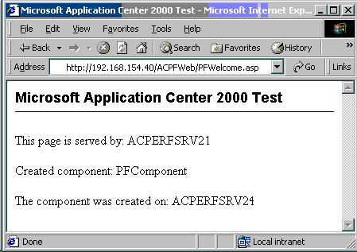

The configuration under load
Start the Web Application Stress Tool script as described in step 3. Watch CPU utilization and created pages per second on the machines from the web cluster. Check the CPU utilization on the machines of the component cluster. Open COM+ snap-in on one of the component servers. Verify that both applications are running and all COM+ components are created at least once. When the scrip finishes – investigate the report. Check for errors and failed connections. If more load is necessary – install Web Application Stress Tool on more client machines and add their names into the list of machines in the Web Application Stress Tool script on the initial client. This will allow the load to be started and stopped from one machine.

Step 7 pre-flight checks: Remote administration
Step seven shows the abilities of Application Center for remote administration.

Administering the whole configuration from the web cluster controller console

Connect to the component cluster
Connect the component cluster to the web cluster controller:
- Select ‘Application Center’, right click, ‘Connect’.
- Enter the name of the component cluster controller
- Click ‘OK’.

Add additional IIS snap-ins
Add the members of the web cluster to ‘Internet Information Services’ MMC snap-in as it was described in step 4: Metabase Replication.

Add component snap-ins
Add the members of the web cluster and all machines from the component cluster to ‘Component Services’ MMC snap-in as it was described in Step 4: COM+ Replication.
At the end you should see the screen below:

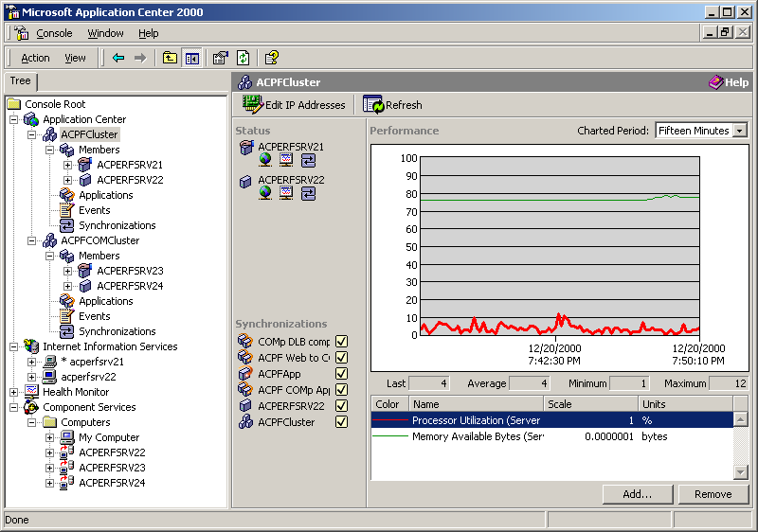

Administering the whole configuration from a remote machine
(Optional) On a remote machine, connected to intranet (the internal client, for example) install Application Center from the CD. During the setup choose ‘Custom’ and select Application Center client only. For everything else use the defaults as it was described in Setup. When the setup is finished connect to the cluster controllers of both clusters, use IIS and COM+ snap-ins to connect to the corresponding services as it was described above. Repeat steps 2, 3 and 4 controlling the clusters remotely (optional).

In Summary
In these seven steps all the major features of Microsoft Application Center 2000 were exercised and tested. If all tests passed, this is a good indication that your clusters are correctly configured and operating within expected parameters.

